Analysis of hospital based ayurvedic clinical practice to gain real world data knowledge

Vinay Mahajan

Guides:
Dr. Ashwini Godbole
Dr. Ashwini Mathur
Dr. Girish Tillu
Contents
Statement of purpose: 6
Title: 6
Short background: 6
Problem: 6
What is the present status in understanding the problem? 6
1. Literature review: 6
2. Hospital data analysis methods: 7
3. Data analysis of Treatment SOPs and implementation: 7
4. Development of robust and replicable clinical documentation based on SOP: 8
Expected outcomes: 8
Introduction 12
Chapter 1: Philosophical commonalities between the ICH and ayurvedic system: 14
Chapter 2: Narrative reviews of the published trials 27
2.1 Introduction 27
2.2 The Consolidated Standards for Reporting of Trials (CONSORT) statement 29
2.3 Jadad score 30
2.4 Narrative review 31
2.4.1 Objectives 31
2.4.2 Search strategy and Selection criteria 31
2.4.3 Main results 33
2.5 Discussion 40
2.5.1 Transparency issues 40
2.5.2 Scientific issues 40
2.5.3 Ethical issues 40
2.6 Summary 41
Chapter 3: Statistical methods to reduce biases in non-randomized and observational studies 43
3 Background 43
3.1 Propensity score: 43
3.2 Estimation of propensity score: 44
3.2.1 Generalized linear models 45
3.2.2 Discrimination analysis 45
3.2.3 Cox Hazard model 45
3.2.4 Bagging or boosting CART 46
3.2.5 Recursive partitioning or tree-based methods 46
3.2.6 Random forests 46
3.2.7. Neural networks 46
3.2.8 Non parametric methods 46
3.2.9 Propensity score calibration 46
3.3 Variable selection: 46
3.3.1 c-statistic 47
3.3.2 Hit or Miss Method 47
3.3.3 Leave-one-out Cross-validation method 47
3.3.4 Overweighting some variables 48
3.5 Impact of misspecification: 48
3.6 Effect of unobserved variables: 49
3.7 Matching methods: 49
3.7.1 Stratification on the propensity score: 49
3.7.2 Random selection within strata: 50
3.7.3 Matching: 50
3.7.3.1 Nearest neighbor matching: 51
3.7.3.2 Greedy matching: 51
3.7.3.3 Matching within calipers: 51
3.7.4 Regression adjustment: 52
3.7.5 Weighting by the inverse propensity score: 52
3.7.6 Propensity score weighting within strata: 52
3.7.7 Proportional weighting within strata: 52
3.7.8 Kernel and local-linear matching: 53
3.8 Common support region: 54
3.8.1 Visual method 54
3.8.2 Minima and maxima method 54
3.8.3 Method with S.D. +/- mean 55
3.9 Post estimation tools – Balance checking 55
3.9.1 Standardized differences 55
3.9.2 Variance ratio test 55
3.9.3 t-Test 56
3.9.4 Joint significance and Pseudo R² 56
3.9.5 Stratification Test 56
3.9.6 Iterative approach 56
3.9.7 Interactions 56
3.9.8 Overlapping coefficient 57
3.10 Post estimation tools – Sensitivity analysis 57
3.11 Designing a study using propensity method 58
3.11.1 Rubin Causal Model 58
3.11.2 Major techniques for initial design 59
3.12 Graphical displays: 60
Chapter 4: Review of the hospital data analysis and real world data analysis methods 65
4 Background 65
4.1 What is hospital data 65
4.2 Review Hospital data analysis 65
4.3 Review Real world data analysis methods 67
Chapter 5: Hospital data descriptive analysis 70
5 Background 70
5.1 Hospital database INSTA 72
5.2 Data collection methods 72
5.3 Analysis plan 72
5.4 Description of data 72
6 Analysis description and details: 77
6.1 Understanding the hospital database 77
6.2 Understanding variables from various CRF pages 80
6.3 Base data “01adsl_met_rmsd” analysis for RMSD & Metabolic patients 103
6.4 Demographics analysis using the derived dataset 107
6.5 Visit pattern summary 111
6.6 Patient visit view 112
6.7 Disease and treatment view, listing and summary 113
6.8 Disease view by seasonal variation 115
6.9 Rate of occurrence for diseases for metabolic and RMSD 117
6.10 Medicine prescription by day 118
6.11 Co-morbidity analysis 119
6.12 Treatment and disease combinations 122
6.13 ICD coding of diseases 124
6.14 ISO coding for background work history 124
6.15 Dataset with each disease considered as a reference disease having day 1 124
6.16 Circular disease and treatment view 126
6.17 Before and after disease and treatment java view 130
Chapter 6 CKD 131
1 Background 142
6.1 Investigational Agent 143
6.2 Preclinical Data 143
6.3 Risk/Benefits 143
6.4 Dose Rationale 143
6.5 Trial Conduct 143
6.6 Population 144
6.7 Literature 144
7 Trial Objectives 144
8 Trial Design 144
8.1 Primary Study Endpoints/Secondary Endpoints 148
8.2 Study Design/Type 148
8.3 Randomization 148
8.4 Maintenance 148
8.5 Trial Treatment 149
8.6 Duration 149
8.7 Discontinuation 149
8.8 Product Accountability 149
8.9 Data Identification 149
9 Selection and Withdrawal of Subjects 149
9.1 Inclusion Criteria 149
9.2 Exclusion Criteria 152
9.3 Subject Withdrawal 152
9.4 Treatment of Subjects 152
9.5 Medication 152
9.6 Monitoring for subject compliance 152
10 Assessment of Efficacy 153
10.1 Efficacy Parameters 153
10.2 Method and Timing 153
11 Assessment of Safety 153
11.1 Safety Parameters 153
11.2 Method and Timing 153
11.3 Adverse Event Reporting 153
11.4 Definitions 153
11.5 Adverse Event Follow-up 153
12 Statistical Plan 154
12.1 Statistical Methods 154
12.2 Subject Population(s) for Analysis 154
12.3 Significance 154
12.4 Termination Criteria 154
12.5 Accountability Procedure 154
12.6 Deviation Reporting 154
13 Direct Access to Source Data/Documentation 154
14 Quality Control and Quality Assurance 154
15 Ethical Considerations 154
16 Data Handling and Record Keeping 155
17 Finance and Insurance 155
18 Publication Plan 155
19 Supplements 155

Statement of purpose:

Title:
Observational analysis of ayurvedic principles, ayurvedic hospital data, and patient outcomes By Vinay Mahajan, Girish Tillu, Ashwini Mathur, Darshan Shankar

Short background:
Ayurveda has been practiced over many centuries in India. It will be safe to assume that the conceptual developments in ayurvedic knowledge base have taken place through every day observations and basic laws of nature. These fundamentals have been adjusted to the relevant times as per the passage of time, which is quite evident from vast literary history of Ayurveda which covers subjects like pharmacology, principle of diagnosis and treatment for all branches of medicine and surgery, philosophical framework and logic, pharmacy and numerous pharmacopeias. Traditional texts enumerate more than described for each disease condition (1).
Generating credible evidence for such a large pool only through modern experimental means such as trials is very challenging. Current hierarchical evidence model is being challenged by methodologists and the circular model comprising observational research methods are proposed for CAM research (2). Ayurveda like any other system of medicine, is practiced more in clinics than in clinical research setting, where there are no artificial restrictions on usage of medicines, duration of treatment or type of patients to treat, which is next to impossible in a protocol driven clinical trial setting. To plug the gap of missing empirical evidence, systematic analysis of observational clinical data is required. (3, 4) This project is focused on I-AIM clinical data for study of efficacy and safety trends.In our study of modern regulatory framework, we recognized similarity between concepts written by Charaka and ICH guidelines. This will form the philosophical basis for the research question.

Problem:
To develop a replicable clinical documentation and HMIS system in I-AIM hospital setting, that can generate reliable data on disease classification, treatment protocols and outcomes. To test this system for assessing clinical and patient reported outcomes in musculoskeletal and metabolic diseases at I-AIM hospital.

What is the present status in understanding the problem?
The problem of observational data analysis is split into 4 parts and is presented below. Each of the problem area is explained, the specific actions and possible outcomes are outlined.

Literature review:
Philosophical commonalities between the ICH and ayurvedic system:
Charaka Samhitawill be studied and interpreted on broad parameters used by ICH frameworkquality, efficacy and safety. This will provide philosophical connections between two systems and will create evidence base for the subsequent research work. This work is an effort to bridge the gap between ayurvedic and bio medicinal researchers.Furthermore, Charaka Samhitawill be studied to understand diagnosis and treatment paradigm and outcome measures. To keep the work within practical limits we will focus on musculoskeletal and metabolic diseases. In depth study of various possible variations of the disease, treatment options, diagnostic and prognostic parameters will be carried out.
Specific actions:
- Study ICH guidelines (quality, efficacy, safety) and Charaka Samhita (e.g. Vimana sthana) – see Appendix table 1 below
- Diagnosis approaches (e.g. Dashavidhapariksha)
- Treatment options (See Appendix figure 1)
- Outcome measures (Ayurvedic as well as bio medicinal endpoints)

Hospital data analysis methods:
Over the years, digitization of the hospital data has helped analytic discoveries, rather than only the straight facts. The day to day hospital settings generate a multifold data than clinical trials. This revolution has not been used by the ayurvedic medical industry. These advances should be used to improve patient wellness, better clinical decisions, better care coordination, cut down treatment abuse, and even to cut down costs.
Specific actions:
- Review of the literature to understand the current methods employed across world
- Check for potential solutions to be implemented at hospital (e.g. patient data dash boards)
- Provide suggestions for improvements in day to day functioning at hospital

Data analysis of Treatment SOPs and implementation:
The I-AIM hospital has generated 91,000 patient visits data over the years and perhaps the largest electronically available ayurvedic treatment database. What insights would come out of such a large database? A study will be carried out on patients in 2 disease areas musculoskeletal diseases, and metabolic diseases. This would provide us guidance for the future empirical research and analysis. The concepts explained in the ancient texts have not been proven empirically but have never been disproved either. The analysis of this database would present us with empirical insights never seen before.
Inspection of the current database:
- I-AIM hospital database INSTAwill be studied for
  - What kind of data is collected?
  - What are the issues with the current data
  - Potential fixes for the future
- Queries will be posted to the IT team
- Specific reports or lists will be requested if considered necessary e.g. treatment data is not reported by INSTA reports fully.
Currently, as of August 2016, at IAIM hospital, treatment SOPs are written for musculoskeletal diseases, and metabolic diseases. Several modifications for diagnosis, treatment and outcome measures have been suggested. These will be implemented in the hospital practice over the coming months. The collected data based on these revised SOPs will be analyzed to validate the findings.
Specific actions:
- Statistical methods to be employed:
  - Graphical methods to display a lot of data in a concise form, trellis graphics, heat maps, etc.
  - Pattern or trend analysis: to understand the underlying clusters within the data
  - Decision theory analysis: to understand how the treatment gets assigned and what calculations, algorithms go through a doctor’s mind
  - Multi-variate analysis: to model the data and gain more insights
- Innovative and emerging tools and techniques from Omics / bioinformatics etc.

Development of robust and replicable clinical documentation based on SOP:
Specific actions:
- Define factors for the completeness, robustness of SOPs
- Create a detailed analysis plan for analyzing the implementation
- Analyze the results for completeness, robustness and replicability of the SOPs,
- If any shortcomings are observed then revisions to the SOPs will be suggested

Expected outcomes:
- Philosophical linking between the ayurvedic scientific concepts and western medicinal concepts – building bridges between sciences
- Baseline understanding of the data and descriptive analysis of the current facts of ayurvedic hospital data
- Hospital data analysis methods development

Reference:
- AyuSoft data
- Circular instead of hierarchical: methodological principles for the evaluation of complex interventions http://bmcmedresmethodol.biomedcentral.com/articles/10.1186/1471-2288-6-29
- Vaidya Rama, Observational therapeutics: Scope, challenges, and organization, http://www.ncbi.nlm.nih.gov/pmc/articles/PMC3255445/
- Healthcare outcomes assessed with observational study designs compared with those assessed in randomized trials.http://onlinelibrary.wiley.com/doi/10.1002/14651858.MR000034.pub2/abstract;jsessionid=1951EC6CD7534A7205C1FFE7E6890FCF.f04t03

Appendix:
Table 1: Cells highlighted in Green show similarities between ICH framework and Charaka Samhita.
Quality | Efficacy |  | Safety
Q1A – Q1F Stability | E1 Clinical Safety for Drugs used in Long-Term Treatment | E14 Clinical Evaluation of QT | S1A - S1C Carcinogenicity Studies
Q2 Analytical Validation | E2A – E2F Pharmacovigilance | E15 Definitions in Pharmacogenetics / Pharmacogenomics | S2 Genotoxicity Studies
Q3A – Q3D Impurities | E3 Clinical Study Reports | E16 Qualification of Genomic Biomarkers | S3A - S3B Toxicokinetics and Pharmacokinetics
Q4 – Q4B Pharmacopeias | E4 Dose-Response Studies | E17 Multi-Regional Clinical Trials | S4 Toxicity Testing
Q5A – Q5E Quality of Biotechnological Products | E5 Ethnic Factors | E18 Genomic Sampling | S5 Reproductive Toxicology
Q6A – Q6B Specifications | E6 Good Clinical Practice |  | S6 Biotechnological Products
Q7 Good manufacturing practice | E7 Clinical Trials in Geriatrics Population |  | S7A - S7B Pharmacology Studies
Q8 Pharmaceutical Development | E8 General Considerations for Clinical Trials |  | S8 Immunotoxicology Studies
Q9 Quality Risk Management | E9 Statistical Principles |  | S9 Nonclinical Evaluation for Anticancer Pharmaceuticals
Q10 Pharmaceutical Quality system | E10 Choice of Control Group |  | S10 Photosafety Evaluation
Q11 Development and manufacturing of Drug Substance | E11 Clinical Trials in Pediatric Population |  | S11 Nonclinical Safety Testing
Q12 Lifecycle Management | E12 Clinical Evaluation by Therapeutic Category

Figure 1:
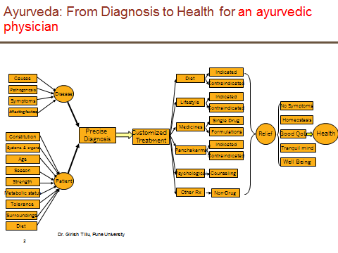

Introduction

The practice of medicine has a history of three thousand years in India. Ayurvedic medicine is one of the world’s oldest medicinal systems. Caraka samhita and Sushrut samhita, two of the ancient texts written in Sanskrit are considered to be the back bone of the ayurvedic medicines. But there is a belief that these practices would have started much before these two samhitas were written. Ayurveda combines a number of approaches, such as changes in lifestyle, Ayurvedic medicines, cleansing or detoxifying, massage, exercise, and meditation. Overall, it aims to strengthen and purify the body and mind and increase spiritual awareness.

Modern medicine took giant strides in the 19th century with advances in chemistry and laboratory equipment. The western medicinal system has surged ahead and has witnessed many fantastic breakthroughs which are helping human kind. For any science to remain relevant to the era there should be ongoing research activities. Any science which is stagnant cannot remain attractive and will soon lose its usefulness. This is even applicable to Ayurvedic medical science.

Ayurveda is considered to be a science based on pure logical explanation. These are called Darshana. But in more than 2000 – 3000 years there have not been major conceptual additions to the science. The concepts written in samhitas are lagging behind compared to the present knowledge base. But this does not make the science less important. There is a huge opportunity to use the traditional understanding in combination with newer available technology like x-rays, ECGs, CT scans, biomarker understanding, etc. to achieve cure for diseases.

Ayurvedic medical system has always been an individualized therapy due to its very nature. For this to have worked, there would have been very good scientific basis. Traditionally, “one fits all” or “big block buster drugs” has been the approach in western medicine system. But with the scientific advances and many biomarkers coming into existence, the focus is moving towards customized medicine, which only seemed possible in sci-fi movies.

There is no documented reference within the samhitas or other historic texts about how did the great sages understand the intricacies of treating different diseases, identifying the medicinal plants, their formulations, etc. Could we assume that did they conduct experiments to understand these properties and somehow that did not get documented at all? Or could it be attributed to our inability to understand the cryptic nature of the shlokas? Could we even dare to assume that there were clinical trials conducted? If not then, could we put a concerted effort on gaining more understanding via good quality clinical trials?

One should not go with the impression that classical Ayurveda has no evidence base. In fact, Ayurveda has always been evidence conscious, and most of the principles and treatment modalities seem to have been critically tested and validated for the conditions existing in their own time frame. The ancient concept of evidence is based on fourfold testing, viz., (1) Pratyaksha pramana (direct observation), (2) Anumana pramana (inferential evidence), (3) Aptopadesa (scriptural evidence) and (4) Yukti pramana (planned rational experimental evidence).

This fourfold battery of testing new knowledge is classical of ancient Indian scientific tradition, which seems to be highly contemporary.

The evidence base of contemporary Ayurveda is to be visualized in several forms, including (1) Textual evidence and folklore claims, (2) Experience-based evidence, (3) Longstanding traditional use, (4) Mass acceptability and (5) New scientific evidence. It cannot be overemphasized that in spite of all the strengths of primary evidence, one cannot deny the need to develop new supportive scientific evidence without which contemporary Ayurveda cannot attain the status of a real global science accessible for the larger benefit of humanity at large. WHO also holds a similar view. However, it must be emphasized that fruitful strategies for developing new scientific evidence cannot succeed if traditional primary evidence is ignored. New research is to be planned on the foundations of existing textual and experience-based evidence. The frequently used term "evidence" essentially means a relevant and reasonable proof for a fact or truth; such a proof need not be necessarily in words or terms of today's science alone.

Even after accepting major differences, there are quite a lot of similarities in the principles of the traditional ayurvedic medicine and western medicine. What Charaka and some of the earliest “doctors” defined in the historical texts still holds validity in today’s world.

Chapter 1: Philosophical commonalities between the ICH and ayurvedic system:

Big pharmaceutical companies have become one of the targets of critics for high prices and not doing enough for society. The health authorities are becoming more stringent in their safety review which has also resulted in less drug approvals and many drugs withdrawn from the market. To add to this the insurance companies are becoming stricter in their coverage making it difficult for a common man to afford lifesaving drugs.
We have a generic market which again base their studies on the big pharmaceuticals and keep battling for a good market price. With innovation taking a back seat here there is only a mad run for money.

In this rage for drugs v/s money v/s life can we look at any alternate solution to combat the prevailing situation? Is there no means of getting the need identified through means which are less invasive and much affordable?

Why do we not look at our own long historic tradition of medicine “The Ayurveda”.
Approximately 3000 – 5000 year old Indian traditional medicinal system is based on 2 major treaties Charaka Samhita (for physicians) and Sushruta Samhita (for surgeons)Earliest texts date on Ayurveda, which is written by Charaka, back to 760 BC, around 660 BC Sushruta wrote Sushruta Samhita, a medical text about the surgical approaches used in that period.

Ayurvedic medical system is a world of medicine and the most holistic system available. Charaka Samhita is considered to be a very highly technical text, which deals with 8 branches of ayurveda. (1) Internal medicine (kayachikitsa), (2) Ear, nose, throat (Shalakya Tantra), (3) Toxicology (Vishagara-vairodh Tantra), (4) Pediatrics (Kaumara bhritya), (5) Surgery (Shalya Tantra), (6) Psychiatry (Bhuta Vidya), (7) Aphrodisiacs (Vajikarana), (8) Rejuvenation (Rasayana). These details point to holistic approach. These could rival various franchisees.

Rig-veda (a lot of things, a lot of medical content), Sam-veda (Soma sacrifice), Yajur-veda (entire sacrificial rite), Athar-veda with a lot of medical text are the 4 vedas which could be considered to be the first of its kind encyclopedias written by human kind. These are considered to be written around 1500 to 2000 BC. Athar-veda is considered to be written in 1200 BC. Ayurveda is considered to be based on these vedas.

Under the rule of king Ashoka Ayurveda flourished. The ayurvedic treatment was in use till 12th century, but the decline started after theinvasion of India by the Muslims.
No documentation of any major development on ayurvedic text or ayurvedic discipline has been documented post 12th century.

Similar developments have been seen happening in China around 300 BC and few evidences of medicinal science development in Middle East around 980 AD known as Unani medicine are also seen.

Physician Hippocrates of Kos (ca. 460 BC – ca. 370 BC), is considered the “father of modern medicine”. The Hippocratic Corpus is a collection of around 70 early medical works from ancient Greece, associated with Hippocrates and his students. Hippocrates and his followers were first to describe many diseases and medical conditions.

There are major differences in ayurvedic medicinal system and western medicinal system, in terms of what is the origin of the disease, what causes it, how to treat the same?But the ultimate aim in both the systems is to have disease free existence for human beings. Modern medicine took giant strides in the 19th century with advances in chemistry and laboratory equipment. The western medicinal systemhas witnessed many fantastic breakthroughs which are helping human kind. Some of these have come at a huge cost not just monetary but sometimes at a cost of ethics and integrity.

Traditionally, “one fits all” or “big block buster drugs” has been the approach in western medicine system. But with the scientific advances and many biomarkers coming into existence, the focus is moving towards customized medicine, which only seemed possible in sci-fi movies. Today the western medicine is aiming towards customized therapies for patients by thinking in terms of disease and patient as one constraint and solution very patient centric i.e. one patient – one solution.

Ayurvedic medical system has always been an individualized therapy due to its very nature. For this to have worked, there would have been very good scientific basis.

Despite of these major differences in their ideologies, there are quite a lot of similarities in the principles of the traditional ayurvedic medicine and western medicine. What Charaka and some of the earliest “vidyas (doctors)” defined in the historical texts is still valid in today’s world. The concepts defined in the Helsinki declaration, GxP guidelines and the ICH guidelines concur with what is in the historic books.

- What is a hospital?
- Who is a doctor?
- How to treat patients?
- Who should be treated, how much money should be charged?
- How should the special populations (e.g. pediatric population, geriatric population) be treated?

These questions have similar answers in both the worlds. Why is it important to know this? This could be a very crucial step in order to achieve the evidence which western world is expecting. The similarities are very stark and would even prompt us to think “are we trying to re-do what we know for so many years?”

It is up to us now to expedite this process of finding similarities and identify strategy to capitalize on the same. This step would help in building confidence amongst the two medicinal systems.Below are few examples of the like mindedness of the two systems:
Topic | Modern guidelines | Historic text
Well-being of patients | Helsinki declaration:  The first and foremost thing in a clinical practice or a clinical trial would be of patient safety. World Medical Health (WMA), in their 18th General assembly, 1964 came up with “Ethical Principles for Medical Research Involving Human Subjects”. The declaration covers various principles of medical research and medical care. Focus on protection, well-being of the human beings participating in the clinical research.  As per the current version of the declaration, 59th WMA General Assembly, Seoul, October 2008, there are 35 sections across 3 major headings A. Introduction, B. Principles for all medical research, C. Additional principles for medical research combined with medical care.  One of the most important sentences: The health of my patient will be my first consideration and a physician shall act in the patient’s best interest when providing medical care.  This declaration protects various types of vulnerable populations. | Ayurveda is considered to be eternal in nature. As a part of “study” in Charaka Samhita, the ayurvedic physician was taught to keep all the living things before. He was taught to make all the efforts to provide health to the patients. He was taught to think about the welfare of society and not to think ill about any of the patients.  The physician should not treat female patients or kids (pediatrics) without the required consent, which could be a parallel to the “vulnerable population”.  The physician is expected to keep all the data about patient confidential. Charaka Samhita Viamansthana8 #13  Page 113 of part I has explanation related to what should be done
Qualifications of a doctor and concept of a hospital | In this world of documentation and audit trails, every single item needs to be documented. This evidence has to be submitted along with each and every Clinical Study Report to various health authorities around the world.  ICH E6 “Guidelines for Good Clinical Practice”, outline international ethical and scientific quality standard for designing, conducting, recording and reporting trials that involve the participation of human subjects.  Section 4 of the guidelines focuses on “INVESTIGATOR” which is defined as in section 1.34 of the guideline: “A person responsible for the conduct of the clinical trial at a trial site. If a trial is conducted by a team of individuals at a trial site, the investigator is the responsible leader of the team and may be called the principal investigator. See also Subinvestigator.”  Section 4.2 talks about “Adequate Resources”. | Charaka defined how a hospital should be in Sutrashtan adhyaya 15 shloka 7 According toCharaka,thehospital should be designed by an architect, someone who is trained in “vastu shastra”.  The concept of a hospital defined in the texts is in line with the modern thought process. The thought process of having a clean place which is accessible to common man, a pharmacy with abundant medicines and availability of medicinal equipments still holds good in these times.  There are references to the number of attendants (16 in number), furniture, livestock, fixtures which should be available in the hospital “house”.  The building should be strong and well-built in  a location free from high winds, although it should be constructed in such a way that gentle winds can pass through it if desired, freshening the interior environment. The building should not be built in  mountainous places (for lack of accessibility), and  nor should it be located next to a bigger building (which brings misfortune upon it). Dusty locations, wet environments, or locations with foul or toxic smells should be rejected as building sites. The attendants that work in the clinic or hospital should be enthusiastic, skilled and compassionate. Caraka states that people well versed in music and poetry should also be encouraged to participate in the healing centre. Outside the building a herb and vegetable garden should supply medications and food for the clinic or hospital, and certain animals, such as a cow and her calf, and birds such as quail and partridge, should be kept by the facility for the benefit and enjoyment of the patients and faculty.  He defined quadraple concept for successful medical practice which included vaiyda (the doctor), paricharika (a nurse), good medicine and good patient. Sutrashtan adhyaya 15 shloka 9  In Sushruta samhita Sutra sthan adhyaya 2 shloka
Informed use of treatment | As per ICH E6 guidelines, section 4.6.6, it is important to tell a patient about what is being administered to him or her.  4.6.6 The investigator, or a person designated by the investigator/institution, should explain the correct use of the investigational product(s) to each subject and should check, at intervals appropriate for the trial, that each subject is following the instructions properly.  This is a very important GCP constraint before administering any kind of a drug to any patient or a subject. | There are a lot substances used as medicines in the ayurvedic treatments, documented in various texts. Different types of flora, fauna, poisonous materials, meat, etc. are used. It is a vaidya’s duty to inform the patient what is being administered before administering the medicine. A drug, if unknown, is fatal like poison, weapon, fire and thunderbolt while, if known, is vitalizer like nector, as per SutraSthan adhyaya 1 shloka 124-125.
Pediatric population and concerns | The pediatric population represents a vulnerable subgroup. Therefore, special measures are needed to protect the rights of pediatric study participants and to shield them from undue risk.  ICH E11 guideline “CLINICAL INVESTIGATION OF MEDICINAL PRODUCTS IN THE PEDIATRIC POPULATION” is designed to provide an outline of critical issues in pediatric drug development and approaches to the safe, efficient, and ethical study of medicinal products in the pediatric population.  There are very limited number of medicinal products available labeled for pediatric usage. Ages are defined in completed days, months, or years.  - Preterm newborn infants  - Term newborn infants (0 to 27 days)  - Infants and toddlers (28 days to 23 months)  - Children (2 to 11 years)  - Adolescents (12 to 16-18 years (dependent on region))  This kind of classification is very important to correctly identify the dose level.  Similarly, these are covered under Helsinki declaration. | Charaka specifically talks about the pediatric diseases in one of the 8 branches of ayurveda, Kaumarabhrtya.  Some of the diseases which are seen in adults are the same in pediatrics, but only in less quantity. These are very difficult to identify as pediatric patients are unable to express what they are going through. Smaller doses should be given and formulations of drugs should be sweet and soft. These are the problems which are still worked on even in the modern times.  Charaka defines age groups in vimansthan adhyaya 8 and shloka 122. He has classified life into 3 age groups, childhood (up to 16 years), middle age (up to 60 years) and old age (up to 100 years).
Ethnic suitability | ICH guideline E5 “ETHNIC FACTORS IN THE ACCEPTABILITY OF FOREIGN CLINICAL DATA” outlines guidelines for usage of a medicinal product across various parts of the world. It provides a framework for evaluating the impact of ethnic factors upon a medicine’s effect, i.e., its efficacy and safety at a particular dosage and dose regimen. | Chikitasasthan adhyaya 30 and shloka 316-328 in these shlokas Charaka has written about the benefits of using suitable foods.  A drug could fail if the doctor does not take age, sex, strength, body, etc. into account before prescribing it.  There is a reference to different parts of “India” and what kind of food and drugs could be suitable to them. Madhya desa, south region, eastern region, Chinese parts.  For patients, the drug should be administered along with the items suitable to them because the suitable medicine provides strength quickly and does not harm even if taken plentiful. [Even if taken in large dose.]  Other than just ethnic suitability there are references to how males should be treated differently than females.
Formulations, route, type of doses, frequency, Food effect | In the development cycle of a drug, there are different type studies conducted to understand the properties of the drug. These could be bioavailability, formulation-route-dosing frequency studies, drug-drug interaction studies, food effect studies, QT studies, organ impairment studies (renal, hepatic, etc. impairment studies)  These studies help in making the label of the drug. | There are a lot of references in various texts about when should drug be given, how much should it be given, and so on.  They had understood the importance of considering route of administration, time, place, suitability and dose.  “anupana” is a special category of the Ayurvedic pharmacy which relates to the usage of certain additional substances given along with the medicines. Water, milk, ghee, jaggery, honey,fresh plant juices, meat broths, etc. could be some of the examples.  Dosing strategies: Abhakta (dosing on empty stomach), adhobhakt (dosing after meal), muhuh muhuh (multiple times a day), nisa (dose to be taken before sleeping) etc.  The following shlokas from Chikitasasthan adhyaya 30 and shloka 298-300, explain time of administration, which could be equated to Food effect.  (page 550 in part I)  ebooksclub[1].org__Ayurveda__The_Divine_Science_of_Life.pdf: page 93, 6.13 dosing strategy.
Dose toxicity (under dosing and over-doing) | In the modern day medicine, finding the right dose is a huge problem. There has been considerable amount of research which is ongoing.  Under dosing is not going cure the disease and over dosing may end up creating significant side effects.  This problem is a very important problem in cancer trial as the drugs can be very toxic. | Chikitasasthan adhyaya 30 shlokas 313-314 in Charaka Samhita, talk about under dosing or over dosing of the drug and what are the consequences.  Very less dose of any medicine is ineffective and too much of it could prove harmful.
Commercial aspect: |  | In ChikistaSthan  The doctor should not use his knowledge of medicine to make money to wealthy. Instead, the powers which he has gained through studying ayurveda should be used for welfare of the society. Someone who helps patients come out jaws of death enjoys maximum happiness.  Page 467 of Part I book talks about the non commercial aspect:
Repeatability | Clinical trials are nothing but experiments conducted on human beings. For any scientific experiment to be considered as reliable, is should have the property of producing similar results time and again. | Page 114 su29#7, page 133 Vi8#101
Classification of diseases (Girish) | > 4500 type of disease | ICD 10
Sushruta’s concept of sterlization

All of the above points contribute to the analyses which is performed for the modern medicines and submitted as a part of the submission dossiers. Could this help change the perception of Ayurveda being only “evidence based” or “nonscientific” to something better? Could these potential similarities help lessen the gap?

Ayurveda to further focus on the treatment therapies has been split in to 8 branches which are very closely related to the branches of western medicine. Below is the list of the 8 branches of Ayurveda and its equivalent in the western medicine.

Ayurveda Branch | English translation | Branch in Western medicine
Kayacikitsa | medicine | General Medicine
Salakya | dealing with diseases of supra-clavicular  region | ENT
Salyapahartrka | dealing with extraction of foreign bodies | Surgery
Visa-gara-vairodhika-prasamana | dealing with alleviation of poisons, artificial  poisons and toxic symptoms due to intake of  antagonistic substances | Toxicology
Bhuta vidya | dealing with spirits or organisms | psychology and psychiatry
Kaumarabhrtya | pediatrics | Obstetrics, Gynecology and Pediatrics
Rasayana | promotive measures | Therapies on wellbeing and wellness
Vajikarana | aphrodisiacs | Fertility and Sexual studies

It is very well known and understood that Ayurveda is an observational science and there is no scientific evidence to its outcome/benefit. But on further reading of the Charaka Samhita on the evaluation of the treatment effect we can see that it closely comparable to how treatment effect is statistically evaluated in the western medicine.

All the factors that could cause an interaction effect during treatment evaluation can be seen below in the means of success in treatment.

(Charaka Samhita 2003rev2vol1 ,Edited by Gabriel Van Loon)

The following properties are known as “Paradi” (“Beginning with Para”). They
are the means of success in treatment:
paratva (excellence)
aparatva (non-excellence)-- These 2 are used in relation to place, time, age,
measure, vipaka, virya, rasa etc.
yukti (rationale)-- is the rational planning of therapeutic measures
sankhya (enumeration)-- is mathematics including statistics
samyoga (conjunction)-- is the joining together of entities. It is of three types
according to the active participation of both, all or only one partner. It is non-eternal.
[this last statement is a profound philosophical one; no union is permanent, but rather
only temporary. All entities are made of the temporary bonding of other entities. All
living creatures are only the temporary union of the foods they have eaten, and will
eventually disperse to become the foods of a different union or creature.] [Samyoga also
refers to conjunction of herbs into formulas, of doshas and dhatus into disease, of
multiple etiologies into single etiology, etc.]
vibhaga (disjunction)-- it is also of 3 types; vibhakti (excision), viyoga
(disjoining) and bhagaso graha (division).
prthaktva (separateness) – is of 3 types; asamyoga (spatial separateness),
vailaksanya (class separateness) and anekata (individual separateness).
parimana (measurement)-- denotes measures (of all types- including weights).
samskara (processing)-- this is processing
abhyasa (practice)–is regular use of substance, habituation and practice.
–Thus all the paradi properties are said with their definitions, which if
unknown, do not let the therapy proceed properly.

The historic texts are indicative of the fact that the doctors practicing Ayurveda somehow knew these things. Only thing lacking here is the supporting data to confirm these claims.
Our aim here is not to outdo or supersede one system over the other but rather to bring about awareness and change in our thought process by moving from calling “Alternative” to “Supplemental” in both ways?

Appendix:
- Well-being of patients:

- Qualifications of a doctor and concept of a hospital

- Informed use of treatment

- Pediatric population and concerns

- Formulations, type of doses, frequency, Food effect (page 550 in part I)

- Ethnic suitability

- Dose toxicity (under dosing and over-dosing)

- Commercial aspect: Page 467 of Part I book talks about the non-commercial aspect:

- Repeatability: Page 114 su29#7, page 133 Vi8#101

These texts have extensive references to various disease areas. E.g. Cancer—an ayurvedic perspective^{(*)}, in this paper, the authors have elaborated about integrated approach towards management of cancer.

Chapter 2: Narrative reviews of the published trials

2.1 Introduction

Use of Ayurveda and other traditional medicines has expanded globally not only in the poor countries but also in the developed countries where conventional medicine is predominant. Due to this expansion documentation of the safety and efficacy of Ayurveda and other traditional medicines has become an important concern

As per Ayurvedic philosophy the entire cosmos is made up of energies of five elements: air, water, fire, earth, ether (space). The human body is also made up of these elements. These elements form the cognitive aspect of human beings. Ayurvedic medicine is oriented toward prevention, health maintenance, and treatment. The belief in Ayurvedic medicine is that a disease is the product of an imbalance in the body and mental elements that reduce the body’s resistance to diseases. If the imbalance is corrected and the body’s defense mechanisms are strengthened, then the body will resist a disease with a goal of eliminating it. The first goal is health promotion and disease prevention. The second goal is to treat physical, mental and spiritual illness. [3]

As the basic principles of Ayurveda and other Traditional systems are different from the Western medicine there is a perceived lack of evidence for all Traditional systems of medicine including Ayurveda. This has resulted in a situation, where in we see that a large section of the population is using these systems of medicine, but it is not accepted as a part of mainstream health care.

The western medicines are developed using a method called as hierarchical method where it tries answering the questions with limited scope e.g. what is the efficacy of a particular drug, what is the safety profile of a drug? This method assumes a step wise approach and deals with the problem in successively conducted clinical trials of various types in a specific sequence. The pharmacology of the molecule is ascertained first at the very beginning. These studies are followed by cohort studies, Open-label randomized studies. The process ends with the blinded, randomized, placebo controlled trials (RCT). The RCTs offer most internal validity and reduce the bias. These studies could be complemented by then moving onto case studies, case series. This “one step at a time” approach has worked very well in the western medicine framework.

There are some other models proposed by various authors to handle complex and tricky situations arising in defining and understanding the action of mechanism of Ayurvedic intervention.

Huge observational data for ayurvedic medicines [9]: There are more than 1,00,000 books and manuscripts, 57 authentic books (Drug and cosmetic act 1940), > 4500 diseases including subtypes and conditions (Ayusoft database), > 81,000 formulations (TKDL database), > 4,00,000 Practitioners (Planning Commission - 11th Plan) in India, Infinite documents, references, experiential data, Living tradition and knowledge in public domain. Dravyaguna (Pharmacology), Bhaisajya Kalpana (Pharmaceutics), Nidana (Diagnosis) and Chikitsa (Management principles), this data points to a validated knowledge base and it is acceptable that Ayurveda is an evidence based knowledge system.

Dr. Ashok D. B. Vaidya has explained the concept of reverse pharmacology to understand the action mechanism of Ayurvedic intervention. Reverse pharmacology is the science of integrating documented clinical/experiential hits, into leads by trans-disciplinary exploratory studies and further developing these into drug candidates by experimental and clinical research. It comprises of three stages - experiential, exploratory and experimental.

- Experiential robust documentation of clinical observations of the biodynamic effects of standardized ayurvedic drugs by meticulous record keeping.
- Exploratory studies for tolerability, drug interactions, dose range finding in ambulant patients of defined subsets of the disease and para-clinical studies in relevant in vitro and in vivo models to evaluate the target activity.
- Experimental studies, basic and clinical, at several levels of biological organization, to identify and validate the reverse pharmacological correlate of ayurvedic drug safety and efficacy.

Based on the huge observational data and the relatively low rate of side effects, it is rather easy to test Ayurvedic intervention in larger clinical trials. This would help build the required safety and efficacy information relevant to the Ayurvedic intervention under question. Once these key parameters are established, the pharmacokinetic properties can be understood. This process is economical may take lesser amount of time when compared with the hierarchical model used in western medicine.

Harald Walach et al. [8] have discussed a circular method to develop medicines. This would imply a multiplicity of methods, using different designs, counterbalancing their individual strengths and weaknesses to arrive at pragmatic but equally rigorous evidence which would provide significant assistance in clinical and health systems innovation.
Experimental methods that test specifically for efficacy have to be complemented by observational, non-experimental methods that are more descriptive in nature and describe real-life effects and applicability. The latter can range from retrospective audit studies, prospective case series to one armed to multiple armed cohort studies. Matched pairs studies can be conducted as experimental studies, by forming first pairs and then randomizing them, or as quasi-experimental studies by forming pairs from naturally occurring cohorts according to matching criteria.

ICH guidelines E2E for Pharmacovigilance planning, and E9 for statistical principles of clinical trials, provide a lot of different study designs to build the necessary evidence base either in form of a RCT or in any other form deemed fit for purpose. Case series, active and passive surveillance, sentinel site surveillance, drug and exposure registries are a few types of study designs to generate necessary data. Comparative observational studies like cross sectional survey, case-control study, cohort study, descriptive study and drug utilization study have been suggested. This is not an exhaustive list, but should be considered as a good starting point.

Similar to the Traditional Indian Medicine, there are other medicinal systems in existence e.g. traditional Chinese medicine (TCM), herbal medicines, etc. These systems are complex and they face similar sort of questions. TCM individualized its treatment protocol or clinical practice without considering the principles of modern medicine. The standard methodology of random selection, blinding and placebo control, followed by statistical analysis was generally overlooked. This had a negative effect on the development of TCM. Since 2000 onward, the volume of applied research in Chinese medicine is growing rapidly and the quality is improving. There is good evidence supporting the use of some Chinese patent medicine treatments. Further, there is a more open attitude to Chinese medicine among conventional health professionals, partly explained by the rise of evidence-based medicine (EBM). They have been reasonably successful in developing CONSORT like standards to define the quality, improve the standard of reporting.

On the other hand, the Western medicine is primarily oriented toward the treatment of disease.The drugs are developed based on the concept that the elimination of specific causes of a disease will cure a disease. Western medicine has been the dominant medical system of the world of the last century due to various reasons. Hence, there has been a tendency to test the effectiveness of all other medical systems and the cures they offer using the framework and methods of Western medicine which rely heavily on pharmacology, safety and efficacy of the drugs in principle. Those molecules which meet these criteria are allowed to be marketed as the drugs. The methods to come up with and test western medicines have undergone a lot of improvements and have developed validated methods which cater to the specific needs e.g. CONSORT, Jadad Score, ICH, GCP guidelines to name a few.

It is very evident that generating evidence which fits into the western medicine frame-work for Ayurvedic system is the need of the hour. But it is a very complex task as Ayurvedic intervention is just not a tablet or a capsule but is a holistic approach towards life. In order to achieve this seemingly very difficult task, it is important to find correlation between different systems. The efforts should be made to convert the evidence which is rooted in Ayurvedic discipline to be converted into “trans-disciplinary” evidence.

2.2 The Consolidated Standards for Reporting of Trials (CONSORT) statement

To comprehend the results of a randomized controlled trial (RCT), readers must understand itsdesign, conduct, analysis and interpretation. That goal can only be achieved through completetransparency from authors. Despite several decades of educational efforts, the reporting of RCTs needed improvement. Investigators and editors developed the CONSORT (ConsolidatedStandards of Reporting Trials) statement to help improve reporting by using a checklist andflow diagram. The CONSORT statement was developed to assist investigators, authors, reviewers and editors on the necessary information to be included in reports of controlled clinical trials [4]. It is intended to improve the reporting of a Randomized Control Trial, enabling readers to understand a trial’s conduct and to assess the validity of its results.The checklist items includes 25-items selected because empirical evidenceindicates that not reporting the information is associated with biasedestimates of treatment effector the information is essential to judge the reliability or relevance of the findings.Theflow diagramdepicts the passage of participants through an RCT.

The CONSORT statement was first published in 1996, revised in 2001, and 2010[4]. This statement consists of a checklist and flow diagram to guide writers and reviewers on the information that should be available from published reports of two-group parallel RCTs [4]. The CONSORT statement has been endorsed by many leading medical journals, editorial associations, professional societies, and funding agencies [4]. Since its inception, several extensions of the CONSORT statement have been developed [4].CONSORTwas extended to cluster randomized trials [4] and for trials examining harms [4]. Also, an international group of acupuncture researchers developed a set of recommendations for improving reporting of the interventions in parallel group trials of acupunctured the Standards for Reporting Interventions in Controlled Trials of Acupuncture or STRICTA [4].

2.3 Jadad score

A numerical score between 0-5 is assigned as rough measures of study design/reporting quality (0 being weakest and 5 being strongest). This number is based on a well-established, validated scale developed by Jadad et al [5]. This calculation does not account for all study elements that may be used to assess quality. A Jadad score is calculated using the seven items in the table below. The first five items are indications of good quality, and each counts as one point towards an overall quality score. The final two items indicate poor quality, and a point is subtracted for each if its criteria are met. The range of possible scores is 0 to 5.
Jadad Score Calculation
Item | Score
Was the study described as randomized (this includes words such as randomly, random, and randomization)? | 0/1
Was the method used to generate the sequence of randomization described and appropriate (table of random numbers, computer-generated, etc)? | 0/1
Was the study described as double blind? | 0/1
Was the method of double blinding described and appropriate (identical placebo, active placebo, dummy, etc)? | 0/1
Was there a description of withdrawals and dropouts? | 0/1
Deduct one point if the method used to generate the sequence of randomization was described and it was inappropriate (patients were allocated alternately, or according to date of birth, hospital number, etc). | 0/-1
Deduct one point if the study was described as double blind but the method of blinding was inappropriate (e.g., comparison of tablet vs. injection with no double dummy). | 0/-1

2.4 Narrative review
In order to understand the existing practices of Ayurvedic therapy the following systematic review was done.

2.4.1 Objectives
The objective of the report was to conduct a search of published literature on how the clinical trials are conducted and reported for Ayurvedic medicines.

2.4.2 Search strategy and Selection criteria
This search result could be biased as it was only electronic and restricted to language English. As this research is aimed for academic purpose, no papers were bought.

As per figure 1,
Broad search:
- Cochrane library database was used as a search engine with the key word “Ayurved” OR “ayurvedic” OR “traditional Indian” for papers published on or before2nd August 2016. 397 potentially relevant papers were retrieved.
- 123 paper were eliminated for the following reasons: 61 duplicate entries, 37 non-interventional studies, 23 studies irrelevant to the study and 2 non-ayurvedic papers.
- Thus, there were 274 papers left for analysis.
Narrowed to specific necessity:
- 274 studies satisfied the inclusion criteria of which for 147 (53.65%) trials were fully available, for 119 (43.43%) trials abstracts were available and 8 (2.92%) trials had no info available in the papers.
These 274 trials were used in the following analyses.

Major versions of CONSORT statements were published in 2001 and 2010. For any new guidance to come in full effect, it usually takes a couple of years, hence the analysis will be done on the overall studies, as well as studies conducted on or before year 2003, between years 2004 and 2012 and 3rd category is between years 2013 and 2016.
Status of each of the paper

Full text available = 147 (53.65%)
Abstract available = 119 (43.43%)
Not available = 8 (2.92%)
Time frame = Till August 2016

Database searched = Cochrane library

Number of studies published before

On or before 2003 = 52 (18.98%)
Between 2004 and 2012 = 130 (47.45%)
Between 2013 and 2016 = 92 (33.58%)
Potentially relevant papers identified
Search words used:ayurved* OR ayurvedic OR traditional indian*

(N = 397)

Papers eliminated from the analysis

(N=123)

Non Ayurveda = 2
Non interventional = 37
Non relevant = 23
Duplication = 61

Papers (studies) used in the analysis

(N=274)

Figure 1: Search strategy and Selection criteria

2.4.3 Main results

- Publication trend: Till the year 2004 the number of studies published was in single digits, but post 2004, the publications have reached 20 to 30 studies per year. The following show the trend of the published clinical trials. Increased publications are a positive sign as the overall research efforts are increasing.

Year | Number of studies published
Till 1980s | 6
1981 to 1990 | 3
1991 to 2000 | 28
2001 to 2005 | 24
2006 to 2010 | 85
2011 to 2016 | 128

52 (18.98%) papers were published before or within 2 years the publication of 2001 version of CONSORT. 130 (47.44%) papers were published within 2004 and 2012, remaining 92 (33.58%) papers were published between 2013 and August 2016.

- Journals: Majority of the papers were published in Indian based journals (173 out of 274). Total 19 different counties were identified to have journal offices. The list of countries is displayed below.

Count of Journal type
 | Abstract | Available | Not available | Grand Total
Indian | 57 | 112 | 4 | 173
American | 25 | 13 | 1 | 39
UK based | 6 | 10 | 2 | 18
Irish | 4 | 6 |  | 10
German | 8 | 2 |  | 10
Dutch | 4 | 1 |  | 5
Pakistani | 3 |  |  | 3
** Unknown | 2 |  | 1 | 3
Bangladeshi | 2 |  |  | 2
Irani |  | 2 |  | 2
Turkish | 1 |  |  | 1
Swiss | 1 |  |  | 1
Canadian | 1 |  |  | 1
Japanese | 1 |  |  | 1
Thai | 1 |  |  | 1
Croatian |  | 1 |  | 1
Belgian | 1 |  |  | 1
Romanian | 1 |  |  | 1
Sri Lankan | 1 |  |  | 1
Grand Total | 119 | 147 | 8 | 274

Papers were published in 119 different journals. AYU had 58 studies, International Journal of Research in Ayurveda and Pharmacy had 47 studies, Journal of Ayurveda and Integrative Medicine had 15 studies and Journal of ethnopharmacology had 9 studies published.

- ICD-10 has 22 major categories listed, out of which for 21 categories at least 1 study was conducted. This is an indication that Ayurveda as a medical science even though is ancient still is relevant in today’s modern world.

Traditional areas managed by ayurvedic treatments appear as the most frequently disease areas. E.g. Endocrine, nutritional and metabolic diseases, Diseases of the musculoskeletal system and connective tissue, Mental and behavioural disorders, Diseases of the genitourinary system, Diseases of the digestive system make the top 5. There are 5 studies done for Neoplasm, but mostly in the palliative setting.

Count of Disease area | Column Labels
Row Labels | Abstract | Available | Not available | Grand Total
Endocrine, nutritional and metabolic diseases | 19 | 22 |  | 41
Diseases of the musculoskeletal system and connective tissue | 18 | 19 | 1 | 38
Mental and behavioural disorders | 13 | 13 | 2 | 28
Diseases of the genitourinary system | 10 | 13 |  | 23
Diseases of the digestive system | 12 | 10 |  | 22
Diseases of the respiratory system | 4 | 12 | 1 | 17
Diseases of the skin and subcutaneous tissue | 3 | 13 |  | 16
Certain Infectious and parasitic diseases | 5 | 7 | 3 | 15
Diseases of the blood and blood-forming organs and certain disorders involving the immune mechanism | 2 | 9 |  | 11
Diseases of the circulatory system | 8 | 2 |  | 10
Symptoms, signs and abnormal clinical and laboratory findings, not elsewhere classified | 3 | 6 |  | 9
Diseases of the eye and adnexa | 7 | 1 |  | 8
NOT APPLICABLE (studies on healthy volunteers) | 4 | 3 |  | 7
Diseases of the nervous system | 3 | 4 |  | 7
Pregnancy, childbirth and the puerperium | 1 | 4 |  | 5
Neoplasms | 3 | 1 | 1 | 5
Injury, poisoning and certain other consequences of external causes | 2 | 3 |  | 5
Factors influencing health status and contact with health services | 2 | 1 |  | 3
Diseases of the ear and mastoid process |  | 2 |  | 2
Certain conditions originating in the perinatal period |  | 1 |  | 1
External causes of morbidity and mortality |  | 1 |  | 1
Grand Total | 119 | 147 | 8 | 274

- Location of studies: Most of the studies 227 out of 274 were conducted in India, for 17 studies the location was Unknown, 7 studies were carried out in Sri Lanka, 4 in Australia and 3 in the USA. Overall 16 countries have conducted at least 1 study.

Count of Location | Column Labels
Row Labels | On or before 2003 | Between 2004 and 2012 | Between 2013 and 2016 | Grand Total
India | 38 | 107 | 82 | 227
** Unknown | 4 | 9 | 4 | 17
Sri Lanka | 1 | 6 |  | 7
Australia | 2 | 1 | 1 | 4
USA | 1 | 1 | 1 | 3
Germany | 2 |  |  | 2
Pakistan |  | 2 |  | 2
UK |  | 1 | 1 | 2
Bangladesh | 2 |  |  | 2
Canada | 1 |  |  | 1
Thailand |  | 1 |  | 1
Switzerland |  |  | 1 | 1
Iran |  |  | 1 | 1
Singapore | 1 |  |  | 1
Norway |  | 1 |  | 1
Italy |  | 1 |  | 1
Japan |  |  | 1 | 1
Grand Total | 52 | 130 | 92 | 274

- What kind of trial designs are used in the clinical trials: Out of 274 studies, there were 127 (46.35%) of studies did not mention study design or noted it as “Randomly”. 126 (45.99%) studies mentioned word “randomized” in the study design. Remaining 21 studies were “Open label”, “Double blind”, “Series”, “Observational”, “Single blind”.
Count of Design | Column Labels
Row Labels | Abstract | Available | Not available | Grand Total
Randomised Double Blind | 33 | 33 | 3 | 69
Unknown | 36 | 26 | 4 | 66
Randomly | 18 | 43 |  | 61
Randomised Open label | 10 | 12 |  | 22
Randomised | 6 | 15 |  | 21
Randomised Single Blind | 5 | 8 |  | 13
Open label | 3 | 8 |  | 11
Double Blind | 4 |  | 1 | 5
Series | 2 |  |  | 2
Observational |  | 2 |  | 2
Single Blind | 1 |  |  | 1
Randomised Triple Blind | 1 |  |  | 1
Grand Total | 119 | 147 | 8 | 274

The number of studies noting “Randomly” or “Unknown” has not gone down as the years have passed by. Researchers should make efforts to document and use the correct study design to make the results reproducible.

Count of Design | Column Labels
Row Labels | On or before  2003 | Between  2004 and 2012 | Between  2013 and 2016 | Grand Total
Randomised Double Blind | 24 | 31 | 14 | 69
Unknown | 13 | 36 | 17 | 66
Randomly | 5 | 31 | 25 | 61
Randomised Open label | 4 | 9 | 9 | 22
Randomised |  | 8 | 13 | 21
Randomised Single Blind |  | 6 | 7 | 13
Open label | 3 | 5 | 3 | 11
Double Blind | 2 | 1 | 2 | 5
Series | 1 | 1 |  | 2
Observational |  | 1 | 1 | 2
Single Blind |  |  | 1 | 1
Randomised Triple Blind |  | 1 |  | 1
Grand Total | 52 | 130 | 92 | 274

- Most of the study designs were parallel group 228 (83.21%), only 11 (4.01%) studies were cross over in nature. 24 (8.76%) studies did not mention or is not applicable due to single arm study.

- 241 studies out of 274 were carried out in single center, 16 were multicenter studies (all conducted in India) and for 17 studies, it was not clear if the studies were carried out in a single center setting or a multi-center setting.

- Duration of studies and the size of the studies: 211 (77%) of the trials reported duration of the trial and 250 (91%) trials reported number of patients in the trial. There were nearly 17,637 patients/healthy volunteers treated in more than 42 years of treatment duration in all these studies put together. In general, the studies were of short duration (median 8 weeks) with lesser patients (median 46 patients). The duration may not be reflective of the true clinical setting, giving rise to meaningless results. Smaller studies tend to overestimate the treatment effects.

 | Duration (weeks) | Total patients | Males | Females
n (%) | 211 (77%) | 250 (91%) | 94 (34%) | 93 (34%)
Mean | 10.4 | 70.5 | 28.5 | 28.8
SD | 9.78 | 118.85 | 32.07 | 34.69
Median | 8 | 46 | 20.5 | 19
Minimum | 0.1 | 8 | 0 | 0
Maximum | 74 | 1646 | 180 | 214
 | Total duration =  2199  ~ 42.28 years | Total patients  = 17637 | Total males  = 2683 | Total females  = 2678

- There were 105 (38.32%) papers/studies discussed the Ayurvedic definition of disease, or ayurvedic endpoint. There were 216 (78.83%) of studies used Western end points. 31 (11.31%) studies used both ayurvedic and western endpoints. This data reflects the attempts made by various people to force fit traditional medicine in western framework. There is a huge scope for improvement in order to develop alternative methods to test the traditional medicines in modern scientific ways.

The standard ways of data collection forms should be one important aspect taken up at the national level. The way CDISC group is driving standardized data collection forms for western clinical trials, similar efforts should be made. TCM is making a lot of progress in this area and has started working with CDISC team for standard data collection pages. https://www.cdisc.org/system/files/all/standard/CFAST-TA-Project-Status.pdf

- The quality of 126 Randomized Clinical Trials was assessed based on Jadad score and only 34 (26.98%) trials had a score of greater than or equal to 3. This reflects areas of improvements from methodological stand point. This is very essential to improve the credibility outside the fraternity.

Count of Jadad  Score | Column Labels
Row Labels | Abstract | Available | Not available | Grand Total | %
0 | 3 | 4 |  | 7 | 5.56%
1 | 18 | 16 | 2 | 36 | 28.57%
2 | 28 | 20 | 1 | 49 | 38.89%
3 | 6 | 20 |  | 26 | 20.63%
4 |  | 6 |  | 6 | 4.76%
5 |  | 2 |  | 2 | 1.59%
Grand Total | 55 | 68 | 3 | 126
The quality of reporting is going up across the time frames. There were only 8 studies on or before 2003 with a Jadad score of 3 or more, this has gone up to 16 in years between 2004 and 2012, and 10 studies between 2013 and 2016.

Count of Jadad  Score | Column Labels
Row Labels | On or before 2003 | Between  2004 and 2012 | Between  2013 and 2016 | Grand Total
0 | 3 | 3 | 1 | 7
1 | 3 | 13 | 20 | 36
2 | 14 | 23 | 12 | 49
3 | 8 | 11 | 7 | 26
4 |  | 3 | 3 | 6
5 |  | 2 |  | 2
Grand Total | 28 | 55 | 43 | 126

- Further analysis was carried out to check if there is any publication bias towards only reporting positive findings. There was a huge difference in published studies with positive results (62.77%) vs. negative results (6.93%). It is very important to build the correct scientific basis for future, to be open about what has worked and what has not. Across different periods, the tendency to report only positive studies continues as is.

- CONSORT scores: CONSORT scores were determined based on the 25 pointchecklist version 2011. 126 studies with design identified as “randomized” were analyzed. 67 studies had scores of less than or equal to 10. 47 studies had scores going from 11 to 15 both inclusive. 12 studies had scores of greater than or equal to 16, with 2 studies having maximum score of 22 out of 25. These 2 studies were conducted between 2013 and 2016.

Count of CONSORT  Score | Column Labels
Row Labels | On or before 2003 | Between  2004 and 2012 | Between  2013 and 2016 | Grand Total
1 |  | 1 |  | 1
2 | 1 | 3 | 1 | 5
3 | 1 |  |  | 1
4 | 1 | 1 |  | 2
5 | 4 |  |  | 4
6 | 2 |  | 4 | 6
7 | 4 | 4 | 3 | 11
8 | 3 | 5 | 7 | 15
9 | 1 | 5 | 1 | 7
10 | 3 | 5 | 7 | 15
11 | 1 | 4 | 6 | 11
12 | 1 | 8 | 5 | 14
13 | 2 | 7 |  | 9
14 | 4 | 3 | 1 | 8
15 |  | 2 | 3 | 5
16 |  | 3 | 1 | 4
17 |  | 1 |  | 1
18 |  | 1 |  | 1
19 |  | 1 | 1 | 2
20 |  | 1 |  | 1
21 |  |  | 1 | 1
22 |  |  | 2 | 2
Grand Total | 28 | 55 | 43 | 126
<= 10 | 20 | 24 | 23
Between 11 and 15 | 8 | 24 | 12
Greater than equal to 16 |  | 7 | 5

In 3 different reporting periods, the scores are going up. Studies reported on or before 2003, has the maximum score of 14, and 20 out of 28 studies have scores of <= 10.

When the full study details are available the COSNORT scores are higher than when only an abstract is available. If all the complete papers were available then there would certainly have been improvement in the scores, but would not have been drastic either.

The consolidation of scores across 274 studies and in the 126 randomized trials.
CONSORT point | Total Overall | Only randomized (N=126)
Title & abstract | 118 | 59
Introduction | 170 | 83
TrialDesign | 101 | 50
Participants | 166 | 84
Interventions | 158 | 79
Outcomes | 169 | 82
Samplesize | 8 | 2
Sequence generation | 3 | 3
Allocation concealment | 10 | 7
Implementation | 3 | 2
Blinding | 44 | 20
StatisticalMethods | 47 | 23
ParticipantFlow | 10 | 6
Recruitment | 72 | 36
BaselineData | 68 | 34
NumberAnalyzed | 50 | 27
Outcomes and estimation | 154 | 76
AncillaryAnalyses | 2 | 2
Harms | 65 | 34
Limitations | 20 | 13
Generalizability | 14 | 10
Interpretation | 141 | 71
Registration | 54 | 25
Protocol | 11 | 6
Funding | 38 | 15
Explanation of trial design, sample size calculations, sequence generation, allocation concealment and implementation has not been done in majority of the studies. Blinding and statistical methods are 2 other major areas requiring a lot of detailed attention. Participant flow diagram has been prepared only for 10 out of 274 studies and 6 out of 126 studies. The baseline data is not presented. Limitations and generalizability related points have been overlooked.

- How many treatment or groups or conditions tested in a study?175 out of 274 studies had 2 treatment groups, with 1 study having 7 treatment groups, for 25 studies the number of treatment groups was not clearly defined.

- 93 (33.94%) studies reported adverse events. This number is considerably low. This should be improved to build transdisciplinary trust.

2.5 Discussion

2.5.1 Transparency issues
The sample of trials may not have been representative. Our search would not have located all published trials. But there are trials published in many journals not indexed by the databases chosen for the search. The trials conducted could have been reported in language other than English. There seems to be tendency of publishing more positive studies vs. negative studies. This publication bias would result in building biased scientific literature.

2.5.2 Scientific issues
The published studies were of short duration with lesser patients. The duration may not reflective of the true clinical setting, giving rise to meaningless results. Smaller studies tend to overestimate the treatment effects. Methodological quality of the trials was suboptimal. There is a scope for improvement in designing and conducting clinical trials which will improve credibility.

2.5.3 Ethical issues
Smaller sample sizes, unpublished work, application of western endpoints to traditional methods would all raise some question or the other. We observed that the basic principle of clinical trial; randomization, was never explained in most of the cases; leading to concerns on reproducibility and bias.

A high chance of fraud during the conduct of the clinical trial due to no standardized process for diagnosis, dosing, follow up and conclusion.

2.6 Summary

- There is a need to be more systematic in reporting the clinical studies in the journals which are available electronically. There is a need to database the existing vast pool of data.
- There is a need to come up with guidelines to conduct, design and report clinical trials for the Ayurvedic interventions to enhance the credibility of the already existing vast pool of data.
- As per the proposals made in the “hierarchical view”, “reverse pharmacology view”, various methods suggested in ICH guidelines and “circular method view” there is a need to define what kind of clinical trials could be performed at what point of time in the whole drug development process for Ayurveda. Internal validity has to be balanced by external validity, and this can rarely be achieved with one single research method such as the RCT, but involves other strategies such as outcomes and cohort studies. In order to answer the questions about the safety, efficacy of a drug, there is a need to optimize the use all three approaches.
- There is a need to standardize the following:
- How to write a protocol, what type of information should go in and how much detail
  - Rationale for a specific study
  - Ayurvedic definition of disease
  - Ayurvedic definition of patient / how to identify the patient?
  - Ayurvedic interventions (treatments and duration)
  - Ayurvedic endpoints
  - Inclusion and exclusion criteria for patients
  - Visit schedule
- How to collect the data based on the protocol?
  - How to capture required information?
  - Categorical variables?
- How to define the statistical analysis plan?
  - Tables, Listings and Figures how many? Is it possible to follow various ICH guidelines (E3)
  - Statistical methods
  - Derivations of the required variables
  - Imputation rules for missing data

Reference:

[1] Ayurveda and Traditional Chinese Medicine: A Comparative Overview
Bhushan Patwardhan, Dnyaneshwar Warude, P. Pushpangadan and Narendra Bhatt
© The Author (2005). Published by Oxford University Press. All rights reserved.

[2] Ashwini Mathur, Vivek Sankar 2010 Standards of Reporting Ayurvedic Clinical Trials – Is There A Need?

[3] Scientific Basis for Ayurvedic Therapies edited by Lakshmi chandra Mishra 2004.

[4] Schulz KF, Altman DG, Moher D, for the CONSORT Group. CONSORT 2010 Statement: updated guidelines for reporting parallel group randomised trials. Ann Int Med 2010;152. Epub 24 March.The CONSORT statement: revised recommendations for improving the quality of reports of parallel group randomized trials.

[5] Jadad AR, Moore RA, Carroll D, et al. Assessing the quality of reports of randomized clinical trials: is blinding necessary? Controlled Clinical Trials 1996;17[1]:1-12.

[6] Joel J. Gagnier, ND, MSc; Heather Boon, PhD; Paula Rochon, MD, MPH; David Moher, PhD; Joanne Barnes, PhD, MRPharmS FLS; and Claire Bombardier, MD, for the CONSORT Group* Reporting Randomized, Controlled Trials of Herbal Interventions: An Elaborated CONSORT Statement Ann Intern Med. 2006;144:364-367.

[7] Zhao-Xiang BIAN, You-Ping Li, David MOHER, Simon DAGENAIS, Liang LIU, Tai-Xiang WU, Jiang Xia MIAO, Andrew K. L. KWAN, Lisa SONG. Improving quality of randomized controlled trials in Chinese herbal medicine Part I- IV, Journal of Chinese Integrative Medicine, March 2006 Vol 4, No 2.

[8] Harald Walach, Torkel Falkenberg, Vinjar Fønnebø, George Lewith and Wayne B Jonas Circular instead of hierarchical: methodological principles for the evaluation of complex interventions.

[9] Girish Tillu Ayurveda: From Diagnosis to Health.

Chapter 3: Statistical methods to reduce biases in non-randomized and observational studies

3 Background

Random treatment allocation ensures that treatment status will not be confounded with either measured or unmeasured baseline characteristics. It assures that the distributions of covariates are similar between treatment groups. Differences in the estimated treatment effect can be completely attributed to the treatments. Therefore, the effect of treatment on outcomes can be estimated by comparing outcomes directly between treatment groups. Due to the random nature of treatment assignment overt bias (bias induced due to measured variables) as well as hidden bias (bias induced due to unmeasured variables) can be avoided in RCTs.

In observational studies, treatment selection is often influenced by subject characteristics. As a result, baseline characteristics of treated subjects often differ systematically from those of untreated subjects. There is no clear answer to the question which study type should be preferred to estimate causal effects. The external validity, generalizability, of observational studies is more attractive compared to internal validity of RCTs in some situations. Effectiveness can be checked using an observational study and efficacy can be checked using RCTs. Apparent benefit of observational studies could be under threat if the studies are of not very good quality, erroneous use of control, missing controls, etc. If important variables are not captured fully or partially which are potentially related to the treatment outcomes in any study design, be it RCT or observational, the causal effect cannot be estimated.

Conventional statistical methods used to adjust for covariate effects are not directed at reducing selection bias but at adjusting for covariate imbalance when randomization has been used. Propensity score methods have been developed with goal of removing selection bias. It aims for bias reduction and increased efficiency to control for covariate balance and not for model generalizability or increasing precision of estimates.

3.1 Propensity score:

The propensity score was defined by Rubin and Rosenbaum in 1983 to be the probability of treatment assignment conditional on observed baseline covariates. The propensity score is the probability of treatment assignment conditional on observed baseline characteristics. The propensity score allows one to design and analyze an observational (nonrandomized) study so that it mimics some characteristics of a randomized controlled trial. The methodology of the propensity score does not model the outcome in dependence of treatment and covariates, but concentrates solely on the association of treatment and covariates. Although using different methods, the overt bias can be reduced but the hidden bias cannot be controlled. Hence the causal relationship between treatment and outcomes cannot be reliably ascertained using observational studies.

The assumptions which should be fulfilled to use the propensity score frame-work were defined by Rubin and Rosenbaum:

Assumption 1: treatment assignment is independent of the potential outcomes conditional on the observed baseline covariates, the assumption that all variables that affect treatment assignment and outcome have been measured “no unmeasured confounders”.

Assumption 2: every subject has a nonzero probability to receive either treatment.

Assume that there are 2 possible treatments (active treatment vs. control treatment) and a possible outcome. Each subject has a pair of potential outcomes Yi (0) and Yi (1). However each subject receives only one treatment and only one outcome is observed for each subject. For each subject, the effect of treatment is defined to be Yi (1) - Yi (0).

The average treatment effect (ATE) = E [Yi (1) - Yi (0)], at the population level, of moving an entire population from untreated to treated. A related measure of treatment is the average treatment effect for treated (ATT). The ATT is the average effect of treatment on those subjects who received the treatment.

ATT = E [Y (1) - Y (0) / Z =1, Z = active treatment].

In an observational study, ATE may not come out to be same as ATT, as treated subjects often differ systematically from those of untreated subjects. Hence an unbiased estimate of the average treatment effect cannot be obtained by directly comparing outcomes between 2 treatment groups.

If treatment assignment is strongly ignorable then conditioning on the propensity score allows one to obtain unbiased estimates of average treatment effects. i.e. ATE ~= ATT.

In an RCT, these 2 measures of treatment effects coincide due to randomization, the treated population, on an average will not differ systematically.

Propensity score is a balancing score aggregating extensive covariate information to a single score with the aim to balance measured covariates between treatment groups. Propensity score method lacks the ability to balance unmeasured covariates which is true in case of other methods as well. In a set of subjects with the same propensity score, the distribution of observed baseline covariates will be the same between the treated and untreated subjects. It allows a meaningful unbiased estimation of causal treatment effects given that a sufficient covariate balance is achieved.

Parameters estimated in regression models are conditional parameters given covariates included in the model. Propensity score based parameters are marginal regarding the distribution of covariates. In case of linear regression, both parameters coincide and the estimation method should be selected taking the efficiency of appropriate estimators into account.

3.2 Estimation of propensity score:

The propensity score exists in both randomized experiments and in observational studies. In randomized experiments the true propensity score is known and is defined by the study design. In observational studies, the true propensity score is not, in general, known. However, it can be estimated as a function of measured covariates using the study data. The use of “estimated propensity score” can simultaneously reduce systematic and random imbalances of measured covariates between treatment groups, so “estimated propensity score” should be preferred over “true propensity score” even if known. The true propensity score eliminates only the systematic covariate imbalances.

The goal of the propensity score estimate is to find the best estimated probability of receiving a particular treatment, so over parameter-zing is not a concern; On the other hand this method encourages use of many covariates which could be impacting the outcome – going closer to the real world experience.

If we estimate propensity score non-parametrically, then we incur the curse-of-dimensionality problem we are trying to avoid. If we estimate it parametrically, sensitivity to the parametric specifications of the propensity score becomes an important issue. Even if the coefficients of the propensity score are poorly estimated in the misspecified models in cases of bimodal and heteroskedastic error terms, these poor estimates have little influence on the estimated treatment effects if the matching assumptions are satisfied. If the unconfoundedness condition fails, the results can be sensitive. The propensity score matching estimator constantly overestimates or underestimates the treatment effect under certain variance-covariance values for the error terms. A sensitivity check is helpful for eliminating sensitive cases, but in general, it cannot help us to solve the fundamental problem that the matching assumptions are untestable.

The following methods have been used to estimate the propensity scores by various researchers:

3.2.1 Generalized linear models
In practice, the propensity score is most often estimated using a logistic regression model.
However, parametric modelmodels require assumptions regarding variable selection, the functional form and distributions of variables, and specification of interactions. If any of these assumptions are incorrect, covariate balance may not be achieved by conditioning on the propensity score, which may result in a biased effect estimate.

Predicted probability, Logit, log[(1-e(X))/e(X)], Odds Ratio and Linear Index could be used the propensity scores as long as its distribution approximates to normal.

3.2.2 Discrimination analysis
Observed covariates are assumed to have a multivariate normal distribution (conditional on treatment). It calculates the best linear or quadratic function of covariates to discriminate treated and control groups. Only numerical variables are allowed here, categorical data do not get used. In some instances, nonparametric analysis plays the important role especially as well in discrimination analysis.

3.2.3 Cox Hazard model
This is used in two distinct circumstances.
- In clinical trials, subjects drop off prior to the trial termination. Propensity score is estimated as the probability that an individual will complete the trial conditioned on their baselines and early outcomes.
- In other cases, propensity score would be kept in consideration when time-dependent outcome or time-dependent covariate exists.

3.2.4 Bagging or boosting CART
Bootstrap aggregated (bagged) CART involves fitting a CART to a bootstrap sample with replacement and of the original sample size, repeated many times. For each observation, the number of times it is classified into a category by the set of trees is counted, with the final assignment of class membership, or probability thereof, based on an average or majority vote over all the trees (Lee, Lessler, & Stuart, 2010; McCaffrey, Ridgeway, & Morral, 2004).

3.2.5 Recursive partitioning or tree-based methods

3.2.6 Random forests
Random forests are similar to bagging but utilize a random subsample of predictors in the construction of each CART (Lee et al., 2010).

3.2.7. Neural networks

3.2.8 Non parametric methods

3.2.9 Propensity score calibration
This method involves information from an external validation sample to calibrate the propensity score, i.e., the estimation of the propensity score is adjusted for potential measurement errors due to unmeasured covariates. This will also adjust treatment effect estimates on outcome for bias due to residual confounding that result from the mis-measured propensity score (Strurmer 2005).

3.3 Variable selection:

Even though the model used to estimate propensity score is a pivotal step, there is mostly no attention paid to model development and evaluation of model fit. There has not been any consensus yet found for optimal strategy to achieve perfect covariate balance and estimate precise causal treatment effects simultaneously.

Investigators are accustomed to including numerous variables in the evaluation model. It is not always correct to do this. Including more variables significantly reduces the sample size due to more restricted conditions. This, in turn will create problems in “common support” region. More variables would increase the variance component.

The model must include all confounders or else it will result in a biased estimate of treatment effect. Risk factors closely related to both treatment effect and the choice of treatment should be included, these would help reduce bias more than the variance it increases during matching.

If a variable affects only the participation decisions but not the treatment effect, it will not contaminate the performance of the treatment effect evaluation. If this factor affects only treatment effect but not the treatment selection then it will not introduce any selection bias into the evaluation process. It is critical to remember that outcome plays no role in propensity score estimation.

Inclusion of imbalanced covariates irrelevant for outcome in the model has negative impact on the estimates similarly not including balanced covariates relevant for outcome in the model decreases efficiency of the estimate.

In studies with large samples (what is the meaning? >100), including many covariates may not pose a problem. With an increasing sample size, the distributional balance tends to be equal to the expected balance. But in smaller studies (<= 100), the variables which are believed to be strongly related to the outcomes should be included. In a small sample study, substantial imbalance of some covariates may be unavoidable despite the appropriate use of propensity score estimation and matching algorithm.

There are not too many documented methods for variable selection but two methods were used.

3.3.1 c-statistic
The c, or concordance, statistic is a measure of the discriminatory power of a predictive model, and is equivalent to the area under the receiver operating characteristic curve. The c-statistic is calculated as the proportion of all possible pairs of subjects comprising one treated subject and one untreated subject, in which the predicted probability of the treatment is higher in the treated than the untreated, P(A) > P(B).

The c-statistic is often cited as a measure of the ‘‘fit’’ of a propensity score model; that is, the ability of the model to predict treatment status using observed covariates. It takes on values between 0.5 (classification no better than a coin flip) to 1.0 (perfect classification), and can be calculated for any method that generates predicted values.

But a high c-statistic in the propensity model is neither necessary nor sufficient for control of confounding; reliance on the c-statistic in selecting a propensity score model may provide false confidence that all confounders have been balanced between treatment groups. Rather than letting the c-statistic guide selection of variables into the propensity score model, the recommendation is that selection of covariates into a propensity score model begin with analysis of causal diagrams based on prior subject-matter knowledge and hypotheses.

3.3.2 Hit or Miss Method
Variables are chosen to maximize the within-sample correct prediction rates. This method classifies an observation as `1' if the estimated propensity score is larger than the sample proportion of persons taking treatment, i.e. ^ P(X) > P. If ^ P(X) · ^P observations are classified as `0'. This method maximizes the overall classification rate for the sample assuming that the costs for the misclassification are equal for the two groups (Heckman, Ichimura, and Todd, 1997).

3.3.3 Leave-one-out Cross-validation method
Black and Smith (2004) implement their model selection procedure by starting with a `minimal' model containing only two variables. They subsequently add blocks of additional variables and compare the resulting mean squared errors. As a note of caution they stress, that this amounts to choosing the propensity score model based on goodness-of fit considerations, rather than based on theory and evidence about the set of variables related to the participation decision and the outcomes.

They also point out an interesting trade-off in finite samples between the plausibility of the Conditional Independence Assumption (CIA) and the variance of the estimates. When using the full specification, bias arises from selecting a wide bandwidth in response to the weakness of the common support. In contrast to that, when matching on the minimal specification, common support is not a problem but the plausibility of the CIA is. This trade-off also affects the estimated standard errors, which are smaller for the minimal specification where the common support condition poses no problem.

3.3.4 Overweighting some variables
Some variables may play a specifically important role in determining participation and outcome. There are two ways to put greater emphasis on specific variables.
- One can either find variables in the comparison group which are identical with respect to these variables, or
- Carry out matching on sub-populations – this implies that the complete matching procedure has to be implemented separately for each subgroup.
If the treatment effect is expected to be heterogeneous between groups, then this procedure is recommendable.

Including irrelevant variables in the propensity score will not cause bias, but over-specifying it (e.g., adding unnecessary nonlinear terms) will probably bias the results.

Estimated treatment effect
 | Bias | Variance
Failure to include confounders

Predictors of outcome but not treatment

Predictors of treatment but not outcome

Omitting confounders strongly related to treatment weakly to outcome

3.5 Impact of misspecification:
Variable selection and impact of misspecification go hand-in-hand. There is not much attention paid to this area. In general, if the propensity score model is misspecified, the estimator of the propensity score will be inconsistent for the true propensity score and the resulting propensity score matching estimator may be inconsistent for estimating the average treatment effect. Drake (1993) suggests that misspecification of propensity score model does not lead to large biases relative to misspecification of the response model.

If the stratification on the propensity score is done, then there is less reliance on correct specification of the model used to estimate the propensity score as probabilities are used to order the data. If the inverse weighting methods are used then estimating propensity score accurately and correctly is of more importance. The propensity score used directly in the process of estimating treatment effects, e.g. inclusion of propensity score as an additional variable in the regression model, can be very influential on the estimated effects, so the probabilities must be very well estimated. Specification tests that can check how well the estimated propensity score is estimated would clearly be important.

3.6 Effect of unobserved variables:

There could be 2 types of unobserved variables considered. There are known unknowns and unknown unknowns. The known unknowns could be defined as the covariates defined theory that cannot be measured or measurement is infeasible. On the other hand, the unknown unknowns are variables that have not been suggested by theory and have not crossed the minds of researchers; hence no theorizing can take place. Inclusion of a new covariate in a propensity score equation can increase or decrease the bias on estimated ATE.

Propensity score matching provides an estimate of the effect of a “treatment” variable on an outcome variable that is largely free of bias arising from an association between treatment status and observable variables. However, matching methods are not robust against “hidden bias” arising from unobserved variables that simultaneously affect assignment to treatment and the outcome variable.

Instrument variable (IV) methods factor in unmeasured or unobserved factors as the source of confounding. The goal of the IV analyses is to find instruments that are correlated with treatment selection but are not directly correlated with the outcome variable. When variables are found, the IV creates variance to estimate the effect of treatment on outcome. Weakness of IV is that the instrument can be challenging to find and difficult to validate and must be agreed upon by subject matter experts.

IV method is less known and less widely used in the health sciences.

3.7 Matching methods:

3.7.1 Stratification on the propensity score:
By grouping subjects into strata determined by the function of many observed background characteristics, propensity score enhances its potential to remove bias from observational covariates. Within individual stratum, subjects have very close propensity scores. Once the propensity score is estimated, then
- Create strata within which all subjects have the same value of the estimated propensity score,
- Within each stratum estimate the treatment effect by the difference in mean outcome between exposed and unexposed groups and
- Calculate a weighted average of the within-strata estimates of the effect of the treatment, with the weight for a stratum equal to the fraction of the sample within that stratum.
Cochran (1968) has presented a Rule-of-Thumb: Forming 5 strata of equal size constructed from the propensity score is sufficient to remove 95% of bias with all covariates in propensity score models. Because some strata may contain only treated or only controlled subjects which leads to impractical comparisons, a common support region needs be detected prior to stratification.

This method would encounter classification error while creating the subgroups – it is not clear as to where to draw a line while creating these subgroups. The sample sizes can differ for each group, and therefore power of each independent t-test would be different than power and sample size of the overall comparison between the treatment groups. An experiment-wide error rate occurs when comparing means from several groups using the same sample of data. When several propensity score groups are created and the means are compared between the comparison and experimental groups within each propensity score group, an experiment wide error rate occurs. This usually requires a Dunn-Bonnferoni adjustment. Using the same data and running several independent t-tests, therefore, the alpha is not 0.05 rather, 5 groups would be 0.05 / 5 = 0.01 level of significance to account for five null hypotheses being tested.

3.7.2 Random selection within strata:
Once the propensity score is calculated and strata are created then
- All observations are ranked on their propensity score, and the data are then divided into quantiles of the propensity score.
- Within each stratum, equal sample sizes in the treatment and control groups are selected. Thus, if the treatment group is larger, a subset of treated observations in that stratum is randomly chosen so that the sample size equals that of the control group, and vice-versa if the control group is larger.
- Inferences will therefore be made only in the space where the distributions of the two groups overlap. If the distributions do not overlap in a region of the space, the data should be excluded.

This method can exclude a substantial amount of data if there are strata that have particularly small numbers of observations in one group or the other, which may create power problems. It is based on random selection; two researchers using this method may identify different analytic samples via randomization and thus obtain different results, violating the scientific principle of replicability.

3.7.3 Matching:
There are several propensity score approaches that use matching. Some of these methods are nearest neighbor matching, Mahalanobis distance, 1:N matching method, Radius matching Kernel matching, Caliper matching, Greedy matching (5 1 matching), Calipers (0.005, 0.01, 0.02, 0.03, 0.1, 0.2 SD logit PS, 0.6 SD logit PS, etc.)

These methods match one treated observation for each control observation (or vice-versa, depending on which group has the smaller number of observations). For each treated observation, an algorithm is used to identify a control that has a similar propensity score.

Rosenbaum and Rubin (1985) suggest that the logit of the propensity score isbetter to use for matching than the propensity score itself. This method linearizesdistances from the 0-1 interval. This suggestion incorporates the fact that differences inprobabilities of a fixed size are more important when the probabilities are close to 0 or 1.For example, a 0.01 difference between 0.01 and 0.02 represents doubling the likelihoodfor an individual, while the same difference between 0.50 and 0.51 is only a 2% increase.

3.7.3.1 Nearest neighbor matching:
This is one of the most straightforward matching procedures. An individual from the comparison group is chosen as a match for a treated individual in terms of the closest propensity score (or the case most similar in terms of observed characteristics). In this strategy, all possible pairs of treated and control observations are considered and the pairs that produce the minimal distance in their propensity scores is used.

Variants of nearest neighbor matching include “with replacement” and “without replacement,” where, in the former case, an untreated individual can be used more than once as a match and, in the latter case, is considered only once.

Either Euclidean or Mahalanobis distance are typically employed for this. If the data are standardized, Mahalanobis and Euclidean distance are identical.

3.7.3.2 Greedy matching:
The simplest, least efficient of these matching protocols is the “greedy algorithm”.
- For each observation in the smaller of the two groups, treatment or control, identify the observation from the other group whose propensity score or logit is closest.
- After matching this pair, remove these observations from the pool of observations and move on to the next one, repeating this process until there are no more observations to match.
- Programming this algorithm is simpler, but can result in matching sub-optimal pairs together which are quite distant from each other.
In addition, since the matches are chosen sequentially, the order of the data matters since each pair is excluded once it has been matched. Rearranging data can result in dramatically different sets of matched pairs. This is not a desirable property.

3.7.3.3 Matching within calipers:
This was proposed to protect against a treated and control observation that are not similar to each other in their propensity score being matched solely due to no other observation being a closer match.
- A limit is set, and if there are no observationsin the other group within that range, the observation is dropped from analysis.
- Calipers with different widths have been used (0.005, 0.01, 0.02, 0.03, 0.1, 0.2 SD logit PS, 0.6 SD logit PS, etc.)
- Extreme observations which are different in covariates from all observations in the other treatment group should be excluded from the analysis.

3.7.4 Regression adjustment:
In this method propensity score is calculated and is simply used as an additional covariate in the outcome model. It is unclear, how this method fixes the problem of bias. The effect of adding propensity score to the outcome model is to allow the treatment effect to vary with the propensity of being in the treated group. D’Agostino (1998) states that this method fails when the discriminant is a non-monotone function of the propensity score, or if the variance between treatment groups is unequal.

3.7.5 Weighting by the inverse propensity score:
Here, the inverse of the propensity score is used to weight each observation in the treated group, and one minus the inverse of the propensity score (i.e., the propensity of NOT being in the treated group) in the controls. Weighting has the nice property of including all the data (unless weights are set to 0) and does not depend on random sampling, thus providing for replicability. Imbens has shown that weighting based in the inverse of the propensity score produces unbiased estimates.

While this method can be shown to have nice mathematical properties, it does not work well in practice. Consider a lone treated observation that happens to have a very low probability of being treated. The value of the inverse of the propensity score will be extremely high, asymptotically infinity. The effect size obtained will be dominated by this single value, and any fluctuations in it will produce wildly varied results, which is an undesirable property.

3.7.6 Propensity score weighting within strata:
There are five steps to calculate the weights:
- Calculate a propensity score for each observation,
- Sort data into quantiles of the propensity score,
- Calculate the number of treated and control observations in each quantile,
- Assign a weight to each observation within each group (treated or control) of each quantile that is the reciprocal of the proportion of observations in that quantile group (treated or control) relative to the total number of observations in that quantile,
- Multiplied by the number of groups (to scale appropriately).
Once this has been accomplished, perform a weighted least squares regression of the outcome of interest using the calculated weights.

3.7.7 Proportional weighting within strata:
This follows the same five steps from Propensity score weighting within strataandadds one more step. The last step is to rescale the weights so that the sum of weights given to each treatment group is equal to the original sample size in that group. The advantage of this method is that it reflects the actual amount of information present from the treatment and the control groups.

These 2 methods (6) and (7) share the virtues of all weighting methods in that they do not involve random selection and include all data in analyses.

3.7.8 Kernel and local-linear matching:
These are nonparametric matching estimators that compare the outcome of each treated person to a weighted average of the outcomes of all the untreated persons, with the highest weight being placed on those with scores closest to the treated individual. One major advantage of these approaches is the lower variance, which is achieved because more information is used. A drawback of these methods is that some of the observations used may be poor matches. Hence, the proper imposition of the common-support condition is of major importance for these approaches. When applying kernel matching, one also has to choose the kernel function and the bandwidth parameter.

Unfortunately, there is no clear rule for determining which algorithm is more appropriate in each context. However, a key issue that should be considered is that the selection of the matching algorithm implies a bias / efficiency trade-off. For instance, by using only one nearest neighbor we guarantee that we are using the most similar observation to construct the counterfactual. This minimizes the bias, since the characteristics between both units will be, in general, very similar. However, using this technique ignores a lot of information from the sample, since many untreated units are not used for the estimation. Therefore, the reduction in the bias comes with an increase in the imprecision of the estimates caused by a higher variance, i.e., a decrease in efficiency. On the other hand, when using many neighbors, the estimator is more efficient since it exploits a larger quantity of information from the untreated pool, but at the price of increasing the bias by using poorer matches.

Bias and efficiency of individual methods
Method | Bias | Variance
Stratification
Random selection within strata
Matching
Nearest neighbor
Greedy
Matching with calipers
Regression adjustment
Weighting by inverse probability
Propensity score weighting within strata
Proportional weighting within strata
Kernel or local linear matching

3.8 Common support region:
A requirement of proper use of the propensity score estimation is an appropriate common support region between treatment groups. Those subjects outside this common region have little opportunity to find a corresponding control during the matching process. The larger the overlap between treatment groups the better it is, as this would allow maximum number of subjects to be included into the analysis. Some of the methods to analyze the same:

3.8.1 Visual method
Determine common region using visual analysis of the density distribution ofthe propensity score in both groups. There is no need implement complicated estimator. The overlap contains most subjects in common support region. This method is a very simple method but a sub-optimal one.

3.8.2 Minima and maxima method
Compare the minima and maxima of the propensity scores of two groups. Compare and delete all subjects whose propensity scores are smaller than the maximum of minima and larger than minimum of maxima in two groups. Any subjects within this region are selected for estimation. Observations which are outside this region are discarded.

Problems with the common support region could arise
- When discarded subjects are actually very close to bound, or
- When there is very narrow overlap within broad common support region, or
- When the density in the tails of the distribution are very thin.

After picking from common region and trimming, only the remaining subjects are included in the estimation of treatment effect. If disregarded subjects occupy only a small part of whole population, no problem is posed and the efficiency of the estimation also increases. Otherwise, the obtained results are questionable to researchers who may question whether the subset sample is really representative of whole population.
Most likely, the lost subjects are taken back to assist the investigation and interpretation.

3.8.3 Method with S.D. +/- mean
The common support region can be specified by standard deviations from the mean, subjects falling beyond three times of the standard deviation, for example, from mean score in left and right tails are dropped off prior to propensity score estimation.

Sensitivity analysis could be performed of the propensity score estimation results to the exclusion of observations or their trimming from the sparser tails of the propensity score distributions.

3.9 Post estimation tools – Balance checking
In assessing the quality of matching is to perform tests that check whether the propensity score adequately balances characteristics between treatment group units. There is a need to test if the propensity score method is a reliable alternative to randomized clinical trials in terms of the bias introduced by using non-experimental data.

In examining the results of after-matching balancing tests, see that any differences in the covariate means between treatment groups in the matched sample have been eliminated, which should increase the likelihood of unbiased treatment effects. If differences remain, refinements to the propensity score model specification should be made to improve the resulting balance, or a different matching approach should be considered.

It is important to compare the influence of background characteristics between treatment groups before matching for variable selection. Since the ability of the propensity score methods to balance measured covariates should be checked first before estimating the causal effects.

3.9.1 Standardized differences
For each covariate X it is defined as the difference of sample means in the treated and matched subjects as a percentage of the square root of the average of sample variances in both the groups. These are the formulae for continuous and discrete variables, respectively. These should be calculated before and after matching.

,
It is not influenced by sample size and allows for the comparison of the relative balance of variables measured in different units. Although there is no universally agreed upon criterion as to what threshold of the standardized difference can be used to indicate important imbalance, a standard difference that is less than 0.1 has been taken to indicate a negligible difference in the mean or prevalence of a covariate between treatment groups.

3.9.2 Variance ratio test
Ratio R = ratio of the variances of logit(propensity scores)
- We want the variances to be homogeneous, so the ratio should be close to 1 (1/2 and 2 are far too extreme).
- Could look at ratio of covariate variances, also

Comparing residuals: Regress each covariate on logit(PS) and look at ratio of variances of residuals

3.9.3 t-Test
A similar approach uses a two-sample t-test to check if there are significantdifferences in covariate means for both groups (Rosenbaum and Rubin, 1985). Beforematching differences are expected, but after matching the covariates should be balancedin both groups and hence no significant differences should be found. The t-test mightbe preferred if the evaluator is concerned with the statistical significance of the results.
The shortcoming here is that the bias reduction before and after matching is not clearlyvisible. It is affected by sample size as well as multiple testing problems.

3.9.4 Joint significance and Pseudo R²
Sianesi (2004) suggests re-estimating the propensity score on the matched sample that is only matched subjects from the treatment groups. The pseudo R²indicates how well the regressors X explain the participation probability. After matching there should be no systematic differences in the distribution of covariates between both groups and therefore, the pseudo-R² should be fairly low. One can also perform a likelihood ratio test on the joint significance of all regressors in the probit or logit model. The test should not be rejected before, and should be rejected after matching.

3.9.5 Stratification Test
Dehejia and Wahba (1999, 2002) divide observations into strata based on the estimated propensity score, such that no statistically significant difference between the mean of the estimated propensity score in treatment groups remain. Then they use t-tests within each stratum to test if the distribution of X-variables is the same between both groups (for the first and second moments). If there are remaining differences, they add higher-order and interaction terms in the propensity score specification, until such differences no longer emerge.

3.9.6 Iterative approach
One proceeds in an iterative fashion until systematic differences in observed baseline covariates between treated and untreated subjects have either been eliminated or reduced to an acceptable level. It is important to note that at each step of the iterative process, one is not guided by the statistical significance of the estimated regression coefficients in the propensity score model (assuming one is using a logistic regression model). Rather, one is working toward the objective of creating a matched sample in which the distribution of observed baseline covariates is similar between treated and untreated subjects.

3.9.7Interactions
In strata matched on the true propensity score, the multivariate distribution of observed baseline covariates will be similar between treated and untreated subjects (at least in large samples). Therefore, in large samples, one would expect that the covariance (or correlation) between pairs of variables to be similar between treated and untreated subjects. Ho et al. have suggested comparing interactions of pairs of variables between treated and untreated subjects in the propensity-score matched sample. Comparing interactions allows one to determine if covariances and not just expectations or means are similar between two groups.

If the standardized differences for the interaction terms are large then the propensity-score model is incorrectly specified; however, these same standardized differences are small when the propensity score model is correctly specified.

3.9.8 Overlapping coefficient
This measure directly quantifies the overlap between a covariate distribution of the treated and the untreated. Its value gives information on the amount of balance that has been reached in a certain propensity score model.
- This measure for balance can be used to quantify balance in an absolute sense.
- It can be used to judge whether the balance created on covariates with propensity score modeling was successful and sufficient to continue the analysis and estimate an adjusted treatment effect.
- Due to its inverse association with bias this measure can also be a help for model selection. The weighted average OVL calculated on the set of available covariates show strongest association with bias for larger data sets. For smaller data sets the p-values from significance tests and the c-statistic have higher predictive power for the bias than the OVL measure.

A disadvantage of the OVL is that it is estimated per covariate and per stratum. For small sample sizes and a large number of covariates this implies a great number of calculations with a small number of observations per stratum which can make the estimated overlap in densities unreliable. This effect will be partly diminished because the focus is on the whole distribution of OVLs. Also when the propensity score is divided in a larger number of strata, although five is common practice, estimation of OVLs becomes less reliable.

A thorough examination of the comparability between treatment groups should compare not just means and prevalence, but higher order moments of covariates and interactions between covariates should be compared between treatment groups.

3.10 Post estimation tools – Sensitivity analysis
Checking the sensitivity of estimated results becomes very important. The selection of a proper matching algorithm is an important procedure affecting estimation of treatment effect. Careful comparison among at least two matching algorithms is critical according to both tests prior to matching and tests after matching.

To test the sensitivity of treatment effect to common support region, Lechner (2000b) described an approach incorporating information from those individuals who failed the common support region restriction to calculate the non-parametric bound of parameter in interest. He declares the misleading concept of either ignoring common support problem or estimating treatment effect only for subjects within region and recommends a “bounds analysis.”

All observational studies are potentially affected by hidden bias, and sensitivity analyses are necessary in any such studies. Rosenbaum solved this problem by estimating hidden factors’ effect on the selection process and matching analysis by using “bounding approach”. The bounds measure degree of departure from a study that is free from hidden bias.

Standard errors in treatment effect estimation:

3.11 Designing a study using propensity method

3.11.1 Rubin Causal Model
– Rubin, Based on “Paper Celebrating the 25th Anniversary of Statistics in Medicine” and “Using Propensity Scores to Help Design Observational Studies: Application to the Tobacco Litigation”

All statistical studies for causal effects were seeking the same sort of answer, and that randomized experiments and observational studies were not on a dichotomy but rather on a continuum, from well suited for drawing such inferences to poorly suited.

Consider Phase III randomized trials, which are required before marketing pharmaceuticals. These studies are carefully designed and their structure is subject to the prior approval of the FDA (Food and Drug Administration); the initial design, which includes data collection and organization, and primary analyses are established before any outcome data from the trials are available. There still can be issues of analysis after the outcome data are available. E.g. a randomized experiment where 90 per cent of those assigned treatment conditions do not comply with their assignments but in unknown ways and where there are many missing values is quite possibly less likely to lead to correct inferences for causal inferences than a carefully conducted observational study with many relevant covariates recorded and well-understood reasons for the assignments of treatments.

The lack of availability of outcome data when designing experiments is a tremendous stimulus for ‘‘honesty’’ in experiments and can be in well-designed observational studies as well. Even if it is difficult to control statistical biases in an observational study, one can design an observational study without access to the outcome data.

The RCM can be seen as having two essential parts, together called the ‘potential outcomes with assignment mechanism’ perspective and a third optional part, which involves extensions to include Bayesian inference.

Study design as conceptualized by Rubin, includes the organization of data, such as by matching and/or sub-classification, that can be done without any examination of outcome data whatsoever. Initial study design excludes the specification of any analyses that use outcome data. Entire study design, in contrast, should include the specification of the analyses to be performed once outcomes are available.

A key tool for implementing initial observational-study design is the use of propensity score methods, whether for the purpose of
- Constructing matched samples of treated-control pairs,
- Subclasses of similar groups of treated and control units, or
- Weighting adjustments
The focus will be on bias reduction in design as it is more important than variance reduction.

3.11.2 Major techniques for initial design

The initial design of an observational study attempts to assemble groups of treated and control units such that within each group the distribution of covariates is balanced. This allows initial attribution of any observed differences in outcomes to the effect of treatment and not to differences in covariates. Matching, sub-classification and weighting could be three techniques used to achieve this section of the design with propensity score as a central component.

Matching refers to the pairing of treatment and control units with similar values of the propensity score, and possibly other covariates, and the discarding of all unmatched subjects. Typically, 1-1 matching is done, but sometimes more than one match is found.

Sub-classification on the propensity score ranks all subjects by their propensity score and then uses boundaries to create subclasses with treated and control subjects with similar values of the propensity score—typically five or six subclasses are used, with approximately the same total number of units within each subclass.

Weighting methods use the inverse of the propensity score as a weight to apply to each treated subject and the inverse of one minus the propensity score as the weight to apply to each control subject.

Why is it important to define this upfront?
- Since no outcome data are available, none of these design efforts can inappropriately slant estimation of treatment effects on outcomes.
- These design efforts, which result in more balanced distributions of covariates across treatment groups, make subsequent model-based adjustments more reliable. Model adjustments could be extremely unreliable when the treatment groups are far apart on covariates.

Once the initial part of study design has been achieved, it is easier to implement the analysis methods to understand the treatment effects. These would a lot more reliable and less prone to biases of “cherry picking”.

A very principled perspective by Rubin on statistical inference for causal effects, for the objective design of observational studies for causal effects to parallel the design of randomized experiments is as follows, first carefully define:
- The units of study
- The treatments (interventions, real or hypothetical)
- The covariates (baseline characteristics) which are not affected by treatment and hence would be useful to define subgroups
- The outcome variables that can be affected by treatment and whose observable values under all possible treatment assignments are represented by the collection of potential outcomes
Plausibility of assumptions such as SUTVA “Stable unit-treatment value assumption” to be considered. No interference between units: treatment assignment of one unit does not affect potential outcomes of another unit.

Choose an assignment mechanism that describes why some of the units got assigned different treatments, as a function of covariates and potential outcomes.

With an unconfounded assignment mechanism, there is no dependence on the potential outcomes, and then two subgroups of units, one subgroup treated and one subgroup control, with the same distribution of the covariates involved in the assignment mechanism, may be fairly compared to estimate the effect of treatment versus control on outcomes because the two subgroups were essentially created by randomization.

Very important for design is the fact that two subgroups of units, one treated and one control, with the same distribution of propensity scores have the same distribution of all measured covariates entering the assignment mechanism. Therefore, we should try to design an observational study such that there are subgroups of treated and control units with the same distributions of propensity scores, and this should be done without ever looking at any outcome data, and thus without looking at any answers about causal effects. Because the propensity score must be estimated, diagnostic analyses assessing the resulting balance of covariate distributions are essential.

3.12 Graphical displays:

Graphical displays such as the following could aid in comparing continuous baseline characteristics:
- Side-by-side boxplot
- Quantile-quantile plots
- Cumulative distribution functions
- Empirical nonparametric density plots

Propensity score overlap (bihistorgram)
Covariate balance

Standardized bias plot

Histogram with overlaid kernel density estimates of standardized differences before and after matching
Line plot of standardized differences before and after matching
Dot plot of propensity score in either matched or unmatched groups

Additional contents

Standardized differences: The standardized difference compares the difference in means in units of the pooled standard deviation. Unlike t-tests and other statistical tests of hypothesis, the standardized difference is not influenced by sample size. Thus, the use of the standard difference can be used to compare balance in measured variables between treated and untreated subjects in the matched sample with that in the unmatched sample.

The standardized difference was proposed in the psychological literature, where it has been referred to as Cohen’s Effect Size Index. Cohen suggested that Effect Size Indices of 0.2, 0.5, and 0.8 can be used to represent small, medium, and large effect sizes, respectively.

When the two populations being considered are normally distributed with equal variance and are of the same size, Cohen derived relationships between the Effect Size Index (d), follows standard normal distribution function and
- the percentage of non-overlap of the two distributions (U₁),
- the percentage in the second population that exceeds the same percentage in the first population (U₂), and
- the percentage of the first population which the upper half of the second population exceeds (U₃)

Cohen derived, relationships between the Effect Size Index and three different measures of overlap between the 2 population distributions:

U₃ = F (d), U₂ = F (d/2), U₁ = (2U₂ – 1) / U_{2.}

Chapter 4: Review of the hospital data analysis and real world data analysis methods

Background

What is hospital data

Review Hospital data analysis
On 4th Oct 2016, Cochrane library review was done for “Hospital data analysis”. There were 113 method studies, 4 technological assessments and 138 economic evaluations identified. There were no time limits imposed.

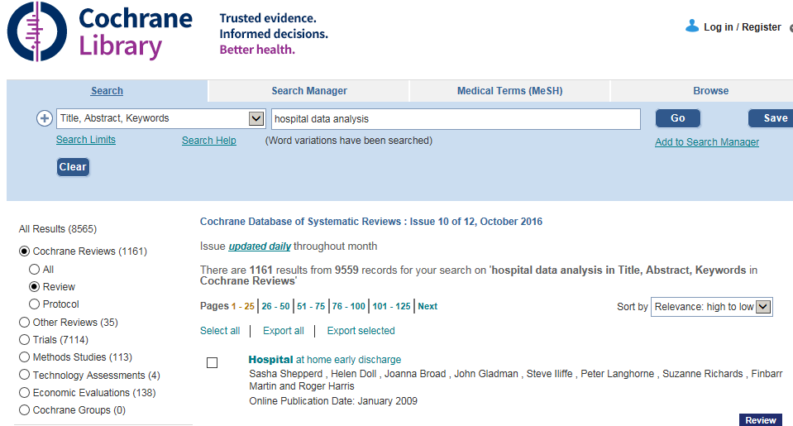

The 113 papers relevant to methods studies were analyzed to identify used statistical methods. Unique values are listed in the table below.

Accelerated failure time models
AIC statistics
Analysis of variance
Andersen-Gill -- proportional hazard model
Binary outcome
Binary outcomes the models for bivariate responses
Bootstrap resampling
Bradford constant
Chi Square test
Clustering
Complete case
Computer simulation
Concordance analysis
Confounding
Cook's distance
Correlation Intra class
Correlation Item-total
Correlation Spearman's rho non-parametric correlation coefficient
Cronbach's alpha coefficients
Factor analysis
Forest plot
frequentist approach-penalized maximum likelihood method--and Bayesian approach--Gibbs sampling method
Geometric progression
Imputation Multiple
Imputation Single
Instrumental variable analysis
Longitudinal data analysis
Matching Case control
Matching Propensity score risk adjustment
Matching propensity-based
Meta analysis
Meta analysis Prospective
Meta analysis Retrospective
Misclassification
Multivariable model risk adjustment
Multivariate analysis
Multivariate analysis using Cox models
Negative binomial
Odds ratio
Pooling
Prevalence rates
Principal components analysis
Questionnaire
Regression analysis
Regression Logistic
Regression Logistic multivariate
Regression Poisson
Relative risk
Relative risk analysis Modified
Reliability
Sensitivity
Simpson's paradox
Specificity
Standardized effect outcome
Survival analysis
Survival analysis Cox proportional hazard
Survival analysis Cox time varying coefficient model
Survival analysis Hazard based analysis
Survival analysis Landmark
Survival analysis Proportional hazards models with random effects
Time series analysis
treatment-by-centre interaction
t-test
Validity
Validity Internal
visual plot of the individual ORs against the quality score
Weighted average approach
Weighted citations ratio

Review Real world data analysis methods
On 19th August 2019, Cochrane library review was done for “Real world evidence” or “Real world data”. There were 499 trials identified. There were no time limits imposed.

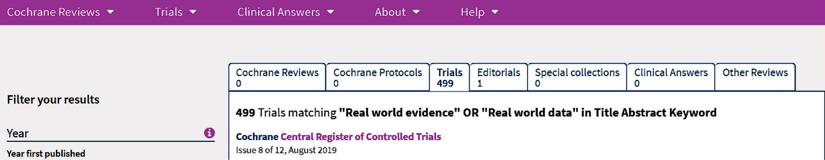

The following table provides unique methods used by researchers for RWD analysis.

Statistical methods | Type of analysis
Decision‐analytic models | Cost
Economic modelling | Cost
Incremental cost-effectiveness ratio | Cost
Per patient per month | Cost
QALY | Cost
Budget Impact Analysis | Cost
A semantic ontology linking algorithm | Graph
Decision tree | Graph
Directed acyclic graphs (DAG) to identify potential confounding and selection bias | Graph
Bayesian network meta‐analysis (NMA) | Graph
Network meta analysis | Graph
NMA polynomial models | Graph
Crude hazard ratio | Hazard ratio
Hazard ratio | Hazard ratio
Least square means | Least square
Ordinary least square | Least square
Markov model | Markov
Probabilistic Markov model | Markov
A Markov state transition cohort model was constructed | Markov
inverse probability censoring weighting to account for informative censoring | Propensity score
inverse propensity scoring | Propensity score
IPCW | Propensity score
Propensity score | Propensity score
Causal analysis | Propensity score
reweighting approach | Propensity score
Difference in proportion | Proportion
Incidence rate | Proportion
Compare EHR vs. CRF | RCT vs. RWE
Potential differences between these real world results and previously obtained phase III results will have to be discussed to assess their impact on patients | RCT vs. RWE
Real‐world data were compared with RCT data using Pearson's v2‐test | RCT vs. RWE
Cox model | Regression analysis
Cox proportional hazard model | Regression analysis
Cox proportional hazards regression | Regression analysis
Cox regression | Regression analysis
Cumulative ordered logistic and negative binomial regression | Regression analysis
Lasso regression | Regression analysis
Logistic regression | Regression analysis
Logistic regression to create Propensity score | Regression analysis
Multivariate cox regression | Regression analysis
Multivariate logistic regression | Regression analysis
Non-linear regression | Regression analysis
Proportional hazard regression | Regression analysis
Stepwise Logistic regression | Regression analysis
Markov model monte carlo simulation | Simulation
Monte carlo simulation study | Simulation
Simulations | Simulation
ANOVA | Statistical model
Bayesian hierarchical model | Statistical model
Dirichlet process mixture model | Statistical model
Exponential, Weibull, Gompertz, log‐logistic, log normal parametric survival models and a nonparametric model | Statistical model
Parametric model | Statistical model
t-test | Statistical model
Cross sectional study | Study type
Post-hoc study | Study type
Pragmatic RCT | Study type
stepped‐wedge cluster trial design | Study type
Canonical correlation analysis
Chi square test
Concordance
Female vs. male comparison
Information overlap
Log-rank test
Multivariate analysis
Non-parametric extension
Odds ratio
PaWei App platform
Predictive model
Reduce selection bias
Relative risk ratio
Survival analysis
target trial” approach (Hernan&Robins, 2016) | Study type
Transition probabilities
Weibull curve

Add explanation about QALY, cost analysis.

- Mapping European database usage: an analysis of published data types 2014
- Optimizing design, conduct and interpretation of EHR-enabled randomised clinical trials: case examples demonstrate the critical role of epidemiology and future challenges 2017

From the https://rwe-navigator.eu/homepage/about/: a lot of information is present

What is real-world evidence (RWE)?

Real-world evidence (RWE) is the evidence derived from the analysis and/or synthesis of real-world data (RWD). RWD is an overarching term for data on the effects of health interventions (such as benefits, risks or resource use) that are not collected in the context of conventional randomized controlled trials (RCTs). Instead, RWD is collected both prospectively and retrospectively from observations of routine clinical practice. It may include clinical and economic outcomes, patient-reported outcomes and health-related quality of life.

Machine learning offers opportunities to extract useful insights from “Big Data” often collected in these registries. Real‐world registries could be used by drug regulatory authorities and industry as an alternative to more costly and time‐consuming phase 4 clinical trials, potentially allowing medication costs to be based on outcomes achieved.

Clinical trial designs often fail to deliver data that jointly satisfy evolving demands of both regulatory and reimbursement authorities. Regulators typically look for a positive benefit-to-risk ratio in a relatively restricted patient population from which they will conclude whether or not a drug merits being made available to patients. Payers, by contrast, look for reassurance that what has been shown in controlled clinical trials also translates into the real world, and is, broadly speaking, good value for money. Payers may also be burdened with cost–effectiveness thresholds and budgetary constraints, restricting their ability to grant reimbursement, as stated by authors of a 2016 published paper “The mixed randomized trial: combining randomized, pragmatic and observational clinical trial designs”. The payers need comparative effectiveness data from a wider, real-world setting, where the focus is on comparing the new drug with a standard of care (SOC). Head-to-head, active comparator RCTs are not typical for marketing authorization (MA), and they are also not usually favored by sponsors. Given the level of bias and uncertainty surrounding treatment estimates obtained from non-randomized, uncontrolled trials, treatment effects generally need to be more convincing (i.e., larger) than those observed from RCTs. More convincing treatment estimates might otherwise support more successful reimbursement.

The authors propose a new trial design the mixed randomized trial (MRT) that integrates both RCT and real-world data. It would be better placed to address some of the challenges associated with analyzing comparative effectiveness data, especially if combined with prospectively defined analyses. The MRT combines aspects of the three main trial types: RCTs (usual phase III procedures), pragmatic (randomized) and observational (non-interventional arm). The relatively simple act of randomizing patients to each trial arm (RCT, PT or OT) within a multi-tiered MRT structure would ensure that baseline patient characteristics are balanced across trial arms. Moreover, it puts into place a prospectively defined framework under which randomized controlled data can be directly compared with uncontrolled, observational data.

Based on a 2017 paper “When and How Can Real World Data Analyses Substitute for Randomized Controlled Trials?” written by Franklin JM, Schneeweiss S. – Regulators consider randomized controlled trials (RCTs) as the gold standard for evaluating the safety and effectiveness of medications, but their costs, duration, and limited generalizability have caused some to look for alternatives. Real world evidence based on data collected outside of RCTs, such as registries and longitudinal healthcare databases, can sometimes substitute for RCTs, but concerns about validity have limited their impact. Greater reliance on such real world data (RWD) in regulatory decision making requires understanding why some studies fail while others succeed in producing results similar to RCTs. Key questions when considering whether RWD analyses can substitute for RCTs for regulatory decision making are WHEN one can study drug effects without randomization and HOW to implement a valid RWD analysis if one has decided to pursue that option. The WHEN is primarily driven by externalities not controlled by investigators, whereas the HOW is focused on avoiding known mistakes in RWD analyses.

To study effectiveness of the medical devices, the real world evidence approaches can be used. Real-world studies do not aim to show whether a technology works but, instead, if it can work in actual clinical practice. From a policy perspective, the message of a real-world study is different but not inferior to the message of a RCT. Policy makers should assess whether the technology is worth investing (incremental clinical value coupled with sustainability) and should, therefore, be more concerned with evidence produced in real settings rather than experimental ones, 2016 paper “What type of clinical evidence is needed to assess medical devices?” by Rosanna Tarricone, Paola Roberta Boscolo, Patrizio Armeni. The authors mention that the possible sources of real-world data (databases, surveys, patient chart reviews, pragmatic clinical trials, observational data from cohort studies, and registries prospectively collecting information and then retrospectively analysing patients' data per specific centre and given conditions) and the phases when real-world studies can support decision-making process of multiple stakeholders are different before the launch at the early development stage, when demonstrating the value, and at and after the launch to support clinical practice.

In a paper published in 2018 “The inclusion of real world evidence in clinical development planning” by Reynaldo Martina et al., the authors propose a framework for inclusion of RWE in planning of a clinical development programme. They present an approach, all evidence, from both RCTs and RWE (i.e. from studies in routine clinical practice), available at the time of designing of a new clinical trial is combined in a Bayesian network meta-analysis (NMA). The use of RWE is currently being explored as the way toward bridging the effectiveness-efficacy gap, i.e. the difference between the efficacy observed in RCTs and the more general effectiveness observed in trials conducted under general practice (real world conditions). The authors have recommended following 5 step strategy for the inclusion of RWE in the drug development process.

Step 1: Use NMA to obtain estimates of relative effectiveness, Perform NMAs sequentially in time to include each phase III trial separately in the meta-analysis of all earlier studies, and then finally include all RCTs together. Extract standard error from the NMA to use in simulation of alternative development strategies.

Step 2: Use estimates from the NMA based on the predictive distribution to simulate the effects and confidence interval of a future alternative phase III trial, Assess how many patients will be needed to execute a similar phase III trial with sufficient power (90%), whilst the probability of falsely claiming effectiveness remains low (< 5%).

Step 3: Compare the size of the original trial with the size of the simulated trial.

Step 4: Investigate whether the original trial could have been executed successfully with the alternative number of patients by analyzing the original trial with a lower number of patents, Using the (lower) number of patients obtained from the simulated trials, run clinical trial simulations assuming the treatment effects are as observed in the reported clinical trials. Assess power and false positive rate.

Step 5: Include the size and relative effect estimates of simulated trials instead of the original trial results in an NMA to investigate whether or not there is a difference in the totality of evidence of effectiveness between the original NMA and the NMA based on simulated results.

Eric Smith published a paper titled “The ACCE method: an approach for obtaining quantitative or qualitative estimates of residual confounding that includes unmeasured confounding” in 2015. He presented the phenomenon of “confounding amplification” to produce, in principle, a quantitative estimate of total residual confounding resulting from both measured and unmeasured factors. He provided a 4 step approach.

Step 1 – Create nested propensity score models and generate treatment effect estimates
Step 2 – Estimate both the proportional amplification of confounding and the quantitative change in the treatment effect estimate between Model 1 and Model 2
Step 3 – Adjust for the association between the Introduced Variable and outcome
Step 4 – Calculate the unconfounded treatment effect estimate

A paper published in 2018 “Real-world evidence research based on big data: motivation-challenges-success factors” by Benedikt E. Maissenhaelter et al. elaborate the following aspects: RCTs often underestimate (long-term) toxicity and they rarely, or with a delay, explore certain research topics such as head-to-head comparisons of novel medications or interventions. Analyses with various clinical outcomes, in particular long-term and quality of life parameters are relatively infrequently addressed. Moreover, a substantial number of RCTs focus on surrogate parameters instead of clinical parameters that are more clinically relevant. RWE studies, as described in this article, are of course not completely new but rather based on established observational study methods such as cohort studies, registry studies and population studies. These registries and types of studies provide different and crucial insights into the quality of cancer care but capture data often with a time delay and necessarily in a limited depth. RWE studies are therefore also complementary to these efforts.

Experience tells us that clinical data sets currently frequently reside in ‘silos’. The data are located in different domains because they are being captured by organizationally different clinical units, by means of different systems and are ultimately stored in different infrastructure units, resulting in often incomparable within a center and the comparability across cancer centers is thus even more challenging. This infrastructure should be built in a manner that ensures comparability of the data for the purpose of conducting research studies. Tools for data protection and pseudonymization/de-identification of patient data need to be embedded in the technical solution. The General Data Protection Regulation (GDPR) from the European Union as of May 2018 further expands the scope of data privacy and protection by including principles such as data protection and privacy by design that obligates the implementation of technical and organizational measures that secure patient data already at the design of systems. (1) Network of hospitals / clinics, (2) IT infrastructure, (3) Data quality, (4) Information governance, and (5) Operations are a key to the challenges and successes in establishing a RWE structure in addition to the Study design and study publication.

A paper published in 2018, “Real world data: an opportunity to supplement existing evidence for the use of long-established medicines in health care decision making” by Katkade et al., states the following: Many institutes have now transitioned to the Electronic Health Records. In clinical practice, data on medication use are routinely captured in different formats, including information on efficacy and tolerability in populations that extend beyond those enrolled in clinical trials. The breadth and quality of the RWD being collected are improving every day. The sources include EHRs, patient/disease registries, routinely collected administrative and insurance claims data, primary and secondary patient-level data collection (prospective and retrospective), and population health surveys, as well as emerging sources, such as social media and data collected via mobile devices and apps. The increasing volume of RWD needs to be balanced against data integrity and usability.

Claims data provide “snapshot” view, EHR data can be more complex and provide an assessment of cause and effect through longitudinal assessment of patient care. One area where RWE may be particularly useful is for medications that have shown beneficial effects in indications for which they are not approved, providing “off-label” efficacy evidence.

The distinction between RWD and RWE, efficacy and effectiveness, and the strengths and weaknesses of each data source should be clearly defined and understood. Concerns surrounding informed consent privacy and data integration also need to be addressed, and protocols developed to maintain data integrity. Methodical challenges will need to be worked out to understand what RWD can and, importantly, cannot provide. RWE has the potential to support, improve, and potentially accelerate the delivery of safe and cost-effective therapeutic interventions, or to support the expansion of approved therapeutics into a new indication.

Nicolucci A in a 2017 paper “Randomized controlled trials vs. observational studies”: Randomized controlled trials (RCTs) are the uncontested “gold standard” for establishing causation between a therapy and its outcomes, since they can guarantee that control and intervention subjects are similar in all the known and unknown attributes that might influence outcomes. RCTs use a rigorous experimental design with the primary goal of understanding the “average” overall benefit and risk of a standardized therapy in a selected group of patients. Yet even when an RCT demonstrates substantial net benefit for a specific therapy, its optimal role in routine clinical practice can remain unclear. Concerns frequently relate to how well the therapy might perform in different clinical settings and in broader patient populations than those studied in traditional RCTs. Observational studies can serve as a useful complement to RCTs, giving a deeper understanding of the long‐ term benefits and harms of a treatment in routine clinical practice, when administered to unselected populations. Real‐world data also help identify the subgroups of patients most likely to benefit from a treatment, or to suffer side effects. However, observational studies are often limited in their ability to account for confounding and bias due to patient selection. A rigorous methodological approach and the use of advanced statistical techniques can help reduce the risk of selection bias. When carefully applied, observational studies remain a reliable, often invaluable source for informing routine clinical practice. Whilst there are some differing opinions around the use of RWE for regulatory purposes, most respondents see it as a complement to RCT, rather than a replacement. The general opinion is that RWE will become more valuable over time if data quality and availability can be improved.

A paper titled “Practical issues of using real-world data in effectiveness research” in year 2018 by Amr Makday et al., covers the following content: Surrogate end points measured in RCTs, such as progression-free survival in oncology patients may also be less relevant to decision-making than overall survival. Furthermore, clinical practice may vary on a regional or national level. These differences can lead to a discrepancy between the observed efficacy of interventions in RCTs and their effectiveness in clinical practice, a phenomenon often referred to as the efficacy–effectiveness gap.

RWE may also provide information on parameters not examined in clinical trials, such as adherence to treatment, rare adverse events and resource use in clinical settings. The insights provided from RWE may have significant implications for drug developers, regulators and particularly, Health Technology Assessment (HTA) agencies and payers whose decisions rely on evidence of comparative effectiveness.

Bearing in mind that Comparative Effectiveness Research (CER) aims to shed light on the ideal implementation of healthcare interventions to achieve maximum societal benefits, inaccessibility to Individual Participant Data (IPD) from RWE repositories adversely affects society as a whole. Moreover, as RWE is generated by patients within routine healthcare, it is essential that patients benefit from the use of this data; increased accessibility to IPD RWE to improve CER and decision-making should benefit all patients, not just those who control access to such data. Consequently, the dynamic, multi stakeholder nature of the healthcare sector warrants a collaborative approach to solving issues pertaining to governance of RWE repositories, including accessibility to IPD.

RWD can provide useful outcomes information across multiple relevant regimens, which can be compared with data from single-arm trials or complement the findings of head-to-head trials that were originally designed with only one comparator in mind, while other comparators may be relevant, especially based on the different clinical practices in respective countries. RWD, therefore, offers the advantages of demonstrating comparative treatment effectiveness in the clinical practice setting and confirming RCT results in real-life patient populations.

“Obtaining real-world evidence: the Salford Lung Study“, a 2014 paper published by John New et al. comment: A standard RCT aims to establish efficacy—an unequivocal cause-and-effect relationship for a very limited number of predefined outcomes. The interventions are double blind, often with double dummy to maintain blinding, in an idealized setting. Well-defined and compliant patients with minimal co-morbidities are closely supervised for >90% adherence and to minimize confounding factors that could compromise the primary outcome, on which a regulatory approval may critically depend. It is extremely difficult to extrapolate data from an RCT into real life for a number of reasons, including patient preference, lower adherence and co-morbidities.

In contrast, ‘real-world’ studies assess effectiveness in large unselected populations, which include patients with co-morbidities. Patients are under routine care, taking open-label treatment over a prolonged period, with no additional visits and no attempt to change adherence. Data are usually obtained using electronic health records, which provide long-term outcomes, including health economics, free from interviewer or recall bias.

The International Society for Pharmacoeconomics and Outcomes Research has made recommendations on prospective observational studies for clinical effectiveness research. Its report defines different types of clinical effectiveness research studies, including retrospective and prospective observational studies, and pRCTs.

pRCTs are large prospective clinical studies in which patients are randomized to two or more interventions, and then followed up according to the investigating physicians’ usual practice. pRCTs bridge the gap between RCTs and non-randomized observational studies, allowing a good approximation of real-world practice. An electronic health record can be used to identify patients and assess outcomes, and provide safety surveillance. However, pRCTs require enrolment of a broad population to maximize external validity and can be expensive and difficult to implement. One important limitation is the likelihood of treatment switching during the trial, which can reduce the value of randomization.

Coleman et al. 2017 paper, “Importance of balancing follow-up time and impact of oral-anticoagulant users' selection when evaluating medication adherence in atrial fibrillation patients treated with rivaroxaban and apixaban”, used rivaroxaban and apixaban medicines as examples to compare medical adherence. Study of medications adherence have become common yet they often do not account for differences in relative follow-up. Patient selection criteria may impact validity and comparability of these studies as well. Adherence was evaluated using proportion of days covered (PDC) >=0.8 for cohorts with (1) unbalanced follow‐up (2) balanced follow‐up (by matching on month and year of followup since fill‐date) (3) >=2 rivaroxaban or apixaban dispensing and a balanced follow‐up, and using (4) the PQA adherence measure.

They conclude: Medication adherence comparisons need to account for differences in follow-up. Selection of chronic medication users may impact comparative adherence advantage between medications.

As per the paper “How RWE Is Becoming the Real Deal” published in 2017 by Thomas Reinke: The US National Academy of Medicine brought together providers, payers, and pharmaceutical executives to discuss ways to lift the barriers to collecting data and producing quality RWE studies. Currently there is very little incentive—especially for providers—to contribute the most accurate data to RWE efforts. The white paper by Margolis Center says four factors will shape the role of RWE: the regulatory context, the clinical context, the data context, and methodology.

The regulatory context concerns the kind of regulatory decision that needs to be made; for example, using RWE in approvals for new indications. How RWE fits into a clinical context hinges on whether it provides some insight into a clinical issue and perhaps would influence a diagnosis or treatment choice. The data context includes the extent to which RWE provides reliable data, and the methodology element relates to the strength of the RWE study design.

The use of RWE will definitely continue to grow both inside and outside of the FDA scope of activities. For the foreseeable future, though, RWE will continue to play second fiddle to randomized clinical trials. But second fiddle is better than not playing at all.

“How insurance claim data can help in health outcomes research: an Indian perspective” 2015 by A Sawant et al.: The major advantages of claims data over RCT data include: (a) health outcomes can be evaluated in real‐world settings; (b) analysis results can be generalized to a broader population; (c) relatively inexpensive than RCTs; (d) provide wide range of information about various conditions and procedures from a large number of patients, belonging to varied demographics; (e) data availability over extended periods of time allow retrospective cohort studies; (f) unaffected by recall bias; (g) large sample size will make the statistical methods more consistent. However, there are some limitations as well, such as incomplete diagnostic and provider identification data, and the fact that the population characteristics are largely influenced by the insurance plan, plan benefit design, and the variables of the database.

In a 2018 paper titled “An algorithmic approach to optimal study design for outcomes research”, D. Thompson discusses: An expanding array of healthcare decision makers—including payers, providers, patient advocacy groups, clinical guideline developers, and regulators—now require, beyond traditional safety and efficacy measures, outcomes data based on RWE. Undertaking real-world research without due diligence on stakeholder needs is a game of hit and miss—with misses having dramatic consequences for commercial success. It is therefore essential to engage with stakeholders during the design phase so as to ensure that once executed the study findings will resonate with decision-makers.
(1) Is the study focused on an intervention? (2) If so, is the intervention on the market?
(3) Is the study intended to be comparative? (4) If so, is treatment assigned by study protocol?
(5) Are data needed for the study available from existing sources?
(6) If so, are those existing sources accessible in computerized form (i.e., in administrative claims or electronic medical records)? And (7) is the study setting real world?
As research designs vary dramatically in terms of time and cost requirements, the algorithm steers the researcher to the most cost‐effective option first in those instances in which multiple approaches are viable.
One of six different research designs:
(1) retrospective database analysis; (2) manual chart review; (3) prospective non‐interventional study/registry; (4) traditional randomized controlled trial; (5) pragmatic clinical trial; or (6) economic modeling.
A European regulatory perspective laid out by a few authors in 2018: Adaptive Licensing (AL) is an ambitious and evolving new initiative which incorporates Real World Evidence (RWE): clinical data collected outside of a conventional randomized controlled trial. In 2014 EMA launched a pilot project to explore the adaptive pathways approach, a scientific concept of medicines development and data generation intended for medicines that address patients' unmet medical needs. AL is not a new route of approval for medicines. It makes use of existing approval tools, in particular conditional marketing authorization, which has been in operation in the EU since 2006. The adaptive pathways concept is not meant to be applicable to all medicines, but only to medicines that are likely to offer help for a patient population with an unmet medical need, and where the criteria for adaptive pathways apply. RWE refers to the planned and systematic recollection of the data generated outside the clinical studies. Adaptive approaches link decision making to an evolving evidence base, parts of which are frequently seen as being derived from analyses of observational data gathered from sources such as electronic medical records, registries or administrative databases. RWE data collection within AL has the potential to improve our understanding of disease processes, and epidemiological factors, which will in turn allow RCTs to become more efficient. Additionally, for many subpopulations, the life span approach to licensing and coverage and learning from real world experience as advocated by adaptive pathways will become the only viable access route to new treatments in future. Regulators have just begun to explicitly address and communicate “uncertainty” in their templates for benefit‐risk assessment. A growing number of regulators and payer (or HTA) organizations involve patients in their decision making processes. This can be considered as a pertinent analogy for the history of bringing new drugs to market.
Another step wise approach proposed in 2019, by Nicolle M. Gatto, et. Al coined as Structured Pre-approval and Post-approval Comparative study design framework to generate valid and transparent real‐world Evidence (SPACE): as a process for identifying design elements and minimal criteria for feasibility and validity concerns, and for documenting decisions.
Key components of the randomized controlled trial needed to maximize validity, and pragmatic choices are considered when required. A causal diagram is used to justify the variables identified for confounding control, and key decisions, assumptions, and evidence are captured in a structured way.
In this way, SPACE may improve dialogue and build trust among healthcare providers, patients, regulators, and researchers.
Step 1: Articulate research question and design elements
Step 2: Draw causal diagram: Specify causal relationships and supporting evidence among treatment, outcome(s), and other variables to identify variables that must be controlled
Step 3: Specify requirements to validly capture design elements
Step 4: Answer questions in flow chart
Revisit Steps 1–4 as needed: The steps are inherently iterative
Analysis on Psoriasis patients published in 2018 y Yiu ZZN, et. al: suggest that the difference between the baseline characteristics of a real‐world and a trial psoriasis population leads to the underestimation of the true real‐world incidence of SAEs, but not effectiveness, in psoriasis clinical trials. Real‐world data are therefore needed to understand the true safety of biologic therapies in psoriasis.
Hernan and Robins outline an approach “target trial” in their 2016 paper titled “Using Big Data to Emulate a Target Trial When a Randomized Trial Is Not Available”. Researchers resort to observational analyses of existing data because the randomized trial that would answer our causal question—the target trial—is not feasible, ethical, and timely. One can often fruitfully regard causal inference from big data as an attempt to emulate a target trial. If the emulation is successful, the analysis of the observational data yields the same effect estimates (except for random variability) as the target trial would have yielded had the latter been conducted.

A large database is used to emulate a target trial. As the data were not collected for research purposes, data codes may be inconsistent or ambiguous. Hence, researchers unfamiliar with the data must both consult with knowledgeable data users and conduct data validation studies. Note that the eligibility criteria cannot include restrictions based on post baseline events (e.g., “include only individuals who ever used therapy during the follow-up”), which may introduce bias in the analysis of both randomized trials and observational data and which cannot applied at the time of randomization in a true randomized trial.

Suppose we want to emulate a randomized trial in which individuals will be followed via their contacts with the health care system – only include patients who are actively engaged during the follow-up period. A common strategy to emulate this criterion is to restrict the analysis to individuals who have been in regular contact with the health care system before baseline (e.g., those who attended regular check-ups or filled any prescriptions within the 2 previous years) in the hope that they will remain in contact thereafter. Those without any follow-up data should be considered as lost to follow-up or “censored”.

The target trial emulated using observational data will typically be a pragmatic trial. A placebo-controlled trial with tight monitoring and enforcement of adherence to the study protocol cannot be emulated. We can only emulate target trials without blind assignment, which is the standard design of pragmatic trials, because individuals in the data set and their health care workers are usually aware of the treatments that participants receive. This is not necessarily a limitation if the goal is comparing the effects of realistic treatment strategies in individuals who are aware of their care. The adjustment for baseline confounders may be performed via matching (perhaps on the propensity score), stratification or regression, standardization or inverse probability weighting, g-estimation, or doubly robust methods.

If the observational database does not contain sufficient information on baseline confounders or if we fail to identify them, successful emulation of the target trial’s random assignment is not possible. Incompatible or surprising effect estimates suggest that at least 1 of the 2 emulations failed to ensure a fair comparison. A second approach is to consider outcome controls for which no causal effect is expected. Other approaches to better unmeasured confounding rely on extracting information from sources previously considered impractical for large-scale research.

To estimate the intention-to-treat effect in an actual randomized trial, we would conduct an intention-to-treat analysis to compare the outcomes of the groups assigned to each treatment strategy. An intention-to-treat analysis, however, is rarely possible in observational analyses of existing data.

To estimate the per-protocol effect in both true randomized trials and emulated trials like ours, adjustment for baseline and post-baseline confounding is necessary when the treatment strategies under study are sustained over time. Because post-baseline prognostic factors associated with subsequent adherence to the strategies may be affected by prior adherence, Robins's g-methods are generally required, even in the absence of unmeasured confounding and model misspecification.

Successful emulation of a target trial requires a proper definition of time zero of follow-up in the observational data, also referred to as baseline. With observational data, the best way to emulate time zero of the target trial is to define time zero to be the time when an eligible individual initiates a treatment strategy. In emulating a target trial that includes grace periods using observational data, we must allow for an analogous grace period measured from time zero. The use of a target trial with a grace period not only ensures that the strategies remain realistic but also increases the number of people in the observational database whose data can be used to emulate the target trial.

The target trial approach is consistent with a formal counterfactual theory of causality yet avoids the theory’s often unfamiliar mathematical notation and concepts. Further, the approach provides an organizing principle for causal inference methods that implicitly rely on counterfactual reasoning (e.g., new-users design, negative outcome controls), establishes a link between methods for the analysis and the reporting of observational studies and randomized trials, naturally leads to analytic approaches that prevent apparent paradoxes and common biases, facilitates a systematic methodologic evaluation of observational studies and the transportability of their estimates, and may help explain between-studies differences as different observational analyses may be emulating different target trials.

The specification of the protocol of the target trial will typically be an iterative process during which we will learn which particular target trials may be reasonably supported by the observational data. Of all those possible target trials, we will choose the one that is closest to the ideal trial that we would have liked to conduct to answer our question. We will then be able to outline a protocol, present a flow chart, summarize how the observational data set is used to emulate the target trial, and explain how the target trial differs from the ideal trial.

Additional details https://www.hsph.harvard.edu/miguel-hernan/causal-inference-book/

Temple university website “https://guides.temple.edu/c.php?g=78618&p=4156609” as accessed on 7th Sept 2019 provides information related to NMA: Network meta-analysis compares multiple interventions simultaneously by analyzing studies making different comparisons in the same analysis.
Network meta-analyses are best designed for:
- Conditions with multiple interventions
- Many combinations of direct or indirect interactions
- To answer more relevant clinical questions
- To make treatment estimates for an entire treatment network instead of scanning each individual pair-wise comparison
- To give the “full picture” to clinicians
- Gain precision by considering all available evidence, not just (A vs. B comparisons)
- Potential to more explicitly “rank” treatments using summary outputs

Limitations of a Network Meta-Analysis:
- Requires specialist statistical expertise and software
- Assumes that all interventions included in the “network” are equally applicable to all populations and contexts of the studies included
- May introduce study selection bias
- Ease of software may lead researchers to undertake this type of review even though it may not be the most appropriate study design for their research question
- Complex methodological approaches
- Still an evolving method

Joseph C. Cappelleri, presented a short tutorial on NMA in Feb 2016, Wasington DC, USA. New drugs are often compared with placebo or standard care, but not against each other, in trials aimed to contribute toward obtaining approval for drug licensing. Commercial incentive to compare the new treatment with an active control may be wanting. Commercial incentives to compare a new treatment with an active control may be lacking. Additional constraints are due to small sample sizes and short durations of follow-up. Available treatments tend to increase over a period of time. Clinicians, patients, and health-policy makers often need to decide which treatment is “best” based on all relevant evidence. Unfortunately, robustly designed RCTs that simultaneously compare all interventions of interest are almost never available. This is where NMA comes into play.

Network meta-analysis is an extension of standard pair-wise meta-analysis by including multiple pair-wise comparisons across a range of interventions. It addresses the comparative effectiveness of multiple treatment alternatives. There are 2 types of NMA:
- Indirect comparison – when only two (or one pair of) treatments are being compared indirectly
- Mixed treatment comparisons – a generalization of indirect comparisons with more than two (or multiple pairs of) treatments being compared indirectly, at least one pair of treatments is compared both directly and indirectly

He speaks about 3 important concepts:
- Homogeneity occurs when the true treatment effects in a direct comparison of two treatments across studies are the same. Heterogeneity, the opposite of homogeneity, is the extent to which the true treatment effect varies. It is caused by variation in (un)measured effect modifiers of the relative treatment effect.
- Transitivity (similarity) requires that the distribution of patient and study characteristics that are modifiers of treatment effect be sufficiently similar in different sets of randomized controlled studies that go into an indirect comparison. In addition to clinical similarity, methodological similarity (e.g., quality, definition of outcomes) is required for valid estimates. If there is imbalance in the distribution of effect modifiers (treatment-by-covariate interactions) between trials, then estimates become biased.
- Consistency defined as an agreement between Direct and Indirect Evidence for a Given Pair of Treatments.

The author concludes:
- Randomization holds within trials and not across trials in a (network) meta analysis
- Homogeneity, transitivity, and consistency need to be examined
- It all relates to the distribution of patient and study characteristics (including bias) that affect the treatment effects: effect modifiers
- Variation in effect modifiers between studies within direct comparisons: heterogeneity
- Variation in effect modifiers between different direct comparisons: inconsistency
  - Imbalance in effect modifiers between comparisons: transitivity violations
  - This will show as in inconsistency in the data and hence results
- The assumption of consistency allows precision to be gained by combining direct and indirect evidence

Chapter 5: Hospital data descriptive analysis

5Background
Steps followed to get the data from the INSTA database:
- Login onto the INSTA website
- Go to the Patient Search tab
- Identify unique patients
- Use the unique URL for each patient MRNO and MR_NO to get the source data for each patient
- Achieve #4 by creating a VBA macro
  - Access the source code for each patient
  - Filter the source code and get the displayURL parameter from the Java code
  - This parameter contains links to all the data for individual patients
  - Save TXT files for each patient
- Create a R program to read all the TXT files
  - Process this data to get the patient number, visit combination
  - Create a 1-1 match for Patient + Visit + visit date + unique number of visit to hospital
  - This creates 4.25 lakh URLs for almost 50,000 patients in August 2017
- Data coming from URLs, there are 20 different types of programs proving information
 | Name of the program |  | Number of URLs
1 | /vitalForm/genericVitalForm.do?method | generateReport&visited | 72026
2 | /pages/GenericDocuments/GenericDocumentsPrint.do?_method | print&forcePdf | 7238
3 | /emr/print.do?method | printConsultation&consultation_id | 117066
4 | /emr/print.do?method | printTriageSummary&consultation_id | 19753
5 | /dischargesummary/dischargesummaryPrint.do?_method | print&patient_id | 6428
6 | /Service/ServicesConductionPrint.do?_method | print&prescription_id | 165746
7 | /pages/DiagnosticModule/DiagReportPrint.do?_method | printReport&reported | 29170
8 | /progress/PatientProgress.do?_method | getPrint&mr_no | 2623
9 | /wardactivities/DoctorOrderPrint.do?_method | print&patientId | 2434
10 | /wardactivities/VisitSummaryRecord.do?_method | generateReport&patient_id | 2607
11 | /IntakeOutput/genericIntakeOutputForm.do?method | generateReport&visited | 135
12 | /dietary/DietaryMasterPrint.do?method | printPrescription&patient_id | 7
13 | /Service/ServiceReportsPrint.do?_method | print&forcePdf | 4
14 | /Radiology/TestDocumentsPrint.do?_method | print&doc_id | 84
15 | /Dietary/DietaryGenericDocumentsPrint.do?_method | print&doc_id | 1
16 | /MLCDocuments/MLCDocumentPrint.do?_method | print&doc_id | 2
17 | /wardactivities/DoctorsNotes.do?_method | generateReport&patient_id | 82
18 | /InitialAssessment/InitialAssessmentPrint.do?_method | printInitialAssessment&consultation_id | 2
19 | Discharge | NA | 1
20 | /GenericForms/GenericFormPrintAction.do?_method | print&printerId | 1

- The cells marked in yellow in the table above represent the pdf files not downloaded from the INSTA database.
  - Vital form data is available in a CSV file download
  - Lab data is available in a CSV file download
- Use CURL command in Cygwin to extract the individual PDF files. This function works when a user is logged into INSTA system E.g.
curl 'https://182.71.223.195/instahms/Service/ServicesConductionPrint.do?_method=print&prescription_id=175665&printerId=2&doc_id=175665' -H 'Accept-Encoding: gzip, deflate, br' -H 'Accept-Language: en-US,en;q=0.8' -H 'Upgrade-Insecure-Requests: 1' -H 'User-Agent: Mozilla/5.0 (Windows NT 6.3; Win64; x64) AppleWebKit/537.36 (KHTML, like Gecko) Chrome/60.0.3112.90 Safari/537.36' -H 'Accept: text/html,application/xhtml+xml,application/xml;q=0.9,image/webp,image/apng,*/*;q=0.8' -H 'Referer: https://182.71.223.195/instahms/loginForm.do' -H 'Cookie: JSESSIONID=D2D79C9FEC4DC1AB75706C93C80AE523; user_schema@/instahms=iaim; firstMenuIndex=0; lastUser=VmluYXltYWhhamFu' -H 'Connection: keep-alive' -H 'Cache-Control: max-age=0' --compressed –insecure >FILENAME.pdf
- Some of the filenames have “?” at the end of the file, so use DOS command to change the filename
  - i.e. remove “?”At the end of the filename, this is done by using “rename” command as follows: rename *.pdf? *.pdf.
  - The ? at the end of the files make these files unavailable for additional text processing
- Use pdftotext command in Cygwin to convert the PDF files into txt files.
  - Options used pdftotext –layout –nopgbrk provides the same data in text format and
  - It reduces the file size significantly, e.g. 600 KB pdf files becomes 10 KB file,100 KB pdf file becomes 2-3 KB file.
  - The following programming statements created TXT files for each patient in pat_txts folder
vinay@viany /cygdrive/c/Users/Lucky/Documents/Hospital_data/04_2017_DOWNLOAD/pat_pdfs
$ find . -name "*pdf"|sed 's/.pdf//g'|head -n 10|awk '{print "pdftotext -layout -nopgbrk", $1 ".pdf", "../pat_txts/" $1 ".txt"}'|sh

- Use these text files as input to various R programs and create source data.
  - Various data tables to be created
- SQLite freeware database will be used to store the data.

5.1 Hospital database INSTA

5.2 Data collection methods

5.3 Analysis plan

5.4 Description of data

Based on the Vitals sign, Lab results and diagnosis report data dated 31st July 2016, the following numbers are derived:

All patients present in the database | 41,094
Only In-patients | 4,016
Only out-patients | 33,709
Common patients with in-patient and out-patient | 3,368

Summary statistics of the patient’s age (years) in 3 types of patient categories:
Age (years) | Only in-patient | Only out-patients | Common
n | 4017 | 37077 | 3368
Mean | 51.98 | 44.88 | 51.09
SD | 17.89 | 18.48 | 17.99
Median | 53 | 45 | 52
Minimum | 2 | 1 | 2
Maximum | 103 | 108 | 98
The median age for in-patient (53 years) is greater by 8 years than that for the out-patient group (45 years).

Summary statistics of age by gender and type of patient:
Age  (years) | Only  in-patient  (Male) | Only  in-patient  (Female) | Only  out-patient  (Male) | Only  out-patient  (Female) | Common  (Male) | Common  (Female)
n | 1959 | 2058 | 19021 | 18057 | 1652 | 1716
Mean | 51.85 | 52.10 | 45.08 | 44.68 | 50.77 | 51.40
SD | 17.76 | 17.01 | 18.93 | 17.98 | 18.79 | 17.18
Median | 53 | 54 | 45 | 45 | 51 | 53
Minimum | 2 | 3 | 2 | 1 | 2 | 3
Maximum | 103 | 94 | 108 | 101 | 98 | 90
The age for males and females did not differ a lot in each of the 3 categories. The ratio of male to female patients is approximately 50% across each of the 3 categories.

Age group frequency by 10 year age categorization:

Only in-patients:

Only out-patients:

Common patients:

There is 1 patient above 100 years in Only IP group and 3 patients above 100 years in Only OP group, not displayed on the histograms.
All 3 categories on the same graph:

Boxplot representation of the age summary statistics and the individual age values overlayed is displayed below. Age categories are statistically significantly different in 3 groups. The number of patients in “Only IP” category under age of 20 is less than for the other 2 categories.
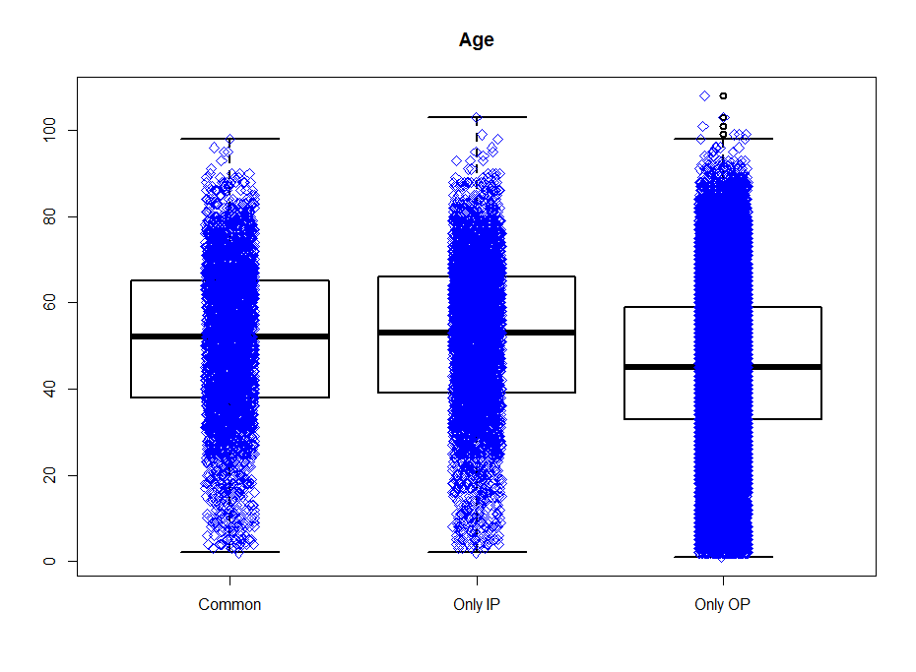
Patients’ residential status: Majority of patients were from Bengaluru city (~ 75% of overall patients).
Patients’ blood group: For 19,500 (47.45%) out of 41,094 patients the blood grouphas been captured. These numbers are quite consistent with the proportions reported for India. The cells in yellow should be checked.

A- | 258 | 1%
A+ | 3708 | 19%
A1 -ve | 2 | 0%
A1 +ve | 25 | 0%
A1B +ve | 6 | 0%
A2 +ve | 1 | 0%
A2B +ve | 1 | 0%
AB- | 94 | 0%
AB+ | 1152 | 6%
B- | 326 | 2%
B+ | 5730 | 29%
O- | 518 | 3%
O+ | 7679 | 39%

Analysis on the diseases experienced by patients in 3 groups by age categories is done as follows. The patients are categorized into 3 age group categories: Age <= 18 years, age in between 18 and 65 years and age >= 65 years. The following tables display cross tabulation of ACD code and 3 groups (Only IP, Only OP and Common) for different age categories.

Expectation: The diseases requiring hospitalization should be different from the diseases not requiring hospitalization. The most frequently occurring diseases should be different across age groups.

Check the 2 csv files created with the frequency counts and distinct patients having the disease at least once.

Total number of patients in Outpatient section
Total number of patients in Inpatient section
Total number of patients only in Outpatient section
Total number of patients only in Inpatient section
Total number of patients present in both Outpatient and Inpatient sections
Demographics of patients
Number of patients checked by different departments

Analysis description and details:

Understanding the hospital database
The hospital database has been created to capture patient level information as well as operational information. The data is collected in various Case Report forms and in various columns called as “variables”. Each Case Report form is systematically stored in a logical table. These tables and variables are named appropriately so that the end user will be able to utilize the data for further analysis. Please find the list of tables and names of the tables where the source data is captured and stored.

CRF number  (section_id) | CRF page name  (section_title) | Classification
1 | History of Present Illness | Ayurvedic data
2 | Review Of Systems
3 | Physical Examination
4 | Past / Family / Personal History/History of trauma/ injury | Ayurvedic data
5 | Nurse Assessment
6 | Gyn History
7 | OBG History
8 | Samprapti Ghatakas | Ayurvedic data
9 | Rogi Pareeksha | Ayurvedic data
10 | Session
11 | Roga Vinischaya
12 | Systemic Examination
13 | Investigations
14 | Complaint
15 | IP Case Proforma
16 | General Examination1
17 | Local Examination
18 | Nidana
19 | Dashavidha Pareeksha | Ayurvedic data
20 | Nutitional Assessment
21 | General Examination
22 | Breathing Practices
23 | Loosening Practices
24 | Postures | Ayurvedic data
25 | Kriyas
26 | Pranayamas | Ayurvedic data
27 | Mudras | Ayurvedic data
28 | Bandhas
29 | Relaxation Techniques
30 | Meditation Techniques | Ayurvedic data
31 | Netra Case Sheet
32 | Vitals
33 | Visual Acuity Test
34 | Glass Power Prescription
35 | Other Findings
36 | Nephrology Case sheet
37 | Personal History
38 | Vihara
39 | Wellness assesment of child
40 | GROWTH & DEVELOPMENT ASSESSMENT
41 | Dosha Assessment Questionnaire
42 | Diet Recommendations
43 | Operation Notes
44 | Conduction Notes
77 | IP - History of Present Illness | Ayurvedic data
78 | IP - Gyn History
79 | IP - Samprapti Ghatakas | Ayurvedic data
80 | IP - Nidan Panchak | Ayurvedic data
81 | IP – Session
82 | IP - Roga Vinischaya
83 | IP - Systemic Examination
84 | IP – Investigations
85 | IP – Complaint
86 | IP - Local Examination
87 | IP - Dashavidha Pareeksha
88 | IP - Nutitional Assessment
89 | IP - General Examination
90 | Visit Breathing Practices
91 | Visit Loosening Practices
92 | Visit Postures
93 | Visit Kriyas
94 | Visit Pranayamas
95 | Visit Mudras
96 | Visit Bandhas
97 | Visit Relaxation Techniques
98 | Visit Meditation Techniques
99 | Doctor Advice
100 | Oral Cavity | Ayurvedic data
101 | Ear
102 | Nose
103 | Complaints And Associated Complaints
104 | History of Previous Illness
105 | Medical History
106 | Investigation.
107 | Obstetrical History
108 | Food Habit
109 | Activity(Vihara)
110 | Physical.Examination.
111 | ASTA STHANA PARIKSHA | Ayurvedic data
112 | DASHA VIDHA PARIKSHA | Ayurvedic data
113 | Date
114 | Treatment Plan
115 | Final Diagnosis
116 | Physiotherapy Treatment Plan
117 | Physiotherapy Short term Goal
118 | Physiotherapy Long Term Goal
119 | Yoga Treatment Plan
120 | Physiotherapy Assessment
121 | Physiotherapy Outcome
122 | ROGA VINISCHAYA
123 | ROGA VINISCHAYA – IP
124 | CCHPI
125 | Health History: Do you have Or have you ever had any of the following?
126 | CLINICAL EXAMINATION

The rows in the table above marked in yellow color contain very little data (33 tables out of 66), so are not utilized for the analysis purpose. The tables and variables are classified into following sections to get an idea about what kind of data is collected:
- Ayurvedic data
- Background
- Disease
- Doctor's Notes
- Food / Exercise
- Hospital Visit
- Lab report
- Measurement
- Treatment / Procedure

This data was analyzed to understand data collection pattern for patients. If there is any non-missing data present in a particular variable or a column then a pseudo value “Yes” is assigned, if the data is missing then a pseudo “Blank or No” value is assigned for the purpose of analysis. Tableau display is presented below as an illustration.

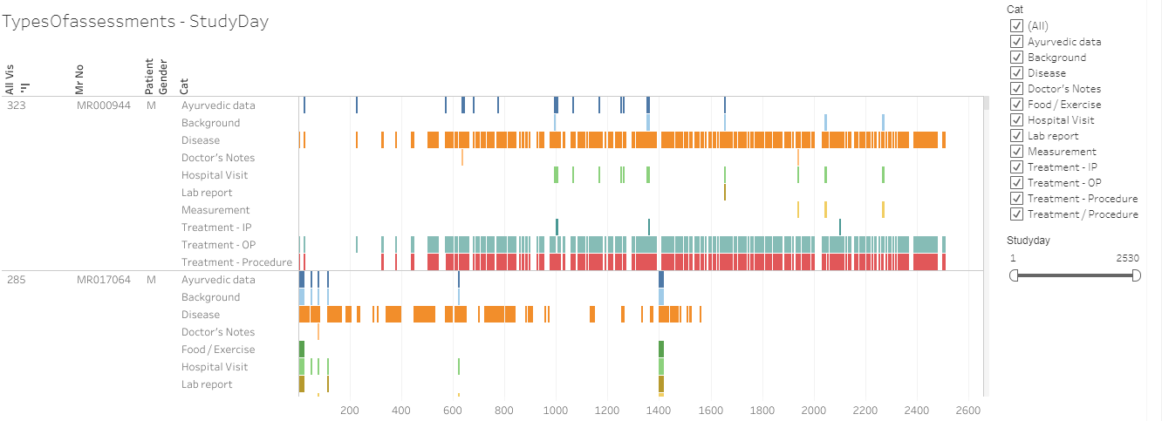

The analysis carried out shows that for majority of the patient and for majority of the visits, the disease data and medication (Treatment /Procedure) are entered and is not missing. Most of the other categories are not entered as consistently as they should have been. This lack of information should be addressed.*

References to the analysis files:
R program | 03_typesOfassessment.R
Datafile | 03_typesOfassessent.csv
Tableau vizname | 03_typesOfassessment
Tableau sheetname | TypesOfassessments – StudyDay

Understanding variables from various CRF pages
The following analysis provides information about distinct number of patients present in individual table as well as unique values present for various variables.
- As explained above, there are many CRF pages with very little number of patients.
- There are many variables where captured data is in a “free text” format. These provide the doctors flexibility during data entry and the complete information gets captured.
- This creates challenges in analysis. Same data value could be represented in different cases, minor spelling mistakes, human errors in data handling, etc. This causes lower data accuracy

E.g. Let us take a look at the following row in the table below:
sec001_var008_Diabetes | 1064 | 4124 |  |  | Background

- sec001_var008_Diabetes: presents CRF page 1 “History of Present Illness” and variable number 8 “Diabetes”.
- This variable has 1064 unique values entered by different doctors for different patients.
- There is some entered data for 4124 distinct patients and
- This variable is categorized as variable capturing data for category “Background”.

Another example:
sec001_var018_Associated Complaint with Onset & Duration | 5102 | 4549 |  |  | Disease

- sec001_var018_Associated Complaint with Onset & Duration: presents CRF page 1 “History of Present Illness” and variable number 8 “Associated Complaint with Onset & Duration”.
- This variable has 5102 different values entered by different doctors for different patients.
- There is some entered data for 4549 distinct patients and
- This variable is categorized as variable capturing data for category “Disease”.

This data provides the following areas of improvements:
- Standardization of CRF pages for better data capture – there are some standards already available in healthcare industry, they could be implemented at the hospital.
  - CDISC standards
  - ISO standards
- Implementation of the standard dictionaries to capture data uniformly and make analysis ready, some of these could be directly implemented; some could be modified for our requirements.
  - LOINC standards
  - NCI USA Code lists
  - MedDRA dictionary
  - ICD Codes
- There are some variables present in more than 1 CRF page, this duplication should be removed.
- After consulting experts in specific fields make some variables mandatory with appropriate values, pre-defined drop down lists.
- Data quality as well as amount of data for Ayurvedic parameters should be improved to recreate patient information.
These steps should help in improving the data quality and data consistency.

The CRF page + Variable name | Distinct values of the variable | Distinct number of patients | Data | Status | Data category
sec001_var001_Location | 7 | 6 |  |  | Measurement
sec001_var002_Quality | 2 | 1 |  |  | Measurement
sec001_var003_Duration | 3 | 2 |  |  | Measurement
sec001_var004_Context | 4 | 3 |  |  | Measurement
sec001_var005_Modifying Factors | 2 | 1 |  |  | Measurement
sec001_var006_Associated Signs & Symptoms | 3 | 2 |  |  | Disease
sec001_var007_Additional Complaint | 9 | 8 |  |  | Disease
sec001_var008_Diabetes | 1064 | 4124 |  |  | Background
sec001_var009_Hypertension | 967 | 3895 |  |  | Background
sec001_var010_Allergy | 189 | 587 |  |  | Background
sec001_var011_Renal Diseases | 39 | 79 |  |  | Background
sec001_var012_Liver Diseases | 13 | 53 |  |  | Background
sec001_var013_Food Allergy | 52 | 102 |  |  | Food / Exercise
sec001_var014_Food Intolerance | 13 | 45 |  |  | Food / Exercise
sec001_var015_Chief Complaint with Onset & Duration | 16488 | 11536 |  |  | Disease
sec001_var016_Upashaya | 250 | 585 |  |  | Ayurvedic data
sec001_var017_Anupashaya | 369 | 588 |  |  | Ayurvedic data
sec001_var018_Associated Complaint with Onset & Duration | 5102 | 4549 |  |  | Disease
sec002_var001_ENT | 3 | 2 | Little data | Not to be used | Measurement
sec002_var002_Respiratory | 3 | 2 | Little data | Not to be used | Measurement
sec002_var003_Abdominal Pain | 3 | 2 | Little data | Not to be used | Measurement
sec002_var004_Gastrointestinal | 4 | 3 | Little data | Not to be used | Measurement
sec002_var005_Urinary Frequency | 2 | 1 | Little data | Not to be used | Measurement
sec002_var006_Joint Pain | 10 | 10 | Little data | Not to be used | Measurement
sec002_var007_Joint Swelling | 5 | 5 | Little data | Not to be used | Measurement
sec002_var008_Muscle Pain | 4 | 3 | Little data | Not to be used | Measurement
sec002_var009_Musculoskeletal | 15 | 14 | Little data | Not to be used | Measurement
sec002_var010_Integumentary | 6 | 5 | Little data | Not to be used | Measurement
sec002_var011_Tremor | 2 | 1 | Little data | Not to be used | Measurement
sec002_var012_Neurological | 2 | 1 | Little data | Not to be used | Measurement
sec002_var013_Psychiatric | 2 | 1 | Little data | Not to be used | Measurement
sec003_var001_Eyes | 2 | 1 | Little data | Not to be used | Measurement
sec003_var002_Sinusitis | 2 | 1 | Little data | Not to be used | Measurement
sec003_var003_ENT | 3 | 2 | Little data | Not to be used | Measurement
sec003_var004_Respiratory | 3 | 2 | Little data | Not to be used | Measurement
sec003_var005_Abdominal Pain | 3 | 2 | Little data | Not to be used | Measurement
sec003_var006_Gastrointestinal | 4 | 3 | Little data | Not to be used | Measurement
sec003_var007_Arthralgia | 8 | 8 | Little data | Not to be used | Measurement
sec003_var008_Edema | 2 | 1 | Little data | Not to be used | Measurement
sec003_var009_Lumbago | 3 | 3 | Little data | Not to be used | Measurement
sec003_var010_Myalgia | 2 | 1 | Little data | Not to be used | Measurement
sec003_var011_Pain in the Limb | 4 | 3 | Little data | Not to be used | Measurement
sec003_var012_Stiffness | 3 | 2 | Little data | Not to be used | Measurement
sec003_var013_Swelling | 5 | 4 | Little data | Not to be used | Measurement
sec003_var014_Musculoskeletal | 17 | 16 | Little data | Not to be used | Measurement
sec003_var015_Integumentary | 6 | 5 | Little data | Not to be used | Measurement
sec003_var016_Tremor | 2 | 1 | Little data | Not to be used | Measurement
sec003_var017_Neurological | 4 | 3 | Little data | Not to be used | Measurement
sec003_var018_Psychiatric | 2 | 1 | Little data | Not to be used | Measurement
sec004_var001_Medical History | 8679 | 9472 |  |  | Background
sec004_var002_Family History | 1465 | 3270 |  |  | Background
sec004_var003_Diagnostic History | 4018 | 4247 |  |  | Background
sec004_var004_Surgical History | 3157 | 4796 |  |  | Background
sec004_var005_Psychological & Occupational History | 623 | 2035 |  |  | Background
sec004_var006_Ahara | 1961 | 8906 |  |  | Ayurvedic data
sec004_var007_Vihara | 364 | 2000 |  |  | Ayurvedic data
sec004_var008_Nidra | 940 | 8778 |  |  | Ayurvedic data
sec004_var009_Vyayama | 710 | 1718 |  |  | Ayurvedic data
sec004_var010_Vyavaya | 40 | 138 |  |  | Ayurvedic data
sec004_var011_Mala | 1750 | 9121 |  |  | Ayurvedic data
sec004_var012_Mutra | 1051 | 8302 |  |  | Ayurvedic data
sec004_var013_Madakari Dravya Abhyasa | 1041 | 1532 |  |  | Ayurvedic data
sec004_var014_Immunization History | 25 | 533 |  |  | Background
sec004_var015_Birth History | 48 | 617 |  |  | Background
sec004_var016_Growth and development History | 35 | 613 |  |  | Background
sec006_var001_Menarche (yrs) | 87 | 367 |  |  | Background
sec006_var002_Menopause (yrs) | 488 | 801 |  |  | Background
sec006_var003_MH | 749 | 961 |  |  | Measurement
sec006_var004_LMP | 989 | 717 |  |  | Measurement
sec006_var005_PMH | 143 | 99 |  |  | Measurement
sec006_var006_Colour | 29 | 151 |  |  | Measurement
sec006_var007_Consistency | 15 | 83 |  |  | Measurement
sec006_var008_Characteristics | 110 | 105 |  |  | Measurement
sec006_var009_Flow | 182 | 429 |  |  | Measurement
sec006_var010_Clots | 63 | 200 |  |  | Measurement
sec006_var011_Smell | 19 | 84 |  |  | Measurement
sec006_var012_Discharge | 44 | 62 |  |  | Measurement
sec006_var013_Pre Menstrual Symptoms | 53 | 54 |  |  | Measurement
sec006_var014_Menopausal Symptoms | 9 | 7 |  |  | Measurement
sec007_var001_Married | 110 | 138 |  |  | Background
sec007_var002_Single | 2 | 1 |  |  | Background
sec007_var003_Widow | 2 | 1 |  |  | Background
sec007_var004_FTND | 108 | 764 |  |  | Measurement
sec007_var005_Mode of Delivery | 45 | 47 |  |  | Background
sec007_var006_PTND | 4 | 6 |  |  | Background
sec007_var007_LSCS | 77 | 333 |  |  | Background
sec007_var008_Instrumental | 17 | 21 |  |  | Background
sec007_var009_Complications | 9 | 8 |  |  | Background
sec007_var010_LMP | 83 | 78 |  |  | Background
sec007_var011_POG | 39 | 15 |  |  | Background
sec007_var012_EDD | 18 | 14 |  |  | Background
sec007_var013_OH | 119 | 128 |  |  | Background
sec007_var014_G | 20 | 1145 |  |  | Background
sec007_var015_P | 19 | 1075 |  |  | Background
sec007_var016_A | 82 | 956 |  |  | Background
sec007_var017_L | 34 | 1094 |  |  | Background
sec007_var018_D | 19 | 639 |  |  | Background
sec007_var019_Antenatal/Foetal History | 3 | 2 |  |  | Background
sec008_var001_Rasa | 3 | 3 | Little data | Not to be used | Ayurvedic data
sec008_var002_Dooshya | 10 | 11 | Little data | Not to be used | Ayurvedic data
sec008_var003_Rakta | 3 | 3 | Little data | Not to be used | Ayurvedic data
sec008_var004_Mamsa | 3 | 2 | Little data | Not to be used | Ayurvedic data
sec008_var005_Asthi | 4 | 3 | Little data | Not to be used | Ayurvedic data
sec008_var006_Majja | 5 | 8 | Little data | Not to be used | Ayurvedic data
sec008_var007_Mala | 2 | 1 | Little data | Not to be used | Ayurvedic data
sec008_var008_Mutra | 2 | 1 | Little data | Not to be used | Ayurvedic data
sec008_var009_Stanya | 2 | 1 | Little data | Not to be used | Ayurvedic data
sec008_var010_Artava | 2 | 1 | Little data | Not to be used | Ayurvedic data
sec008_var011_Sira | 3 | 3 | Little data | Not to be used | Ayurvedic data
sec008_var012_Twacha | 4 | 3 | Little data | Not to be used | Ayurvedic data
sec008_var013_Snayu | 2 | 1 | Little data | Not to be used | Ayurvedic data
sec008_var014_Srotas | 6 | 8 | Little data | Not to be used | Ayurvedic data
sec008_var015_Raktavaha | 3 | 3 | Little data | Not to be used | Ayurvedic data
sec008_var016_Mamsavaha | 2 | 1 | Little data | Not to be used | Ayurvedic data
sec008_var017_Asthivaha | 3 | 2 | Little data | Not to be used | Ayurvedic data
sec008_var018_Majjavaha | 4 | 5 | Little data | Not to be used | Ayurvedic data
sec008_var019_Mutravaha | 2 | 1 | Little data | Not to be used | Ayurvedic data
sec008_var020_Manovaha | 6 | 5 | Little data | Not to be used | Ayurvedic data
sec008_var021_Ati pravrutti | 3 | 2 | Little data | Not to be used | Ayurvedic data
sec008_var022_Sangha | 3 | 2 | Little data | Not to be used | Ayurvedic data
sec008_var023_Vimarga gamana | 4 | 3 | Little data | Not to be used | Ayurvedic data
sec008_var024_Sira granthi | 3 | 3 | Little data | Not to be used | Ayurvedic data
sec009_var001_Nidana.... | 1088 | 2648 |  |  | Ayurvedic data
sec009_var002_Poorvaroopa | 521 | 1045 |  |  | Ayurvedic data
sec009_var003_Roopa | 1955 | 2693 |  |  | Ayurvedic data
sec009_var004_Ahara | 62 | 173 |  |  | Ayurvedic data
sec009_var005_Vihara | 48 | 150 |  |  | Ayurvedic data
sec009_var006_Vyasana | 12 | 17 |  |  | Ayurvedic data
sec009_var007_Manasika | 7 | 9 |  |  | Ayurvedic data
sec009_var008_Abhighata | 15 | 14 |  |  | Ayurvedic data
sec010_var001_Session Start Time | 3692 | 16073 |  |  | Hospital Visit
sec010_var002_Session End Time | 3460 | 15950 |  |  | Hospital Visit
sec010_var003_Screening Doctor | 769 | 15625 |  |  | Hospital Visit
sec011_var001_Allopathic Diagnosis | 4907 | 5880 |  |  | Disease
sec012_var001_Examination | 114 | 111 |  |  | Measurement
sec012_var002_Neurological | 961 | 849 |  |  | Measurement
sec012_var003_Ophthalmic | 27 | 26 |  |  | Measurement
sec012_var004_ENT | 142 | 135 |  |  | Measurement
sec012_var005_Cardiovascular | 108 | 650 |  |  | Measurement
sec012_var006_Respiratory | 541 | 1035 |  |  | Measurement
sec012_var007_Gastrointestinal | 749 | 909 |  |  | Measurement
sec012_var008_Urinary | 30 | 34 |  |  | Measurement
sec012_var009_Genital | 62 | 54 |  |  | Measurement
sec012_var010_Musculoskeletal | 6037 | 4843 |  |  | Measurement
sec012_var011_Integumentary | 286 | 253 |  |  | Measurement
sec012_var012_Endocrine | 16 | 15 |  |  | Measurement
sec012_var013_Psychiatric | 15 | 14 |  |  | Measurement
sec012_var014_Hemotological/Lymphatic | 146 | 138 |  |  | Measurement
sec012_var015_Allergic/Immunologic | 9 | 8 | Little data | Not to be used | Measurement
sec012_var016_Local Examination | 29 | 28 | Little data | Not to be used | Measurement
sec012_var017_All other systems | 22 | 25 | Little data | Not to be used | Measurement
sec013_var001_Investigation Reports | 6241 | 4246 |  |  | Lab report
sec014_var001_Complaint | 46658 | 16385 |  |  | Background
sec014_var002_Doctor's Notes | 4751 | 3064 |  |  | Doctor's Notes
sec014_var003_Source of History | 195 | 6502 |  |  | Background
sec017_var001_Examinationm,,,,, | 3891 | 3016 |  |  | Measurement
sec017_var002_VAS | 79 | 194 |  |  | Measurement
sec017_var003_Tenderness | 247 | 269 |  |  | Measurement
sec017_var004_Crepitation's | 142 | 255 |  |  | Measurement
sec017_var005_Measurement of the knee | 86 | 90 |  |  | Measurement
sec017_var006_Goniometric assessment | 160 | 132 |  |  | Measurement
sec017_var007_Examination | 865 | 728 |  |  | Measurement
sec019_var001_Rasa | 3 | 4 | Little data | Not to be used | Ayurvedic data
sec019_var002_Rakta | 3 | 4 | Little data | Not to be used | Ayurvedic data
sec019_var003_Mamsa | 3 | 4 | Little data | Not to be used | Ayurvedic data
sec019_var004_Meda | 3 | 4 | Little data | Not to be used | Ayurvedic data
sec019_var005_Asthi | 3 | 4 | Little data | Not to be used | Ayurvedic data
sec019_var006_Majja | 4 | 4 | Little data | Not to be used | Ayurvedic data
sec019_var007_Shukra | 3 | 2 | Little data | Not to be used | Ayurvedic data
sec019_var008_Satva | 2 | 1 | Little data | Not to be used | Ayurvedic data
sec020_var001_Normal | 4 | 4 | Little data | Not to be used | Measurement
sec020_var002_Poor | 2 | 1 | Little data | Not to be used | Measurement
sec020_var003_Yes | 6 | 6 | Little data | Not to be used | Measurement
sec020_var004_No | 2 | 1 | Little data | Not to be used | Measurement
sec020_var005_Yes | 6 | 5 | Little data | Not to be used | Measurement
sec020_var006_No | 2 | 1 | Little data | Not to be used | Measurement
sec020_var007_Junk Foods | 16 | 148 | Little data | Not to be used | Food / Exercise
sec020_var008_Untimely Food | 10 | 156 | Little data | Not to be used | Food / Exercise
sec020_var009_Excessive Food | 7 | 129 | Little data | Not to be used | Food / Exercise
sec020_var010_Yes | 6 | 5 | Little data | Not to be used | Food / Exercise
sec020_var011_No | 20 | 32 | Little data | Not to be used | Food / Exercise
sec020_var012_Yes | 48 | 74 | Little data | Not to be used | Food / Exercise
sec020_var013_No | 2 | 1 | Little data | Not to be used | Food / Exercise
sec020_var014_Yes | 111 | 188 | Little data | Not to be used | Food / Exercise
sec020_var015_No | 3 | 2 | Little data | Not to be used | Food / Exercise
sec020_var016_Yes | 106 | 163 | Little data | Not to be used | Food / Exercise
sec020_var017_No | 2 | 1 | Little data | Not to be used | Food / Exercise
sec020_var018_Consultant Dietic Restrictions | 149 | 248 | Little data | Not to be used | Food / Exercise
sec020_var019_General Dietic restrictions | 129 | 216 | Little data | Not to be used | Food / Exercise
sec021_var001_Appearance | 56 | 1078 |  |  | Background
sec021_var002_Body Built | 55 | 1124 |  |  | Background
sec021_var003_Body Strength | 33 | 1094 |  |  | Background
sec021_var004_Orientation | 58 | 1118 |  |  | Background
sec021_var005_Conciousness | 41 | 1018 |  |  | Background
sec021_var006_Appearance | 47 | 796 |  |  | Background
sec021_var007_Pallor | 22 | 904 |  |  | Background
sec021_var008_Jaundice | 10 | 880 |  |  | Background
sec021_var009_Odema | 99 | 878 |  |  | Background
sec021_var010_Lymphadenopathy | 19 | 644 |  |  | Background
sec021_var011_Nourishment | 48 | 655 |  |  | Background
sec021_var012_Posture | 51 | 494 |  |  | Background
sec021_var013_Mental State | 47 | 553 |  |  | Background
sec021_var014_Facies | 29 | 303 |  |  | Background
sec022_var001_Shashankasana breathing | 2 | 1 | Little data | Not to be used | Measurement
sec022_var002_Side leg raising | 2 | 1 | Little data | Not to be used | Measurement
sec022_var003_Straight leg raising | 2 | 1 | Little data | Not to be used | Measurement
sec022_var004_Naukasana breathing | 2 | 1 | Little data | Not to be used | Measurement
sec023_var001_Neck movement Ã¢Â€Â“ Forward/backward bending | 3 | 2 | Little data | Not to be used | Measurement
sec023_var002_Neck movement Ã¢Â€Â“ side bending | 2 | 1 | Little data | Not to be used | Measurement
sec023_var003_Neck movement Ã¢Â€Â“ Twisting | 2 | 1 | Little data | Not to be used | Measurement
sec023_var004_Neck movement Ã¢Â€Â“ Rotation | 2 | 1 | Little data | Not to be used | Measurement
sec023_var005_Shoulder rotation | 2 | 1 | Little data | Not to be used | Measurement
sec023_var006_Elbow movements/Rotation | 2 | 1 | Little data | Not to be used | Measurement
sec023_var007_Wrist movements/rotation | 2 | 1 | Little data | Not to be used | Measurement
sec023_var008_Finger joint loosening | 2 | 1 | Little data | Not to be used | Measurement
sec023_var009_Waist rotation | 2 | 1 | Little data | Not to be used | Measurement
sec023_var010_Forward/backward bending | 2 | 1 | Little data | Not to be used | Measurement
sec023_var011_Side bending | 2 | 1 | Little data | Not to be used | Measurement
sec023_var012_Twisting | 2 | 1 | Little data | Not to be used | Measurement
sec023_var013_Alternate toe touching | 2 | 1 | Little data | Not to be used | Measurement
sec023_var014_Drill walking | 2 | 1 | Little data | Not to be used | Measurement
sec023_var015_Knee bending | 5 | 6 | Little data | Not to be used | Measurement
sec023_var016_Ankle movement/rotation | 2 | 1 | Little data | Not to be used | Measurement
sec023_var017_Toe bending | 2 | 1 | Little data | Not to be used | Measurement
sec023_var018_Sit-ups | 2 | 1 | Little data | Not to be used | Measurement
sec024_var001_Utkatasana | 2 | 1 | Little data | Not to be used | Ayurvedic data
sec024_var002_Ardhakati-chakrasana | 2 | 1 | Little data | Not to be used | Ayurvedic data
sec024_var003_Ardha-chakrasana | 2 | 1 | Little data | Not to be used | Ayurvedic data
sec024_var004_Vrikshasana | 2 | 1 | Little data | Not to be used | Ayurvedic data
sec024_var005_Tadasana | 2 | 1 | Little data | Not to be used | Ayurvedic data
sec024_var006_Vajrasana | 2 | 1 | Little data | Not to be used | Ayurvedic data
sec024_var007_Paschimottanasana | 2 | 1 | Little data | Not to be used | Ayurvedic data
sec024_var008_Padmasana | 2 | 1 | Little data | Not to be used | Ayurvedic data
sec024_var009_Yogamudrsana | 2 | 1 | Little data | Not to be used | Ayurvedic data
sec024_var010_Vakrasana | 3 | 2 | Little data | Not to be used | Ayurvedic data
sec024_var011_Shashankasana | 2 | 1 | Little data | Not to be used | Ayurvedic data
sec024_var012_Bhujangasana | 2 | 1 | Little data | Not to be used | Ayurvedic data
sec024_var013_Shalabhasana | 2 | 1 | Little data | Not to be used | Ayurvedic data
sec024_var014_Naukasana | 2 | 1 | Little data | Not to be used | Ayurvedic data
sec024_var015_Shavasana | 2 | 1 | Little data | Not to be used | Ayurvedic data
sec026_var001_Yogic breathing | 4 | 3 | Little data | Not to be used | Ayurvedic data
sec026_var002_Suryaanuloma | 2 | 1 | Little data | Not to be used | Ayurvedic data
sec026_var003_Nadishodhana | 4 | 3 | Little data | Not to be used | Ayurvedic data
sec026_var004_Bhramari | 3 | 2 | Little data | Not to be used | Ayurvedic data
sec026_var005_Sadanta | 3 | 2 | Little data | Not to be used | Ayurvedic data
sec026_var006_Sheetali | 2 | 1 | Little data | Not to be used | Ayurvedic data
sec026_var007_Sheetkari | 2 | 1 | Little data | Not to be used | Ayurvedic data
sec027_var001_Jnana mudra | 2 | 1 | Little data | Not to be used | Ayurvedic data
sec030_var001_Nadanusandhana | 3 | 2 | Little data | Not to be used | Ayurvedic data
sec031_var001_Chief Complaint & Duration | 991 | 819 |  |  | Disease
sec031_var002_History Of Present Illness | 470 | 425 |  |  | Disease
sec031_var003_Surgical History | 81 | 92 |  |  | Background
sec031_var004_Bowel | 40 | 129 |  |  | Background
sec031_var005_Appetite | 14 | 70 |  |  | Food / Exercise
sec031_var006_Micturation | 13 | 55 |  |  | Background
sec031_var007_Sleep | 26 | 93 |  |  | Background
sec031_var008_Past History | 493 | 470 |  |  | Background
sec031_var009_Family History | 41 | 53 |  |  | Background
sec032_var001_Height in Cms | 31 | 28 |  |  | Measurement
sec032_var002_Weight in Kgs | 53 | 40 |  |  | Measurement
sec032_var003_BP | 40 | 38 |  |  | Measurement
sec032_var004_Pulse | 12 | 17 |  |  | Measurement
sec032_var005_Built | 11 | 21 |  |  | Measurement
sec032_var006_Temperature | 4 | 23 |  |  | Measurement
sec033_var001_OD | 132 | 790 | Eye data | Not to be used | Measurement
sec033_var002_OS | 113 | 779 | Eye data | Not to be used | Measurement
sec033_var003_OD | 8 | 16 | Eye data | Not to be used | Measurement
sec033_var004_OS | 7 | 14 | Eye data | Not to be used | Measurement
sec033_var005_OD | 131 | 336 | Eye data | Not to be used | Measurement
sec033_var006_OS | 118 | 333 | Eye data | Not to be used | Measurement
sec033_var007_OD | 47 | 582 | Eye data | Not to be used | Measurement
sec033_var008_OS | 44 | 582 | Eye data | Not to be used | Measurement
sec034_var001_Right | 34 | 77 | Eye data | Not to be used | Measurement
sec034_var002_Left | 35 | 79 | Eye data | Not to be used | Measurement
sec034_var003_Right | 20 | 72 | Eye data | Not to be used | Measurement
sec034_var004_Left | 24 | 78 | Eye data | Not to be used | Measurement
sec034_var005_Right | 53 | 72 | Eye data | Not to be used | Measurement
sec034_var006_Left | 58 | 78 | Eye data | Not to be used | Measurement
sec034_var007_Right | 21 | 55 | Eye data | Not to be used | Measurement
sec034_var008_Left | 17 | 57 | Eye data | Not to be used | Measurement
sec035_var001_Retinoscopy | 79 | 75 | Eye data | Not to be used | Measurement
sec035_var002_Acceptance | 7 | 6 | Eye data | Not to be used | Measurement
sec035_var003_ST(SCHIOTZ TONOMETRY) OD | 49 | 37 | Eye data | Not to be used | Measurement
sec035_var004_Findings | 894 | 730 | Eye data | Not to be used | Measurement
sec035_var005_Final Diagnosis | 538 | 791 | Eye data | Not to be used | Measurement
sec035_var006_Doctor's Signature | 182 | 254 | Eye data | Not to be used | Hospital Visit
sec036_var001_Main Complaints | 206 | 63 |  |  | Disease
sec036_var002_Associated Symptoms | 10 | 8 |  |  | Disease
sec036_var003_History Of Present Illness | 16 | 14 |  |  | Disease
sec036_var004_History of Past illness (Upadrava) | 31 | 27 |  |  | Background
sec036_var005_Family History | 4 | 6 |  |  | Background
sec037_var001_Potatoes | 5 | 4 | Little data | Not to be used | Food / Exercise
sec037_var002_Tomatoes | 6 | 5 | Little data | Not to be used | Food / Exercise
sec037_var003_Spinach | 4 | 4 | Little data | Not to be used | Food / Exercise
sec037_var004_Rice | 3 | 3 | Little data | Not to be used | Food / Exercise
sec037_var005_Wheat | 4 | 3 | Little data | Not to be used | Food / Exercise
sec037_var006_Ragi | 2 | 1 | Little data | Not to be used | Food / Exercise
sec037_var007_Green Gram | 2 | 1 | Little data | Not to be used | Food / Exercise
sec037_var008_Black Gram | 3 | 2 | Little data | Not to be used | Food / Exercise
sec037_var009_Chanaka Gram | 3 | 2 | Little data | Not to be used | Food / Exercise
sec037_var010_Aprouted | 2 | 1 | Little data | Not to be used | Food / Exercise
sec037_var011_FastFoods | 2 | 1 | Little data | Not to be used | Food / Exercise
sec037_var012_Chats | 3 | 2 | Little data | Not to be used | Food / Exercise
sec037_var013_Pizza | 2 | 1 | Little data | Not to be used | Food / Exercise
sec037_var014_Biscuits | 3 | 2 | Little data | Not to be used | Food / Exercise
sec037_var015_Cake/Pasteries | 3 | 2 | Little data | Not to be used | Food / Exercise
sec037_var016_Sweets | 5 | 4 | Little data | Not to be used | Food / Exercise
sec037_var017_Milk | 3 | 3 | Little data | Not to be used | Food / Exercise
sec037_var018_Curds | 5 | 4 | Little data | Not to be used | Food / Exercise
sec037_var019_Ghee | 3 | 2 | Little data | Not to be used | Food / Exercise
sec037_var020_Paneer | 3 | 2 | Little data | Not to be used | Food / Exercise
sec037_var021_Soft drinks | 3 | 2 | Little data | Not to be used | Food / Exercise
sec037_var022_Hot Drinks | 3 | 2 | Little data | Not to be used | Food / Exercise
sec037_var023_Milk Shakes | 2 | 1 | Little data | Not to be used | Food / Exercise
sec037_var024_Pickles | 4 | 3 | Little data | Not to be used | Food / Exercise
sec037_var025_Chutneys | 3 | 2 | Little data | Not to be used | Food / Exercise
sec037_var026_Chillies | 3 | 3 | Little data | Not to be used | Food / Exercise
sec037_var027_Garlic | 3 | 3 | Little data | Not to be used | Food / Exercise
sec037_var028_Ginger | 3 | 3 | Little data | Not to be used | Food / Exercise
sec037_var029_Refined Oil | 3 | 2 | Little data | Not to be used | Food / Exercise
sec037_var030_Non Refined Oil | 3 | 2 | Little data | Not to be used | Food / Exercise
sec037_var031_Cucumber | 3 | 2 | Little data | Not to be used | Food / Exercise
sec037_var032_Fruit Salads | 3 | 2 | Little data | Not to be used | Food / Exercise
sec037_var033_Carrot | 4 | 3 | Little data | Not to be used | Food / Exercise
sec037_var034_Onion | 4 | 3 | Little data | Not to be used | Food / Exercise
sec037_var035_Raddish | 2 | 1 | Little data | Not to be used | Food / Exercise
sec037_var036_Stale food intake frequency | 2 | 1 | Little data | Not to be used | Food / Exercise
sec037_var037_Water Intake frequency | 6 | 5 | Little data | Not to be used | Food / Exercise
sec037_var038_Totla Quantity in Lts | 11 | 10 | Little data | Not to be used | Food / Exercise
sec037_var039_Fasting Frequency | 3 | 2 | Little data | Not to be used | Food / Exercise
sec038_var001_Breakfast | 15 | 14 | Little data | Not to be used | Food / Exercise
sec038_var002_Lunch | 15 | 14 | Little data | Not to be used | Food / Exercise
sec038_var003_Dinner | 17 | 16 | Little data | Not to be used | Food / Exercise
sec038_var004_Timing Of work | 3 | 2 | Little data | Not to be used | Background
sec038_var005_Nature Of Work | 4 | 3 | Little data | Not to be used | Background
sec038_var006_Wake UpTime | 12 | 18 | Little data | Not to be used | Background
sec038_var007_Sleeping Time | 7 | 11 | Little data | Not to be used | Background
sec038_var008_Smell | 5 | 4 | Little data | Not to be used | Measurement
sec038_var009_Consistency(Well formed/hard/Liquid) | 4 | 6 | Little data | Not to be used | Measurement
sec038_var010_Frequency | 5 | 6 | Little data | Not to be used | Measurement
sec038_var011_Colour | 2 | 1 | Little data | Not to be used | Measurement
sec038_var012_Smell | 2 | 1 | Little data | Not to be used | Measurement
sec038_var013_Any Complaints | 2 | 1 | Little data | Not to be used | Background
sec038_var014_Alcohol | 2 | 1 | Little data | Not to be used | Background
sec038_var015_Pan | 2 | 1 | Little data | Not to be used | Background
sec038_var016_Others | 4 | 3 | Little data | Not to be used | Background
sec038_var017_Cycle | 2 | 1 | Little data | Not to be used | Background
sec038_var018_Psychological | 4 | 2 | Little data | Not to be used | Background
sec038_var019_Appearance | 2 | 1 | Little data | Not to be used | Background
sec038_var020_Body Weight | 2 | 1 | Little data | Not to be used | Measurement
sec038_var021_Pulse (Nadi) | 4 | 3 | Little data | Not to be used | Measurement
sec038_var022_Blood Pressure | 2 | 1 | Little data | Not to be used | Measurement
sec038_var023_Appearance | 2 | 3 | Little data | Not to be used | Measurement
sec038_var024_Body weight in kgs | 43 | 23 | Little data | Not to be used | Measurement
sec038_var025_Pulse (Nadi) | 3 | 2 | Little data | Not to be used | Measurement
sec038_var026_Blood Pressure | 22 | 20 | Little data | Not to be used | Measurement
sec044_var001_Notes | 2 | 1 | Little data | Not to be used | Measurement
sec077_var001_Chief Complaint with Onset & Duration | 1605 | 1360 |  |  | Disease
sec077_var002_Upashaya | 4 | 4 |  |  | Ayurvedic data
sec077_var003_Anupashaya | 6 | 5 |  |  | Ayurvedic data
sec077_var004_Associated Complaint with Onset & Duration | 343 | 325 |  |  | Disease
sec077_var005_Diabetes | 70 | 230 |  |  | Background
sec077_var006_Hypertension | 61 | 225 |  |  | Background
sec077_var007_Allergy | 8 | 44 |  |  | Background
sec077_var008_Renal Diseases | 5 | 19 |  |  | Background
sec077_var009_Liver Diseases | 3 | 9 |  |  | Background
sec077_var010_Food Allergy | 3 | 6 |  |  | Food / Exercise
sec077_var011_Food Intolerance | 2 | 1 |  |  | Food / Exercise
sec078_var001_Menarche (yrs) | 9 | 10 | Little data | Not to be used | Measurement
sec078_var002_Menopause (yrs) | 24 | 26 | Little data | Not to be used | Measurement
sec078_var003_MH | 29 | 37 | Little data | Not to be used | Measurement
sec078_var004_LMP | 26 | 25 | Little data | Not to be used | Measurement
sec078_var005_PMH | 3 | 2 | Little data | Not to be used | Measurement
sec078_var006_Colour | 4 | 9 | Little data | Not to be used | Measurement
sec078_var007_Consistency | 2 | 4 | Little data | Not to be used | Measurement
sec078_var008_Characteristics | 7 | 6 | Little data | Not to be used | Measurement
sec078_var009_Flow | 9 | 16 | Little data | Not to be used | Measurement
sec078_var010_Clots | 5 | 6 | Little data | Not to be used | Measurement
sec078_var011_Smell | 5 | 6 | Little data | Not to be used | Measurement
sec078_var012_Discharge | 3 | 2 | Little data | Not to be used | Measurement
sec078_var013_Pre Menstrual Symptoms | 2 | 1 | Little data | Not to be used | Measurement
sec078_var014_Menopausal Symptoms | 2 | 1 | Little data | Not to be used | Measurement
sec079_var001_Dooshya | 7 | 7 | Little data | Not to be used | Ayurvedic data
sec079_var002_Mala | 2 | 1 | Little data | Not to be used | Ayurvedic data
sec079_var003_Mutra | 2 | 1 | Little data | Not to be used | Ayurvedic data
sec079_var004_Srotas | 4 | 4 | Little data | Not to be used | Ayurvedic data
sec079_var005_Ati pravrutti | 2 | 1 | Little data | Not to be used | Ayurvedic data
sec080_var001_Nidana | 547 | 888 |  |  | Ayurvedic data
sec080_var002_Poorvaroopa | 242 | 635 |  |  | Ayurvedic data
sec080_var003_Roopa | 797 | 921 |  |  | Ayurvedic data
sec080_var004_Upashaya/Anupashaya | 62 | 74 |  |  | Ayurvedic data
sec081_var001_Screening Doctor | 174 | 1466 |  |  | Hospital Visit
sec081_var002_Session End Time | 704 | 1466 |  |  | Hospital Visit
sec081_var003_Session Start Time | 665 | 1466 |  |  | Hospital Visit
sec082_var001_Allopathic Diagnosis | 439 | 594 |  |  | Disease
sec083_var001_Examination | 19 | 18 |  |  | Measurement
sec083_var002_Neurological | 226 | 230 |  |  | Measurement
sec083_var003_Ophthalmic | 26 | 25 |  |  | Measurement
sec083_var004_ENT | 25 | 29 |  |  | Measurement
sec083_var005_Cardiovascular | 77 | 423 |  |  | Measurement
sec083_var006_Respiratory | 62 | 447 |  |  | Measurement
sec083_var007_Gastrointestinal | 116 | 221 |  |  | Measurement
sec083_var008_Urinary | 9 | 11 |  |  | Measurement
sec083_var009_Genital | 5 | 4 |  |  | Measurement
sec083_var010_Musculoskeletal | 784 | 697 |  |  | Measurement
sec083_var011_Integumentary | 31 | 27 |  |  | Measurement
sec083_var012_Endocrine | 5 | 5 |  |  | Measurement
sec083_var013_Psychiatric | 7 | 5 |  |  | Measurement
sec083_var014_Hemotological/Lymphatic | 14 | 12 |  |  | Measurement
sec083_var015_Allergic/Immunologic | 4 | 3 |  |  | Measurement
sec084_var001_Investigation Reports | 277 | 333 |  | Not be used | Lab report
sec085_var001_Complaint | 1665 | 1427 |  |  | Disease
sec085_var002_Doctor's Notes | 78 | 78 |  |  | Doctor's Notes
sec085_var003_Source of History | 41 | 636 |  |  | Background
sec086_var001_Examination | 642 | 588 |  |  | Measurement
sec088_var001_Yes | 8 | 10 | Little data | Not to be used | Measurement
sec088_var002_Yes | 6 | 5 | Little data | Not to be used | Measurement
sec088_var003_No | 8 | 9 | Little data | Not to be used | Measurement
sec088_var004_Yes | 28 | 57 | Little data | Not to be used | Measurement
sec088_var005_Yes | 89 | 179 | Little data | Not to be used | Measurement
sec088_var006_No | 2 | 1 | Little data | Not to be used | Measurement
sec088_var007_General Dietic restrictions | 118 | 321 | Little data | Not to be used | Food / Exercise
sec088_var008_Yes | 95 | 120 | Little data | Not to be used | Food / Exercise
sec088_var009_Consultant Dietic Restrictions | 130 | 305 | Little data | Not to be used | Food / Exercise
sec088_var010_Normal | 3 | 2 | Little data | Not to be used | Food / Exercise
sec088_var011_<50 % | 2 | 2 | Little data | Not to be used | Food / Exercise
sec088_var012_Yes | 4 | 3 | Little data | Not to be used | Food / Exercise
sec088_var013_Junk Foods | 2 | 11 | Little data | Not to be used | Food / Exercise
sec088_var014_Untimely Food | 4 | 13 | Little data | Not to be used | Food / Exercise
sec088_var015_Excessive Food | 3 | 12 | Little data | Not to be used | Food / Exercise
sec089_var001_Appearance | 114 | 1190 |  |  | Background
sec089_var002_Pallor | 25 | 1238 |  |  | Background
sec089_var003_Icterus | 15 | 1236 |  |  | Background
sec089_var004_Odema | 133 | 1228 |  |  | Background
sec089_var005_Lymphadenopathy | 14 | 964 |  |  | Background
sec089_var006_Nourishment | 59 | 930 |  |  | Background
sec089_var007_Posture | 58 | 672 |  |  | Background
sec089_var008_Mental State | 73 | 723 |  |  | Background
sec089_var009_Facies | 28 | 490 |  |  | Background
sec089_var010_Appearance | 147 | 1320 |  |  | Background
sec089_var011_Body Built | 65 | 1339 |  |  | Background
sec089_var012_Body Strength | 49 | 1322 |  |  | Background
sec089_var013_Orientation | 89 | 1346 |  |  | Background
sec089_var014_Conciousness | 64 | 1237 |  |  | Background
sec099_var001_Doctor Advice | 585 | 1335 |  |  | Doctor's Notes
sec100_var001_DANTA MOOLA | 3 | 2 | Little data | Not to be used | Ayurvedic data
sec100_var002_DANTA | 4 | 3 | Little data | Not to be used | Ayurvedic data
sec100_var003_JIHVA | 2 | 1 | Little data | Not to be used | Ayurvedic data
sec100_var004_EXAMINATIONATION | 4 | 3 | Little data | Not to be used | Ayurvedic data
sec100_var005_Talu | 2 | 1 | Little data | Not to be used | Ayurvedic data
sec100_var006_GALA | 20 | 20 | Little data | Not to be used | Ayurvedic data
sec100_var007_INVESTIGATIONS | 2 | 1 | Little data | Not to be used | Measurement
sec101_var001_EAM | 38 | 41 |  | Not to be used | Measurement
sec101_var002_TM | 65 | 61 |  | Not to be used | Measurement
sec101_var003_EXAMINATIONS | 18 | 17 |  | Not to be used | Measurement
sec102_var001_External Nose | 2 | 1 |  | Not to be used | Measurement
sec102_var002_Septum | 20 | 24 |  | Not to be used | Measurement
sec102_var003_Nasal Cavity | 30 | 35 |  | Not to be used | Measurement
sec102_var004_Investigations | 2 | 1 |  | Not to be used | Measurement
sec103_var001_Pain | 2 | 1 | Little data | Not to be used | Measurement
sec103_var002_HTN | 2 | 1 | Little data | Not to be used | Measurement
sec103_var003_Any others | 2 | 1 | Little data | Not to be used | Measurement
sec106_var001_Additional Data | 2 | 1 | Little data | Not to be used | Measurement
sec111_var001_Nadi | 2 | 1 | Little data | Not to be used | Ayurvedic data
sec111_var002_Jihwa | 2 | 1 | Little data | Not to be used | Ayurvedic data
sec111_var003_Mala | 2 | 1 | Little data | Not to be used | Ayurvedic data
sec111_var004_Mutra | 2 | 1 | Little data | Not to be used | Ayurvedic data
sec111_var005_Shabda | 2 | 1 | Little data | Not to be used | Ayurvedic data
sec111_var006_Sparsha | 2 | 1 | Little data | Not to be used | Ayurvedic data
sec111_var007_Drik | 2 | 1 | Little data | Not to be used | Ayurvedic data
sec111_var008_Akruthi | 2 | 1 | Little data | Not to be used | Ayurvedic data
sec112_var001_Prakriti | 2 | 1 | Little data | Not to be used | Ayurvedic data
sec112_var002_Sara | 2 | 1 | Little data | Not to be used | Ayurvedic data
sec112_var003_Samhanana | 2 | 1 | Little data | Not to be used | Ayurvedic data
sec112_var004_Pramana | 2 | 1 | Little data | Not to be used | Ayurvedic data
sec112_var005_Ahara shakti | 2 | 1 | Little data | Not to be used | Ayurvedic data
sec112_var006_Vyayama Shakti | 2 | 1 | Little data | Not to be used | Ayurvedic data
sec112_var007_Satmya | 2 | 1 | Little data | Not to be used | Ayurvedic data
sec112_var008_Satwa | 2 | 1 | Little data | Not to be used | Ayurvedic data
sec112_var009_Vaya | 2 | 1 | Little data | Not to be used | Ayurvedic data
sec114_var001_Treatment procedures | 2 | 1 | Little data | Not to be used | Treatment / Procedure
sec115_var001_Final Diagnosis | 2 | 1 | Little data | Not to be used | Disease
sec116_var001_Physiotherapy Treatment Plan | 5 | 4 | Little data | Not to be used | Treatment / Procedure
sec119_var001_ | 13 | 13 | Little data | Not to be used | Measurement
sec120_var001_Assesment | 3 | 2 | Little data | Not to be used | Measurement
sec122_var001_Allopathic Diagnosis | 1279 | 2617 |  |  | Disease
sec123_var001_Allopathic Diagnosis | 281 | 410 |  |  | Disease
sec124_var001_Chief Complaints | 55 | 108 |  |  | Disease
sec124_var002_History & presenting illness | 50 | 45 |  |  | Background
sec126_var001_Stains | 4 | 37 | Dental data | Not to be used | Measurement
sec126_var002_Calculus | 5 | 72 | Dental data | Not to be used | Measurement
sec126_var003_Attrition | 6 | 6 | Dental data | Not to be used | Measurement
sec126_var004_Abrasion | 7 | 7 | Dental data | Not to be used | Measurement
sec126_var005_Grade I | 6 | 5 | Dental data | Not to be used | Measurement
sec126_var006_Grade II | 8 | 7 | Dental data | Not to be used | Measurement
sec126_var007_Grade III | 5 | 4 | Dental data | Not to be used | Measurement
sec126_var008_Class I | 2 | 1 | Dental data | Not to be used | Measurement
sec126_var009_Present | 8 | 8 | Dental data | Not to be used | Measurement
sec126_var010_Present | 2 | 1 | Dental data | Not to be used | Measurement
sec126_var011_Present | 19 | 23 | Dental data | Not to be used | Measurement
sec126_var012_Absent | 2 | 1 | Dental data | Not to be used | Measurement
sec126_var013_Attached Gingiva | 2 | 1 | Dental data | Not to be used | Measurement
sec126_var014_Mucosal Lesion | 2 | 1 | Dental data | Not to be used | Measurement
sec126_var015_Ulcer | 2 | 1 | Dental data | Not to be used | Measurement
sec126_var016_Swelling | 2 | 1 | Dental data | Not to be used | Measurement
sec126_var017_Others | 17 | 17 | Dental data | Not to be used | Measurement
sec126_var018_Provisional Diagnosis | 84 | 105 | Dental data | Not to be used | Disease
sec126_var019_Differential Diagnosis | 3 | 2 | Dental data | Not to be used | Disease
sec126_var020_IOPAR | 20 | 23 | Dental data | Not to be used | Measurement
sec126_var021_OPG | 3 | 2 | Dental data | Not to be used | Measurement
sec126_var022_Others | 2 | 1 | Dental data | Not to be used | Measurement
sec126_var023_Final Diagnosis | 81 | 102 | Dental data | Not to be used | Disease
sec126_var024_Treatment Planned | 80 | 100 | Dental data | Not to be used | Treatment / Procedure
sec126_var025_Drugs Prescribed | 2 | 1 | Dental data | Not to be used | Treatment / Procedure

Base data “01adsl_met_rmsd” analysis for RMSD&Metabolic patients
Explanation related to 01adsl_met_rmsd.rds data. This is a very important dataset with key patient information stored in it. Section 3 of protocol has the schematic diagram and the flow of steps for creating this dataset. This section outlines all the variables and explanation for them.

Variable name | Description | Derivation
mr_no | Unique Patient ID | Source variable, no derivation needed  E.g. MR000001, MR040237, etc.
patient_gender | Patient gender | Source variable, no derivation needed  E.g. M, F
patient_id | Visit ID | Source variable, no derivation needed, the hospital database captures unique visit ID for each visit.
city_name | City name | Source variable, no derivation needed
state_name | State name | Source variable, no derivation needed
country_name | Country name | Source variable, no derivation needed
dateofbirth | Date of birth | Source variable, no derivation needed, for some patients this is missing
newdt0 | Date of visit to hospital | Date of visit to hospital in numeric format  All the InPatient visits, OutPatient visits and Service related visits are combined from source datasets into dataset, unique visit and date combinations are created.
newdt | Date of visit to hospital | Character version of newdt0
vis | Visit | - Based on all the InPatient visits, OutPatient visits and Service related visits unique visit numbers are created.  - Visit numbers are numeric values from 1 to n, based on current version of data; a patient has maximum number 323 visits.
all_vis | All visits | This variable contains maximum number of for each patient. all_vis = max(vis) grouped by each mr_no
all_ip | All IP visits | This variable contains maximum number of for each patient for IP type of visits. all_vis = max(vis) grouped by each mr_no and visit type is IP.
all_op | All OP visits | This variable contains maximum number of for each patient for OP type of visits. all_vis = max(vis) grouped by each mr_no and visit type is OP.
studyday | Study day | studyday = 1 when the visit minimum visit or first visit for a patient, else studyday is calculated as newdt0 – min(newdt0) + 1.  Studyday is never missing and never less than 0 for the dataset created.
age | Age of patient at that visit | If date of birth is non-missing for a patient, then age is calculated as round( (anydate(newdt) - anydate(dateofbirth) + 1)/365.25, digits = 0 )
baseage | Age of patient at the first visit | Age at vis = 1 for each patient is stored as base age
death_date | Date of death | Source variable, no derivation needed
cstdt | Min Start date | cstdt = min(newdt)
cendt | End date | cendt = max(newdt)
cdur | Total duration in days | cdur = max(newdt) - min(newdt) + 1
stdt_IP | Start date of IP visits | Minimum visit date for IP visits for each patient
endt_IP | End date of IP visits | Maximum visit date for IP visits for each patient
dur_IP | Duration of IP visits | dur_IP = endt_IP – stdt_IP + 1
stdt_OP | Start date of OP visits | Minimum visit date for OP visits for each patient
endt_OP | End date of OP visits | Maximum visit date for OP visits for each patient
dur_OP | Duration of OP visits | dur_OP = endt_OP – stdt_OP + 1
serstdt | Service Start date | Minimum visit date for Service visits for each patient
serendt | Service End date | Maximum visit date for Service visits for each patient
Code | Code | Source variable, no derivation needed, ACD code
description | Description | Source variable, no derivation needed, description
Type | Type of visit | This variable identifies a visit either as IP or OP based on visit classification
diag_type | Diagnosis type | Source variable, no derivation needed:  Primary or Secondary
year | Year | Year part of the newdt variable
season | Indian seasons | Derivation of Indian seasons based on the date variable for each visit:  # Add Indian rutus as new variables  # https://www.drikpanchang.com/seasons/season-tropical-timings.html?geoname-id=1277333&year=2010  01 Vasant Rutu  02 Grishma Rutu  03 Varsha Rutu  04 Sharad Rutu  05 Hemant Rutu  06 Shishir Rutu
C, N, P, U, X, Y | Values related to Services offered to patients | Source variable, no derivation needed:  C- Cancelled  U - Condn. Unnecessary  Y -Conducted  N - Not Conducted  P - Partially Conducted
presc_type |  | Source variable, no derivation needed
medicine_name | Medicine name | Source variable, no derivation needed  Prescribed medicine names follow a certain predefined naming convention. Medicine name + Quantity + Producer’s name are the details recorded for each prescribed medicine.
item_name | Source value of medicine name | Source variable, no derivation needed
quantity | Quantity of prescribed medicine | Source variable, no derivation needed
med_route | Route of administration of prescribed medicine | Source variable, no derivation needed
generic_code |  | Source variable, no derivation needed
remarks | Notes provided by doctors for medicines | Source variable, no derivation needed
frequency | Frequency of prescribed medicine | Source variable, no derivation needed
duration | Duration of prescribed medicine | Source variable, no derivation needed
duration_units | Unit for duration of prescribed medicine | Source variable, no derivation needed
Coded_med | Only name of medicine | Derived from medicine_name
Company | Name of the company producing the drug | Derived from medicine_name
Quantity | Quantity of prescribed medicine | Derived from medicine_name
Unit | Unit of prescribed medicine | Derived from medicine_name
Type_med | Type of medicine | Derived based on medicine_name. Classified into different kinds of medicines, e.g.  Ghritam  Kashayam  Asavam  Aristham  Bhasma  Abhyanga  Cream  Rasayanam  Tablet / Gulika / Vati  …
cat_id
distype | Disease type | Disease type as OTHER, RMSD, Metabolic  - If a disease code is present in Metabolic list then the value is Metabolic  - If a disease code is present in RMSD list then the value is RMSD  - Any other disease is classified as OTHER
Metabolic | Metabolic | If a patient has reported any Metabolic disease at least once then that patient is given value Metabolic = 1, else Metabolic =0
RMSD | RMSD | If a patient has reported any RMSD disease at least once then that patient is given value Metabolic = 1, else Metabolic =0
combine | Metabolic  RMSD  Both | - If a patient is classified only as Metabolic diseased patient then combine = 1,  - If a patient is classified only as RMSD diseased patient then combine = 2,  - If a patient is classified as Metabolic as well as RMSD diseased patient then combine = 99
Minday Metabolic | First day on which reported metabolic disease | First day on which any metabolic disease has been reported by a patient.
Minday RMSD | First day on which reported RMSD disease | First day on which any RMSD disease has been reported by a patient.

Additional details about the derivations:
- Unique patient ID is assigned to individual patient. Each visit to the hospital is also uniquely captured. A visit is classified into 2 types (1) in-patient visit where a patient is hospitalized for certain duration, (2) out-patient visit where a patient visits hospital, meets a designated doctor and goes back home. The Unique Patient ID and visit number are used as “key variables” to join information from various tables.

- Disease conditions are coded using ACD dictionary. This dictionary was developed at C-DAC Pune and covers approximately 4500 disease conditions. At the time of analysis, the database contained approximately 900 disease conditions.

- There are a few records where the Coded disease value is missing, it will be coded as “** Not yet coded”

- Information for the diseases and medicines from different tables are merged into 1 large table based on Patient ID (mr_no) + Visit ID (Patient ID), this provides a side by side view of Disease conditions and prescribed medicines for the same.

References to the analysis files:
SQL program to extract data from the source data | 100_adsl_sqlpart.sql  Login using the Cygwin terminal (the following command will prompt for password):  psql -h 54.244.12.255 -p 5432 -d iaim -U iaim_ro  Postgress DB details:  Hostname: 54.244.12.255  port: 5432  user: iaim_ro  password: a1b2c3
R program | 100_adsl.R
Datafile(s) | 01adsl_met_rmsd.rds  01adsl_met_rmsd.csv

Demographics analysis using the derived dataset
This section provides insights into patient level data created above. Full analysis is stored in another HTML file. The analysis is split into 7 different sections as follows.

- Frequency counts to understand patient population
  - Disease category
Patients are classified into 2 disease groupings, namely metabolic and RMSD diseases. There are 10 diseases contributing to metabolic and 106 diseases contributing to RMSD group.
  - Disease category by gender
There are 1343 females and 1771 males having metabolic diseases. There are 7180 females and 5778 males having RMSD diseases. There are more numbers females than males for RMSD diseases.
  - Number of metabolic patients
There are 4447 patients with metabolic disease.
  - Number of RMSD patients
There are 14292 patients with RMSD diseases. There are 1333 patients with both metabolic and RMSD diseases.
- Summary statistics of age at baseline and subsequent visits
  - Metabolic: Summary statistics of baseline age in years
For females Mean (SD) is observed as 46.5 (14.51) years, for males, it is 49.4 (13.96) years.
  - RMSD: Summary statistics of baseline age in years
For females Mean (SD) is observed as 48.8 (14.70) years, for males, it is 47.7 (15.88) years.
  - Metabolic: Summary statistics of age in years, by visit
The mean and median age for female patients go on increasing from 46 to 57, similarly for males it is 49 to 52.
  - RMSD: Summary statistics of age in years, by visit
The mean and median age for female patients go on increasing from 48 to 57, similarly for males it is 47.7 to 52.

- Analysis related to number of visits and duration
  - Metabolic: Summary statistics in days and visits
- Total duration of visits to hospital for females Mean (SD) is 265.2 (448.15) days, median (range) is 34 (1-2506) days, for males Mean (SD) is 272.1 (472.95), median (range) is 30 (1-2506) days.
- Total number of IP visits to hospital for females Mean (SD) is 6.3 (5.82) visits, median (range) is 5 (1-39) visits, for males Mean (SD) is 6.9 (5.04), median (range) is 5 (1-60) visits.
- Total number of OP visits to hospital for females Mean (SD) is 5.3 (8.86) visits, median (range) is 2 (1-230) visits, for males Mean (SD) is 5.4 (12.13), median (range) is 2 (1-318) visits.
  - RMSD: Summary statistics in days and visits
- Total duration of visits to hospital for females Mean (SD) is 234.0 (431.44) days, median (range) is 21 (1-2528) days, for males Mean (SD) is 222.3 (441.60), median (range) is 10 (1-2530) days.
- Total number of IP visits to hospital for females Mean (SD) is 7.0 (5.49) visits, median (range) is 6 (1-86) visits, for males Mean (SD) is 7.5 (7.02), median (range) is 6 (1-83) visits.
- Total number of OP visits to hospital for females Mean (SD) is 4.8 (8.96) visits, median (range) is 2 (1-274) visits, for males Mean (SD) is 4.3 (9.47), median (range) is 2 (1-318) visits.
  - Diseases: Summary statistics in days, by gender
This section provides summary statistics by gender for each disease.

- Cumulative analysis:In this analysis patients are counted multiple times as per available data for each time period. Following time points are considered for analysis: Day 1, >=1 month, >=2 months, >=3 months, >=6 months, >=1 year, >=2 years, >=3 years, >=4 years and >=5 years. These provide clinical and operational insights into disease manifestations. A patient visiting for more than 5 years is counted in all categories. If a patient has discontinued in the 4th month then that patient is counted in Day 1, >=1 month, >=2 months, >=3 months categories.
  - Cumulative display of patients by duration
- Total 17406 patients visit hospital on day 1. Out of these 8725 (50%) continue hospital visits after 1 month, 7018 (40%) continue visits after 2 months, 6173 (35%) continue visits after 3 months, 4785 (27%) continue visits after 6 months, 3446 (19%) continue visits after 1 year. 2020 (11%) have visits beyond 2 years, 1168 (6%) have visits beyond 3 years, 579 (3%) have visits beyond 4 years and 256 (1.5%) have visits beyond 5 years.
  - Cumulative display of patients by duration and gender
- Similar patterns for both RMSD and metabolic diseases by gender are observed. Some diseases are cured only after 1 visit. For some diseases, approximately 5 visits are sufficient, for some diseases more than 5 visits spanning more than 30 days, 60 days, 90 days, etc. are needed. Additional analysis is carried out to explore the data.
  - Cumulative display of patients by Code and duration
- Analysis for each disease is carried out. The drop-out pattern for each of the diseases is consistent with overall duration analysis.

- Non-overlapping analysis: this analysis provides information for different time points in mutually exclusive manner. An individual patient is counted only once for each duration period.
  - Total patients present across different time points
  - Summary statistics of total duration across different time points
  - Summary statistics of total visits across different time points
  - Summary statistics of total visits across different time points for each disease
  - Total duration across non overlapping time periods
  - Metabolic: total duration by gender across non overlapping time periods
  - RMSD: total duration across non overlapping time periods
  - Metabolic: total duration for by gender across non overlapping time periods
  - Metabolic: total duration for each disease across non overlapping time periods
  - RMSD: total duration for overall by gender non overlapping time periods
  - RMSD: total duration for each disease across non overlapping time periods

- No-overlapping time period, frequency counts
  - Frequency counts for Total number of patients with treatment and diseases

- Diseases present in each non-overlapping duration: If a disease is present at least in a time period once then denote it by Yes.
- This table does not provide the quantum of patients reporting diseases across time points, but only provides binary representation of presence or absence of a disease.
- This analysis shows, frequency of a disease getting reported across different time periods. If a disease is presented in all the time point categories then it means that the disease is reported consistently. Speculative interpretation could be “patients are getting some benefit”.
- Some diseases which are reported first time only in say after 4th month, or 1st year, etc. could be “additional co-morbities” developed in due course of primary disease. Other interpretation could be that these could be side effects of prescribed treatments.

References to the analysis files:
R program | 100_adsl_analysis.RMD  - 07_cumulative_duration.R  - 07_cumulative_dur_byCode.R  - 07_cumulative_dur_byCode_Part02.R  - 08_nonoverlap.R
Datafile | 01adsl_met_rmsd.rds
KnitR output | 100_adsl_analysis.HTML
Tableau vizname | 01SQL_Dis_Med_Ser
Tableau sheetname | - RMSD_Met_patients:  - Frequency table by gender and high level disease classification, there are more number of RMSD patients compared to the Metabolic, Metabolic and RMSD patients.  - There is more number of female RMSD patients compared to males.  - There are similar number of males and females in Metabolic disease categories  - Visit_Duration:  - Boxplot is plotted for Total duration of hospital visits is calculated as the maximum date of hospital visit - minimum date of hospital visit + 1 in days for each patient, by gender and disease group

Interpretation:
- There is more number of RMSD disease patients compared to metabolic disease patients.
- For metabolic disease group Males and females at baseline have similar age characteristics.
- For RMSD disease group median age of females is more than median age of male patients.
- Approximately 50% of patients come only for 1 visit.
- As number of visits increase, the median age for both males and females continue increasing, elder patients are seen continuing for more number of visits.
- Maximum duration to hospital is almost 2500+ days; median number of days is approximately 30+ days.
- Maximum number of IP visits is 39 and 60 (female and male), maximum number of OP visits is 230 and 318 (female and male).

Visit pattern summary
The following analysis provides information about visit patterns from year 2011 to 2016.
- Unique combinations of individual visits for each patient are created for each day for each year.
- Columns in the display are: (1) Year, (2) Month, (3) Week of month, and (4) Days of a week from Sunday to Saturday.
- Each of the resulting cell is colored in shades of blue from light blue to dark blue based on the frequency count of number of patients
- Each cell has additional information included in the tooltip feature for the following summaries:
  - New Out Patients added on that day
  - Total number of patients visiting on that day
  - Total number of Inpatient visits on that day
  - Total number of Outpatient visits on that day

Interpretation:
- The number of patients visiting hospital on weekdays is less than the number of patients visiting on weekends. This information would help in employing staff across different Line Functions to adequately cover services for patients.
- If the hospital conducts special events then the number of patients goes up.
- Inpatients are considerably less than Outpatients which is quite understanble.

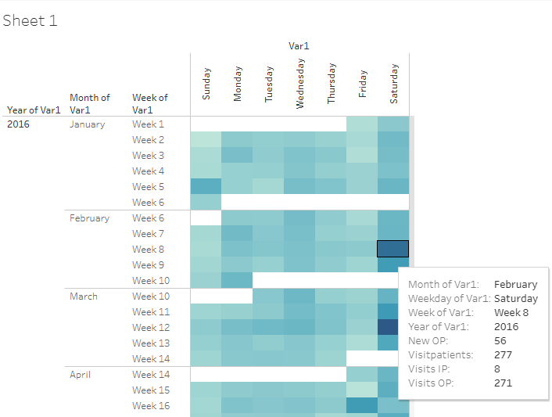

Reference files:
Tableau viz | 04_calendar_view
Tableau sheetname | Sheet 1

Patient visit view
There are 2 analysis views created for individual patient data. These show the longitudinal nature of data.

Columns displayed in the first view are follows: Patient ID (mr_no), gender, study day
- The Inpatient visits are displayed in blur color and Outpatient visits are displayed in Orange color.
- The tooltip contains information about the following data points not displayed on the page:
  - Studyday: Study day
  - Cdur: Total duration of hospital visits.
  - Description: Disease description variable accompanying ACD codes.
  - Medicine Name: Medicine provided at that visit.
  - Minday Metabolic: First day on which any metabolic disease has been reported by patient.
  - Minday RMSD: First day on which any RMSD disease has been reported by patient.

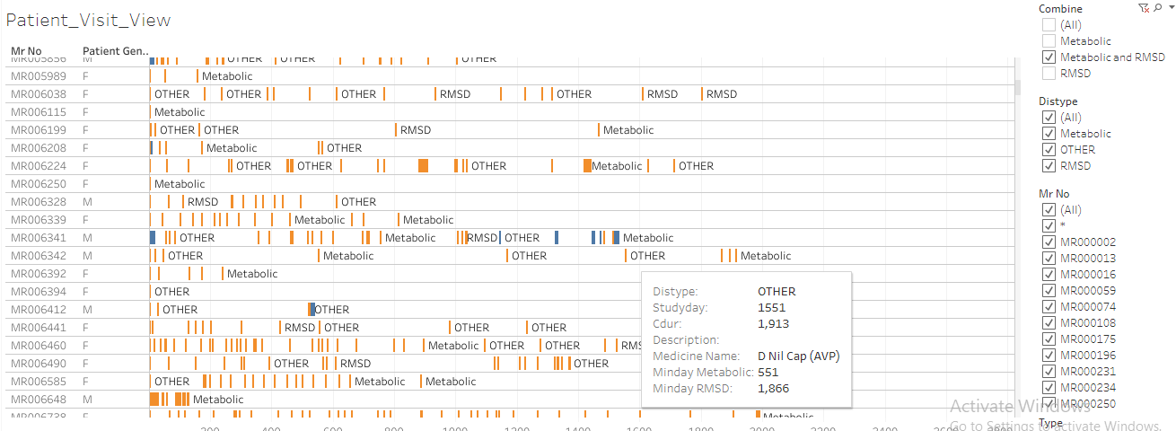

Reference files:
Tableau viz | 01SQL_Dis_Med_Ser
Tableau sheetname | Patient_Visit_View

Columns displayed in the second view are follows: Patient ID (mr_no), gender, base age, category, Code, description, study day
- The Diseases are displayed in blue colored bars and treatments prescribed are marked in orange colored bars.
- Bars are created as followed: Duration between minimum and maximum reported date for a disease as well as prescribed treatment is calculated, this duration is displayed on the visualization. This calculation needs improvements (algorithm is getting developed to derive individual episodes of diseases as well as individual episodes of treatment assignment)
- The tooltip contains information about the following data points not displayed on the page:
  - Daystt: Start of event in days (disease as well as treatment)
  - Disdur: Duration of event in days (disease as well as treatment)
  - Disstt: Start date of event
  - Diend: End date of event

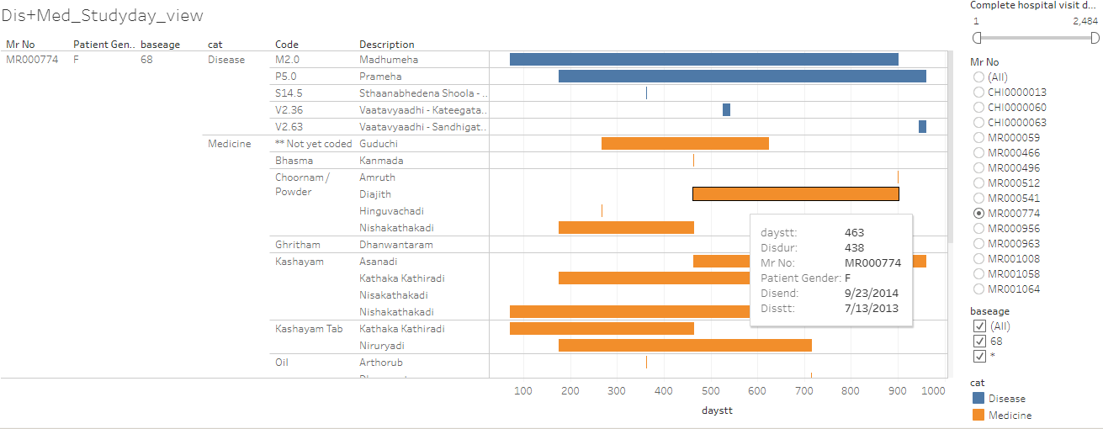

Reference files:
R program | 01_Primary_Gridhrasee.R, 01_Primary_madhumeha.R
Datafile | Primary_gridhrasee.csv, Primary_madhumeha.csv
Tableau viz | 01_Primary_Gridhrasee, 01_Primary_madhumeha
Tableau sheetname | Dis+Med_Studyday_view, Dis+Med_Studyday_view

Interpretation:
- White spaces between the bars represent days between 2 consecutive visits.
- Duration bars displayed one below the other provides an easy visualization of co-morbidities as well as co-prescription of medicines.
- For RMSD disease group, there are a lot more visits. The difference between consecutive visits is smaller than metabolic disease group.
- In the 2nd view, medicines are categorized into types: Bhasma, Ghritam, Kashayam, Oil, Choornam, etc. This classification helps in understanding treatment principles followed by the doctor while treating a disease.
- These 2 views should provide huge information at one glance to the treating doctor. These 2 views could be used as an additional helping aid while talking with patient F2F or over the phone.

Disease and treatment view, listing and summary
There are 3 analysis views created for individual patient data.
1st part of the analysis:
Patients are treated as they come to hospital. This visual provides a patient level view of number of diseases reported for the first time and then repeated, similarly treatment prescribed for the first time vs. a repeat of treatment.
- When a disease is reported very first time then that is considered “1st time disease reported”, any subsequent repetition is considered as “Repeat”.
- When a treatment is prescribed very first time then that is considered “1st time treatment prescribed”, any subsequent repetition is considered as “Repeat”.
- These 2 calculations are repeated through the data for each patient.

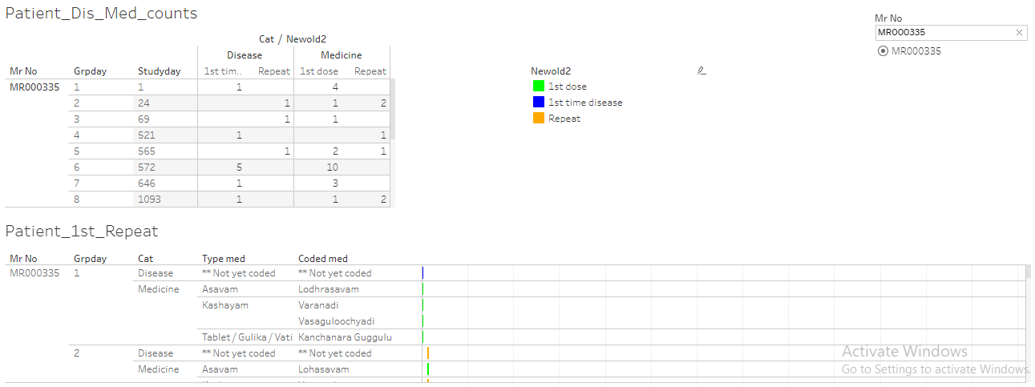

2nd part of the analysis:
This is a cumulative view for an individual patient. This provides a summary of what would have happened to a patient till a certain visit number. There are 2 tables created, first with absolute numbers and second with percentages.

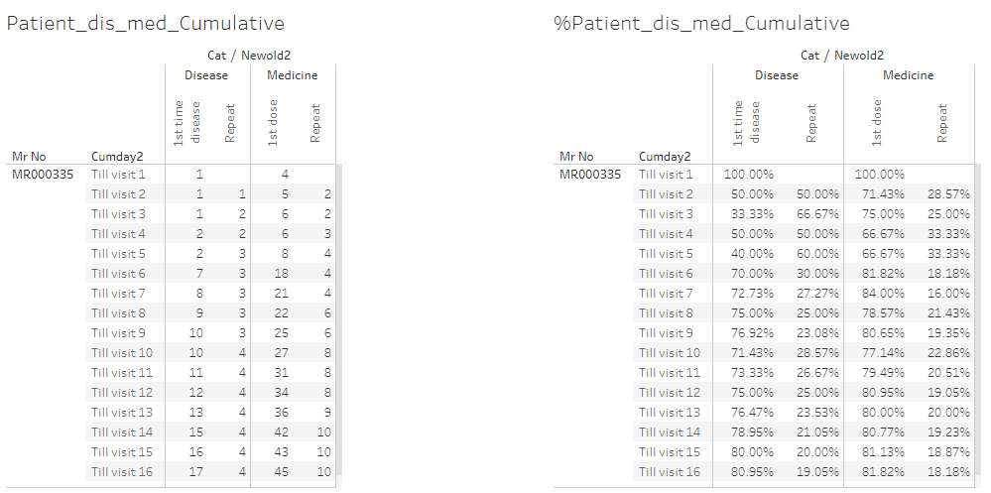

3rd part of analysis: This is another version of display of diseases and treatments for individual patients “non-overlapping or non-cumulative” version.
- Each line is a patient visit. 1st disease, Repeat disease, 1st treatment and Repeat treatment columns are displayed.
- Studyday column shows the visit day.

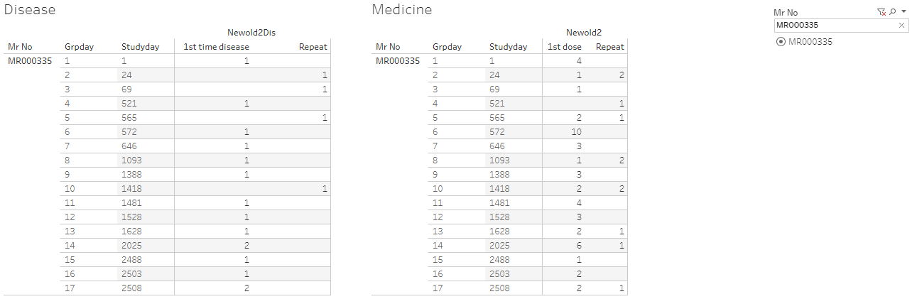

Reference files:
R program | 080_medicine_repeat_prop.R  080_medicine_repeat_prop_addnl_cal.R
Datafile | 080_medicine_repeat_prop.csv,  080_medicine_repeat_prop_cumulative.csv  080_medicine_dis_repeat_prop_cumulative.csv
Tableau viz | 080_medicine_dis_repeat_prop  080_medicine_dis_repeat_prop_cumulative
Tableau sheetname | Dashboard 1

Interpretation:
- When a new disease is reported, usually a new treatment or treatments are reported, if there is only a new treatment added then it could indicate, the earlier treatment may not have worked, or it explains the treatment regimen.
- If only new diseases are added and no new treatment is added then the same treatment could work for multiple diseases.
- The above example shows for patient MR000335,
  - There are 17 visits
  - There are 17 distinct diseases reported and 45 distinct treatments, services prescribed.
  - 4 out of 17 diseases are repeated and 10 out of 45 treatments have been repeated.
  - Based on the 3rd view, at visit 6 on day 572, there is only 1 new disease reported and 10 new treatments are added. At visit 14 on day 2025, there are 2 new diseases reported and 6 new treatments added.
- These visualizations allow the treating doctor insights into newer diseases getting reported as well as what newer treatments have been prescribed at what time points.

Disease view by seasonal variation
The following analysis provides frequency count of patients for each disease by month by gender.
- Unique combinations of patients, diseases by date and gender are created.
- Frequency counts are displayed.
- Counts of females are displayed in blur color and counts for males are displayed in orange color.
- This visual opens for each day, by clicking on “+” sign on the x-axis, showing the operational as well as scientific usefulness.

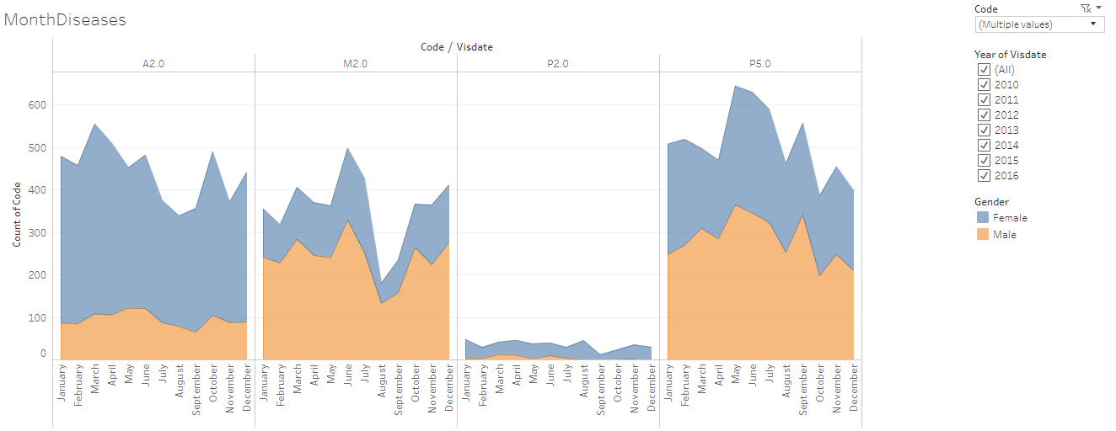
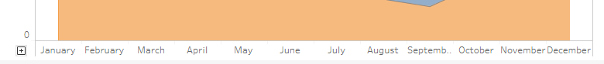
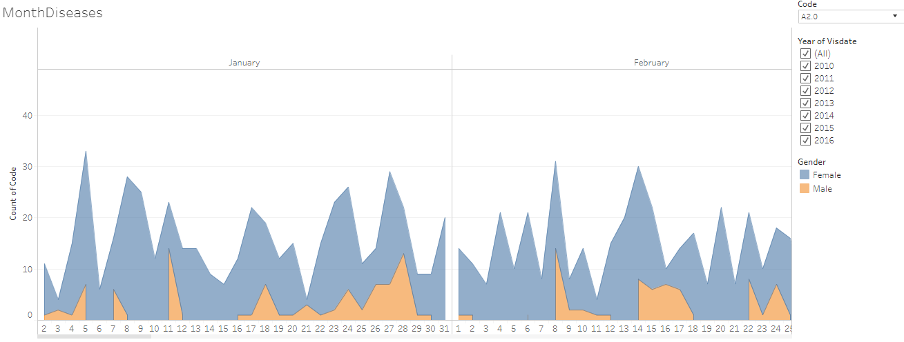

Interpretation:
- This provides information about 800+ diseases in very short space.
- Disease patterns are interesting due to following reasons:
  - Some diseases are reported more than a few other ones, it clearly gets shown easily.
  - Diseases vary seasonally.
  - Diseases are experienced differently by genders and it gets shown easily by looking at the distributions.
- This view is very useful for both operational excellence as well as clinical judgment.

Reference files:
Tableau viz | IndividualPatientCalendar
Tableau sheetname | MonthDiseases

Reference files for 2nd analysis carried out similar in nature:
Datafile | 01adsl_met_rmsd.rds
Tableau vizname | 01SQL_Dis_Med_Ser
Tableau sheetname | Slopegraph_disPatients, Slopegraph_disVisit

Rate of occurrence for diseases for metabolic and RMSD
After understanding the data and some operational side of it, let us understand the rate of occurrence for various diseases reported. The most frequently reported diseases have been sorted in ascending order.

- Metabolic disease group has 10 diseases and RMSD disease group has 100+ diseases.
- For Metabolic disease group the top 3 diseases are:
  - Prameha
  - Madhumeha
  - Sthaulya
- For RMSD disease group the top 5 diseases are:
  - Vaatavyaadhi – Sandhigata Vaata
  - Vaatavyaadhi
  - Vaatavyaadhi – Gridhrasee
  - Sthaanabhedana Shoola – Katee Shoola
  - Sthaanabhedana Graha – Katee Graha
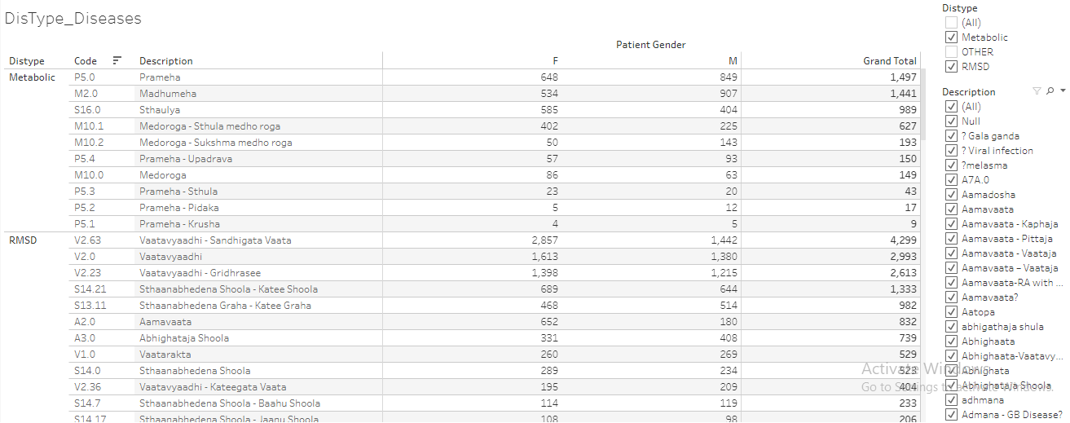

Reference files:
Datafile | 01adsl_met_rmsd.rds
Tableau vizname | 01SQL_Dis_Med_Ser
Tableau sheetname | DisType_Diseases

The analysiswas carried out for disease group by gender and Indian seasons.
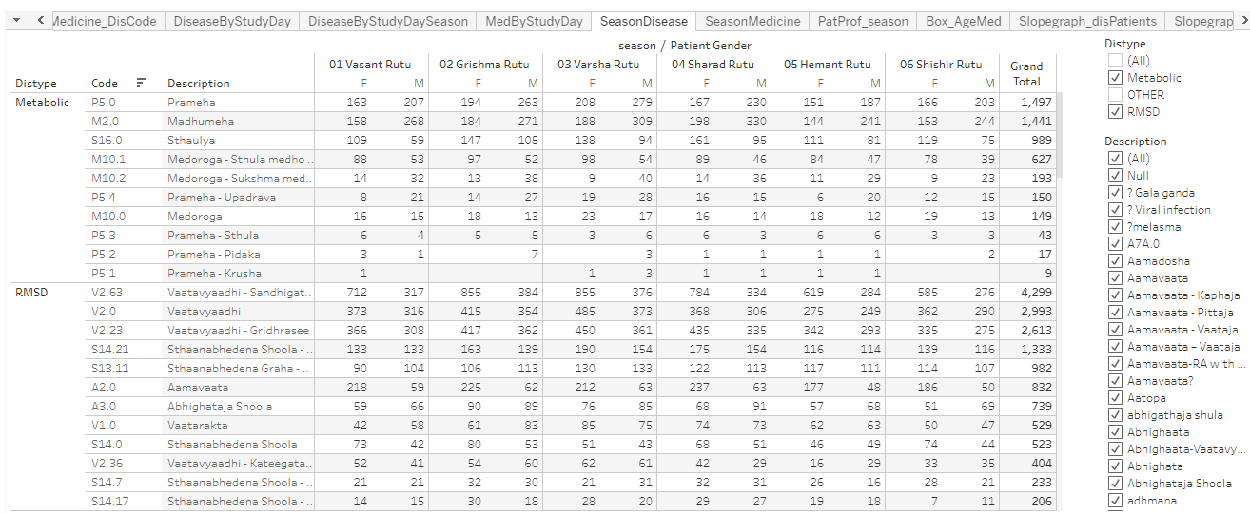

Reference files:
Datafile | 01adsl_met_rmsd.rds
Tableau vizname | 01SQL_Dis_Med_Ser
Tableau sheetname | SeasonDisease

There are many analysis created using to get additional insights into the data.

Interpretation:
- Prameha and Madhumeha are reported more by males than females.
- There are more female patients with disease condition Sthaulya.
- In general, RMSD diseases are reported by more number of females than males.
- For RMSD disease group, 51 out of 100+ disease are reported by <= 10 patients.

Medicine prescription by day
There are numerous medicines prescribed. These medicines are classified into following broad categories:
- Abhyanga
- Aristham
- Arka
- Asavam
- Avagha
- Bhasma / Bhasma Cap / Bhasma Tab
- Dhara
- Ghritam and variations of Ghritam
- Kashayam and variations
- Kshar
- Lehyam
- Oil
- Pichu
- Rasayanam
Etc.
Source variable for treatment will be classified into the following categories. This should allow recreation of treatment protocol as per ayurvedic principles.

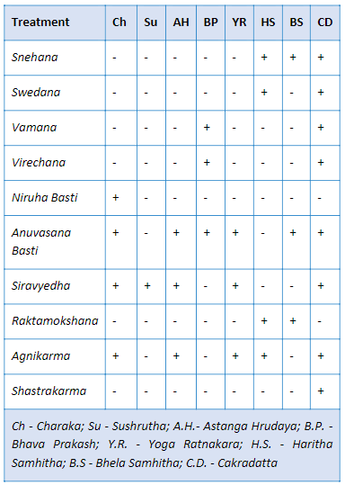

Interpretation:
- Arka, Avagha are prescribed to very few patients.
- Bloddletting has been advised to a few patients.
- Kashayam has been

Reference files:
Datafile | 01adsl_met_rmsd.rds
Tableau vizname | 01SQL_Dis_Med_Ser
Tableau sheetname | MedicineByDay

Co-morbidity analysis
Patients report multiple diseases through their visits to the hospital. There are known as well as unknown disease combinations present due to biological linkages. 3 different analysis provide insights into co-morbidities observed through the existing data.

Algorithm for 1st analysis:
- Create unique combinations of Patient ID, gender and reported disease at any given time point.
- Subsequently create a dataset having combination of 2 diseases for individual patient. E.g. if a patient has reported 5 unique diseases then all the combinations of these 5 diseases will be created.
- The resulting data will have the following structure: Patient ID, Primary disease, Secondary disease, gender.
- Frequency count of distinct patients will be calculated for each Primary disease, Secondary disease combination and gender.
- Using this data following analysis is carried out:
  - Summary statistics of age group for each secondary disease by gender.
  - Boxplot of age group for each secondary disease by gender.
  - Bubble plot for each disease, bubble size is determined by the count of unique patient ID.
  - For a primary disease how many other unique diseases are reported is calculated by gender.
  - Tooltip on the bubble plot provides information about count of distinct number of patients, and summary statistics for age group.
- The dashboard is controlled by a “PrimaryCode” or a reference disease. The corresponding data is displayed on the page.
  - The bubble plot displays the number of distinct patients having the primary disease.
  - Other bubbles display the diseases reported by this subset of patients at any point in time (these could be clinically related or unrelated, could have occurred before or after the occurrence of reference disease).
  - The tooltip shows min, median and max age, distinct counts of patients.
  - A small table on the left side shows number of other diseases experienced.
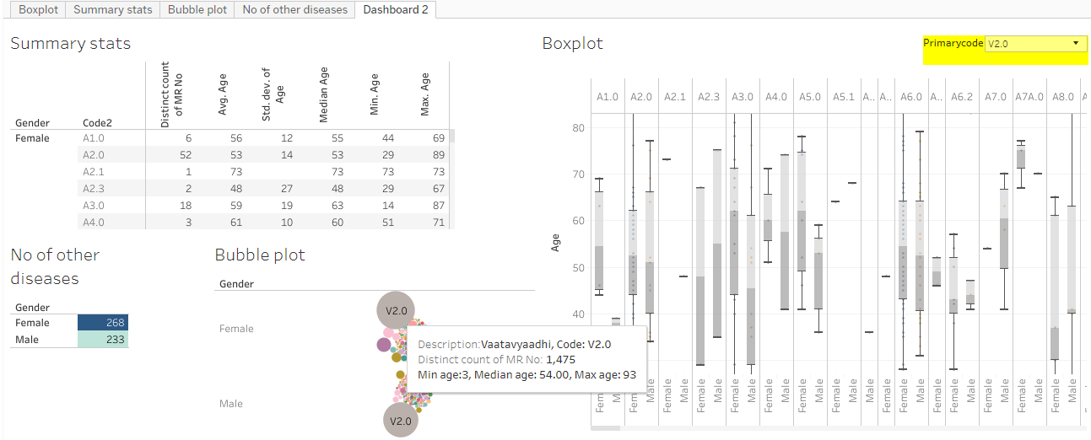

Algorithm for 2nd view: all the steps are same as 1st analysis + addition of monthly variation.

Same calculations for 1st algorithm are followed to create co-morbidities, in addition time factor of month has been added to get insights into seasonal variation.

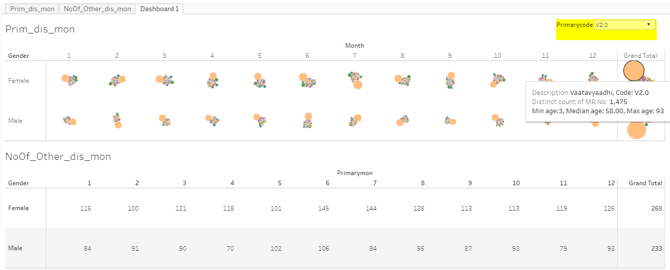

Algorithm for 3rd analysis: steps are similar to the 1st analysis + chronology of diseases is maintained. How is the trajectory of the diseases unfolds is depicted here. The visual display is created in a form of collapsible tree. A brief flow chart of the analysis is as follows:
- Diseases experienced by each patient are sorted by date and only 1stinstance of a disease is retained.
- For each disease trajectory the frequency counts are created and are displayed as a collapsible tree.
- This tree shows progression of diseases as experienced by patients in the database.
- This tree shows approximately 12,500 lines of data in very short space.
- Some diseases are experienced more by males or by females.Some diseases are only reported by one of the genders.
- Some diseases have many more branches than a few others.
- The tree has filled blue dots which open up additional branches, white filled blue dots are the end of the branch, (N=xx) at each of the branches display number of patients reporting that disease trajectory.
- Some of the disease trajectories have very few numbers of patients. Some of the trajectories may be clinically meaningful and some may not be meaningful.

Technical details behind the flowchart:
- Disease trajectories are created using R programming. Final output stored in Json file.
- Json file is used the input to the D3js Java programming.
- Index.html file is hosted on the Github page to create the interactive pagehttps://coursephd.github.io

Initial view of the tree
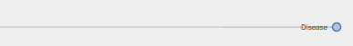
Example of Vaatavyadhi -- Gridhrasee

After clicking on F, the tree opens up
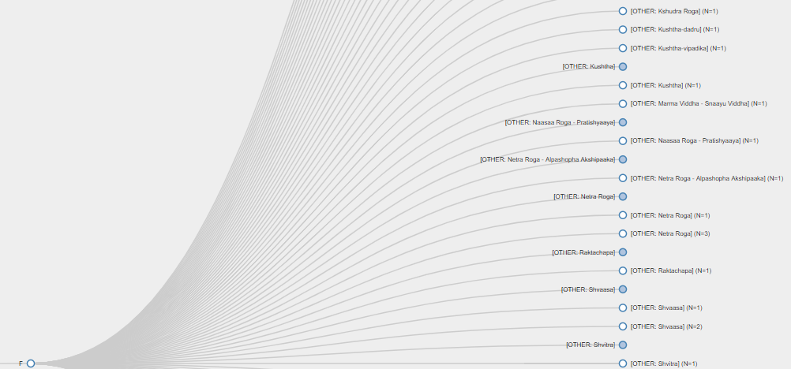

An example of a disease experienced only by one gender
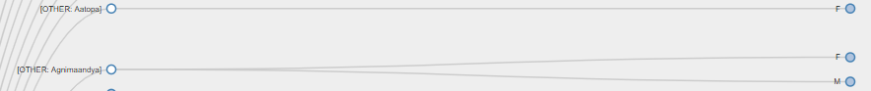

Interpretation:
- This display provides a comprehensive view of the disease clusters. Comorbidities are easily identified, some of them are clinically relevant, and some of them are not.
- Bubble size provides comparative view of number of patients reporting a specific disease. The age group distribution for each gender is available. Some diseases are reported more by males or by females, easy to spot on the graph.
- Box named “Number of other diseases” provides a contextual display about number of co-morbidities. Some diseases have higher number of co-morbidities, some have lower number. Variations are seen amongst gender as well.
- This analysis does not take into account the before or after nature of time points, so this does not provide insights into the causal relationships between diseases.
- 2nd analysis provides views on the seasonal variations of diseases as well as seasonal co-morbidities.

Reference files:
R program | diagnosis_primary.R, diagnosis_primary_month.R
Tableau viz | Primary_disease_and_all_other_diseases , PrimDis_otherDis_ByMonth
Tableau sheetname | Dashboard 2, Dashboard 1
Collapsible tree | https://coursephd.github.io

Treatment and disease combinations
The Patient Report form or Case Report form captures diseases reported on a particular visit along with treatments and services prescribed to a patient. Due to the nature of the CRF page, multiple diseases and treatments are captured on the same visit. This creates many to many relationships and dilutes one to one relation. Even though this challenge exists, the data at a summary level provides good view on treatment and disease relationship.

Medicine and disease group rate of occurrences are calculated as well as medicine and individual disease rate of occurrences are calculated.

E.g. Use Balaristham as a case:
- Balaristham is prescribed to the following number of patients.
- The source variable captures the quantity + unit + company name are presented in the same variable, which does not allow for numerically correct calculations.
- Coded variable is created to get around this challenge.
- The medicine is prescribed for RMSD group. It is not used so much for Metabolic group.

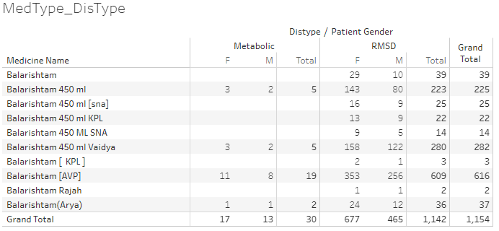

2nd example of bhasma:
- Approximately 287 patients out of 17406, 1.5% of patients are prescribed bhasmas for various diseases.
- Traditionally bhasmas of any kind are prescribed in very limited quantity and same is reflected in observed data.
- Naming convention and spelling correctness need to be considered while capturing data in future.

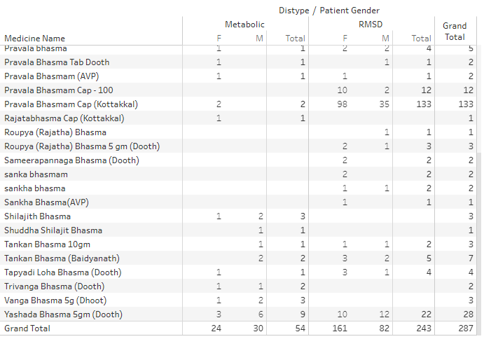

Reference files:
Datafile | 01adsl_met_rmsd.rds
Tableau vizname | 01SQL_Dis_Med_Ser
Tableau sheetname | MedType_DisType  Medicine_DisCode  MedByStudyDay  SeasonMedicine  Box_AgeMed

ICD coding of diseases
National morbidity codes by CCRAS under guidance of Ministry of AYUSH

ISO coding for background work history

Dataset with each disease considered as a reference disease having day 1
This data is generated from every day medical practice at the hospital. Hence the diseases are reported almost at random. The following analysis uses 1st occurrence of any disease as day 1 at an individual patient basis. Using this as reference day “before period” and “after period” is derived. “Before period” provides significant amount of “baseline data”, “after period” provides specific insights into what would happen after the reference disease.

Algorithm to create the underlying data for analysis:
- Each of the 106 diseases (10 Metabolic and 96 RMSD) is considered as a reference disease.
- Day 1 is calculated as the reference day 1 for individual patient for each disease.
- Other diseases for the same patient are positioned either before or after compared to this reference disease.
- Duration w.r.to this reference day is calculated before and after day 1. This calculation provides the background view as well as future view.
- This referencing allows for more informative background disease as well as background medicine information. The duration is split into the following time points:

Before | After
Day 1 as reference
Before 1 month | Within 1 month
Before 2 months | Within 2 months
Before 3 to 6 months | Within 3 to 6 months
Before 7 to 12 months | Within 7 to 12 months
Before 2nd year | Within 2nd year
Before 3rd year | Within 3rd year
Before 4th year | Within 4th year
Before 5 year | Within 5 year

Details about the analysis file:
- 1 sheet for each reference disease is created.
- Frequency count of diseases and prescribed medicines is displayed.
- “Before period” counts are displayed in red colour and “After period” counts are displayed in Green colour. This analysis provides good insights into the causal relationships.

E.g. use Prameha as an example:
- Prameha has been reported by 1497 patients. Out of these 383 patients visit hospital within 1st month, 231, 269, 167, 128, etc are in the following time points.
- Other lines in the table provide details about diseases reported by these 1497 patients.
- Bottom section of the table provides information about the treatment details for these patients.

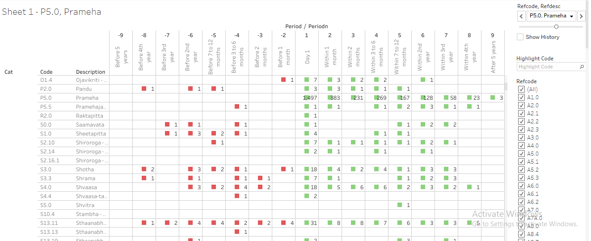

Another example of Vaatavyadhi – Gridhrasee, 4299 patients have reported at least once.

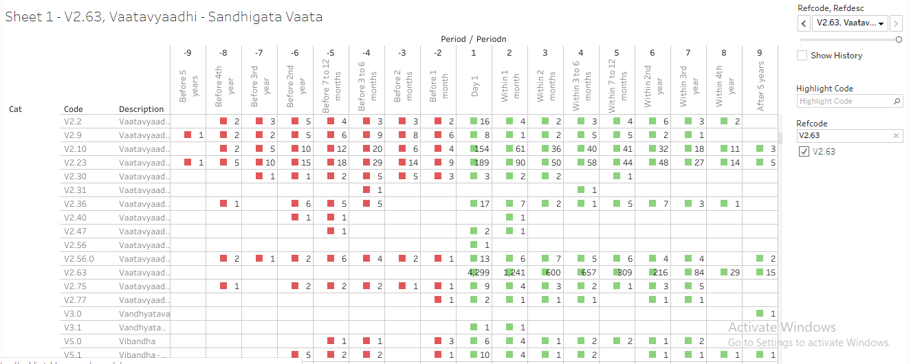

Reference files:
R program | 085_dis_1st_time_refCal_NodesEdges.R
Datafile | 085_dis_1st_time_refCal_NodesEdges.csv  085_dis_1st_time_refCal_NodesEdges.rds
Tableau vizname | 085_dis_1st_time_refCal_NodesEdges
Tableau sheetname | Sheet 1- <Disease code>, <Disease name>

Circular disease and treatment view
This is2nd analysis carried out on the data prepared earlier.

Details about the display:
- For each reference disease 1 page is created. Each page is controlled by a combination of “Reference disease + disease”, “Reference disease + medicine”
Reference disease window: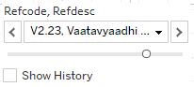,
Reference disease or medicine window: 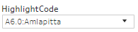

- Tables displayed in the top part of the display:
  - There are 9 columns created for each time point.
  - 2 columns are displayed in each time point to display “count of distinct number of diseases” and “count of distinct number of medicines”.
Count of distinct number of diseases: 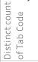
Count of distinct number of medicines: 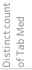
  - There are 3 rows for “Before period”, “Day 1” and “After period” with 2 lines in each period.
  - Day 1 cell shows the start day of reference disease “V2.23: Vaatavyadhi – Gridhrasee”,
    - This example shows 137 total number of distinct diseases reported and 664 total number of distinct medicines prescribed on day 1 for this combination of reference disease “V2.23: Vaatavyadhi – Gridhrasee” and disease “A6.0: Amlapitta”.
    - The first line in the Day 1 cell shows, 1 disease – which is “A6.0: Amlapitta” and 81 distinct medicines prescribed. These 81 different treatments could have been prescribed for “A6.0: Amlapitta”.
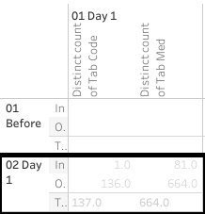
  - Cells in the “Before period” line provide the following information:
    - This example shows 1 month before “V2.23: Vaatavyadhi – Gridhrasee”, there were 61 distinct diseases and 298 distinct medicines reported.
    - The first line in the cell shows, 1 disease – which is “A6.0: Amlapitta” and 11 distinct medicines prescribed. These 11 different treatmentscould have been prescribed for “A6.0: Amlapitta”.
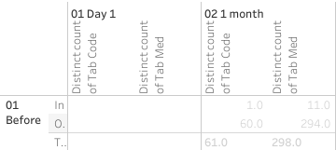
  - Cells in the “Afterperiod” line provide the following information:
    - This example shows 1 month before “V2.23: Vaatavyadhi – Gridhrasee”, there were 96 distinct diseases and 633 distinct medicines reported.
    - The first line in the cell shows, 1 disease – which is “A6.0: Amlapitta” and 49 distinct medicines prescribed. These 49 different treatmentscould have been prescribed for “A6.0: Amlapitta”.
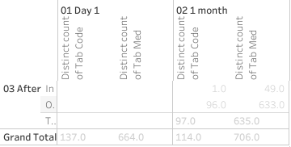
- The bottom section follows the same structure as the top section. The following table provides distinct number of diseases reported and distinct number of medicines prescribed for this particular combination. There are 308 diseases and 1357 medicines reported for this combination of reference disease “V2.23: Vaatavyadhi – Gridhrasee” and disease “A6.0: Amlapitta”.
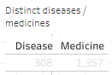
- Explanation about the circular view:
  - The starting point marks the position of the other disease in this case, “A6.0: Amlapitta”,
  - The green colored spokes going from point of origin are different treatments prescribed.
  - These are showing 664 distinct medicines prescribed on day 1.

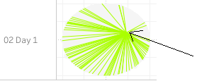
  - Hovering tooltip provides details about the disease, treatment name and count of number of patients: 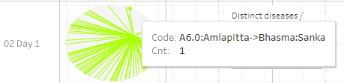

- The inner circle displays the diseases.
- The outer circle displays the treatments.

Circular view of disease and medicine view allows the following comparisons:
- Relationship between diseases and treatments across different time points.
- If a disease is experienced in different time windows then would the treatment options look different or would they look similar.
- Occurrence of diseases and proximity -- do the diseases precede and / or succeed each other, etc.

E.g. Amavaata, what all diseases were experienced and treatments given before the 1st occurrence of disease and after the 1st occurrence of disease. How far or how close were these events are given in terms of within 1 month, within 2 months, within 3 to 6 months, 1 year, 2year etc. on both sides.

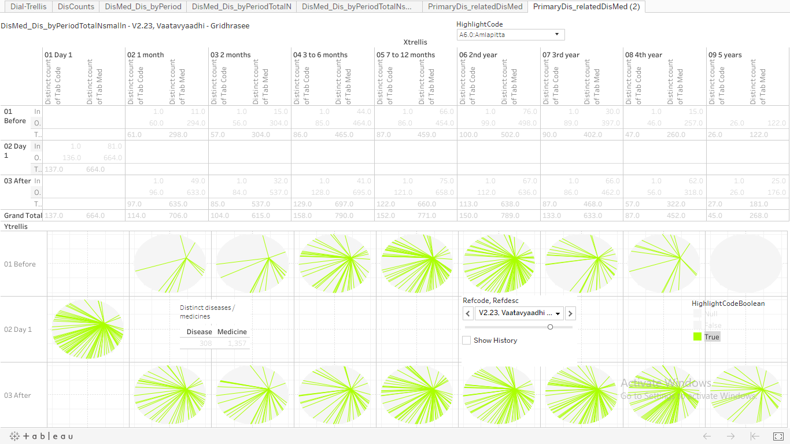

Example view of the combination of a treatment “Dhanwanaristham” and reference disease “V2.23: Vaatavyadhi – Gridhrasee”. Very few Green colored lines show that this treatment may not be a heavily used treatment against this specific disease condition.

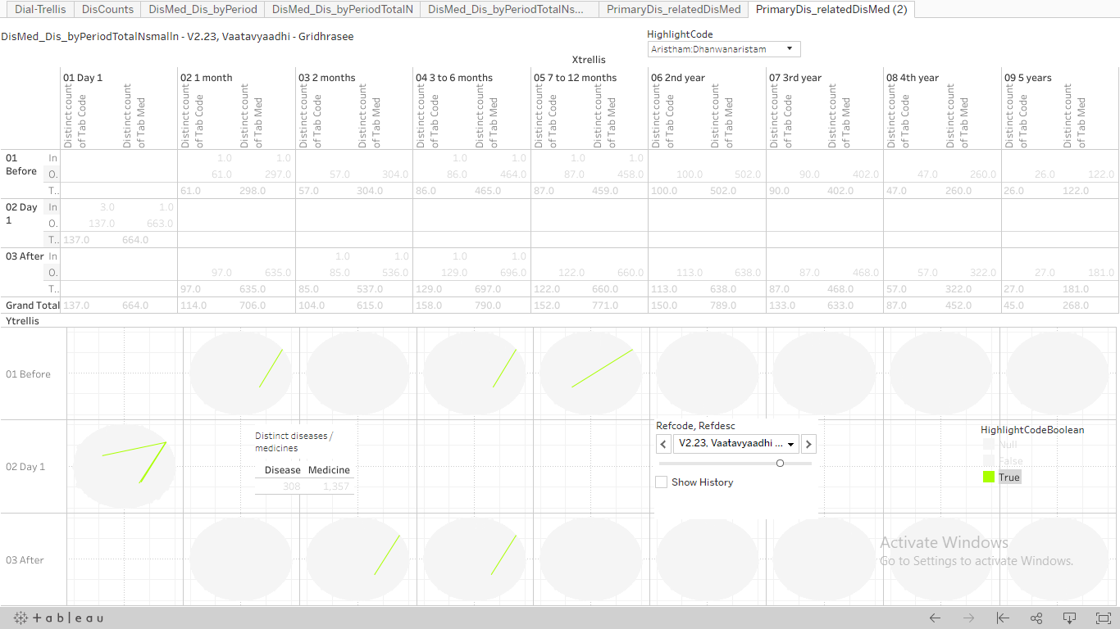

Before and after disease and treatment java view
This is 3rd analysis carried out on the data prepared earlier.

Chapter 6 CKD
- What is CKD and how does it relate to the V16.0 Vrikka Roga in ayurveda?
There's no cure for chronic kidney disease (CKD), but treatment can help relieve the symptoms and stop it getting worse. ... The main treatments are: lifestyle changes – to ensure you remain as healthy as possible medication – to control associated problems, such as high blood pressure and high cholesterol.
^{Vrikka Roga analysis}
The hospital database contains approximately 320 patients who have reported Vrikka Roga at least once between years 2011 and 2017. The ACD classification V16.0 identifies Vrikka Roga. It is equivalent to the Chronic Kidney Disease reported in the western medicine.
Serum creatinine level > 1.8 mg/dL
- What is the available data in public forums?
The approximate prevalence of CKD is 800 per million population (pmp), and the incidence of end-stage renal disease (ESRD) is 150–200 pmp.(0.1% rate for both these stages put together). Community studies estimate the prevalence between 0.16% and 0.79%, the hospital database proportion of patient is 318 / 51000 ~ 0.62%, it is in the range reported by the authors. 70% of male patients are observed.
How fast or slow is the progression from CKD to ESRD to resulting in a renal transplant?
https://www.karger.com/Article/FullText/199460
http://www.apiindia.org/medicine_update_2013/chap130.pdf

- Who is likely to get it, at what age, which gender?

The database has 79 female and 239 male patients reporting the disease, 46 females out of 79 female patients have reported other diseases. 139 males out of 239 male patients have reported other diseases. 25% females and 75% male patients contribute to the total number of patients. This proportion is similar to other big databases.

56.8 (16.9) years is the average (SD) age reported by females. 61.8 (17.0) years is the average (SD) report by males. The minimum reported age is 2 years for males and females, whereas 85 and 89 are the maximum reported ages for females and males respectively.

127 patients reported only single disease and 185 patients have reported multiple diseases. Approximately 40% of patients report only Vrikka Roga. 240 (~75%) patients report Vrikka Roga on day 1 of coming to the hospital. A lot of patients would come to Ayurvedic treatment option after trying out all other options. Or a lot of patients would be coming to take second opinion and never come back for any additional visits.

93 (29%) patients reporting only single disease visit hospital only once. 38 (12%) patients reporting multiple diseases visit hospital only once.

The following table outlines the distribution of patients continuing on for specific periods of time:

^{Day 1} | ^{310 (100%)}
^{Within 1 month} | ^{90 (29%)}
^{Within 2 months} | ^{60 (19%)}
^{Within 3 to 6 months} | ^{64 (20%)}
^{Within 7 to 12 months} | ^{33 (10%)}
^{Within 2nd year} | ^{19 (6%)}
^{Within 3rd year} | ^{7 (2%)}
^{Within 4th year} | ¹
^{Within 5th year} | ¹

There is a steep decline in number of patients after 1st day. By the 2nd year, there are only 6% patients taking any medicine, 2% continue for 3rd year and more. Only 1 patient has continued for more than 4 years.

Approximately 90 (28%) patients have reported diabetes and heart disease. Approximately 35 (10%) patients have reported renal diseases.

Analysis of lab parameter Creatinine (mg/dL):

127 (40%) patients have reported creatinine value and summary statistics is as follows:

^{Unique patients} | ^{Mean} | ^{Median} | ^{SD} | ^{Min} | ^{Max}
^{127 (40%)} | ^{5.01} | ^{4.5} | ^{3.20} | ^{0.7} | ^{21.0}

Analysis for Male and female patients: mean (median) values for males are considerably higher than for females.

^{Unique patients} | ^{Mean} | ^{Median} | ^{SD} | ^{Min} | ^{Max}
Male: 99 (31%) | 5.48 | 5.18 | 3.42 | 0.7 | 21.0
Female: 28 (9%) | 3.77 | 3.30 | 2.06 | 0.9 | 9.6

Analysis for patients with single and multiple diseases: patients reporting only Vrikka roga have mean (median) values considerably higher than patients who have reported multiple diseases.

Unique patients | Mean | Median | SD | Min | Max
Multiple: 78 (25%) | 4.71 | 3.76 | 3.10 | 0.7 | 14.5
Single: 49 (15%) | 5.82 | 6.00 | 3.32 | 0.7 | 21.0

Analysis by time point: for both types of patients, the mean and median values at post-baseline time point are lower than that of the pre-baseline time point, showing some benefit.

 | Time point | n | Mean | Median | SD | Min | Max
Multiple disease | 01-Pre-baseline | 44 | 4.86 | 3.83 | 3.23 | 1.5 | 13.87
Multiple diseases | 02-Post-baseline | 50 | 4.59 | 3.70 | 2.99 | 0.7 | 14.50
Single disease | 01-Pre-baseline | 37 | 5.89 | 6.00 | 2.89 | 0.9 | 14.60
Single disease | 02-Post-baseline | 18 | 5.68 | 5.95 | 3.66 | 0.7 | 21.00

Analysis by time point and gender: males having only Vrikka Roga as a single disease reported have mean value more than 5 mg/dL for both the time points and may not have been benefited in reducing the creatinine value. Males having reported multiple diseases have pre-baseline value around 5 mg/dL and report small reduction at post-baseline time point.

Female patients with only Vrikka Roga show reduction in creatinine values from pre-baseline to post-baseline, but the number of patients is very low. Females reporting multiple diseases show reversal in creatinine values, they worsen at post-baseline time point.

 | Time point |  | n | Mean | Median | SD | Min | Max
Multiple diseases | 01-Pre-baseline | F | 9 | 2.85 | 2.05 | 1.61 | 1.5 | 6.20
Multiple diseases | 02-Post-baseline | F | 13 | 4.03 | 3.65 | 1.91 | 0.9 | 7.70
Multiple diseases | 01-Pre-baseline | M | 35 | 5.60 | 4.83 | 3.37 | 1.5 | 13.87
Multiple diseases | 02-Post-baseline | M | 37 | 4.83 | 3.72 | 3.33 | 0.7 | 14.50
Single disease | 01-Pre-baseline | F | 6 | 5.90 | 5.51 | 2.18 | 3.4 | 9.60
Single disease | 02-Post-baseline | F | 4 | 3.79 | 2.60 | 2.67 | 1.3 | 7.30
Single disease | 01-Pre-baseline | M | 31 | 5.88 | 6.00 | 3.04 | 0.9 | 14.60
Single disease | 02-Post-baseline | M | 14 | 6.31 | 6.05 | 3.78 | 0.7 | 21.00

Analysis for patients at time points of baseline and post baseline. Baseline is defined as any value on or before day 1 of Vrikka Roga, post baseline is defined as any value on or after day 1 of Vrikka Roga.

Unique patients | Mean | Median | SD | Min | Max
Pre-baseline: 81 (26%) | 5.28 | 5.00 | 3.11 | 0.9 | 14.6
Post-baseline: 68 (14%) | 4.82 | 4.80 | 3.16 | 0.7 | 21.0

The mean and median values for post-baseline are lesser than that of the baseline values. This shows favorable treatment effect on kidney function.

Gender wise view of the pre-baseline and post-baseline values of creatinine:

Male: The mean and median values for post-baseline are lesser than that of the baseline values.
Unique patients | Mean | Median | SD | Min | Max
Pre-baseline: 66 (%) | 5.72 | 5.40 | 3.20 | 0.9 | 14.6
Post-baseline: 51 (%) | 5.16 | 4.90 | 3.47 | 0.7 | 21.0

Female: The mean and median values for post-baseline are bigger than that of the baseline values.
Unique patients | Mean | Median | SD | Min | Max
Pre-baseline: 15 (%) | 3.76 | 3.15 | 2.26 | 1.5 | 9.6
Post-baseline: 17 (%) | 3.98 | 3.48 | 2.04 | 0.9 | 7.7

Overall pre-baseline values for males are higher than that of pre-baseline female values. Females may not have been benefitted in reducing the creatinine values.

Following box plots show the data in graphical format:
- The first box plots show the data by gender and comparison of baseline and post baseline data. There are a few patients with lab data but no dates associated with them.
- The values of 2 mg/dL and 5 mg/dL are marked as red colored dashed lines to show abnormal value upper limit and kidney failure levels. There are a lot of values more than 10 mg/dL for males at both time points. Females have not reported values of more than 10 mg/dL
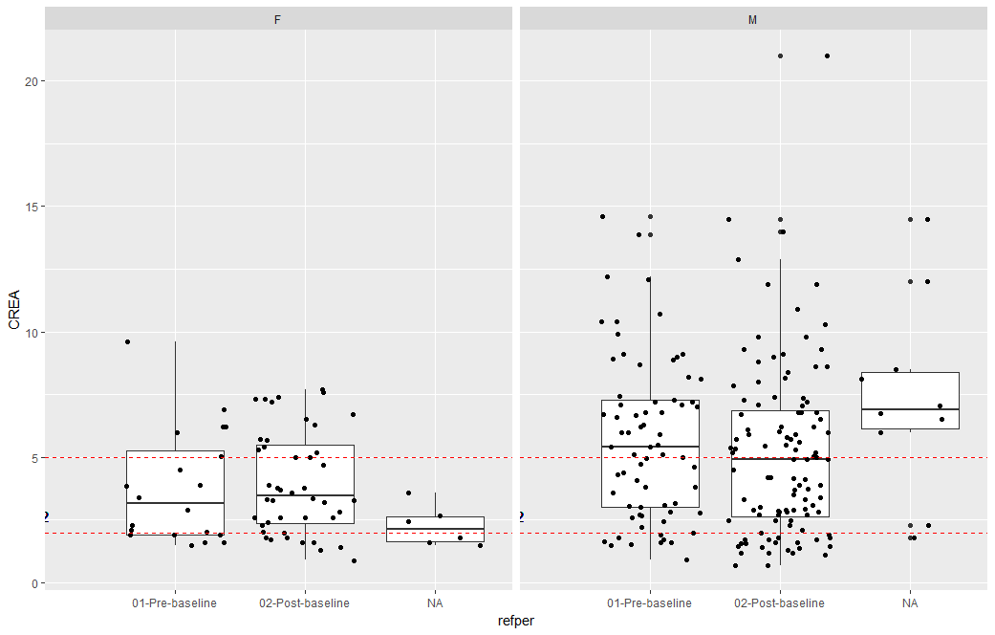

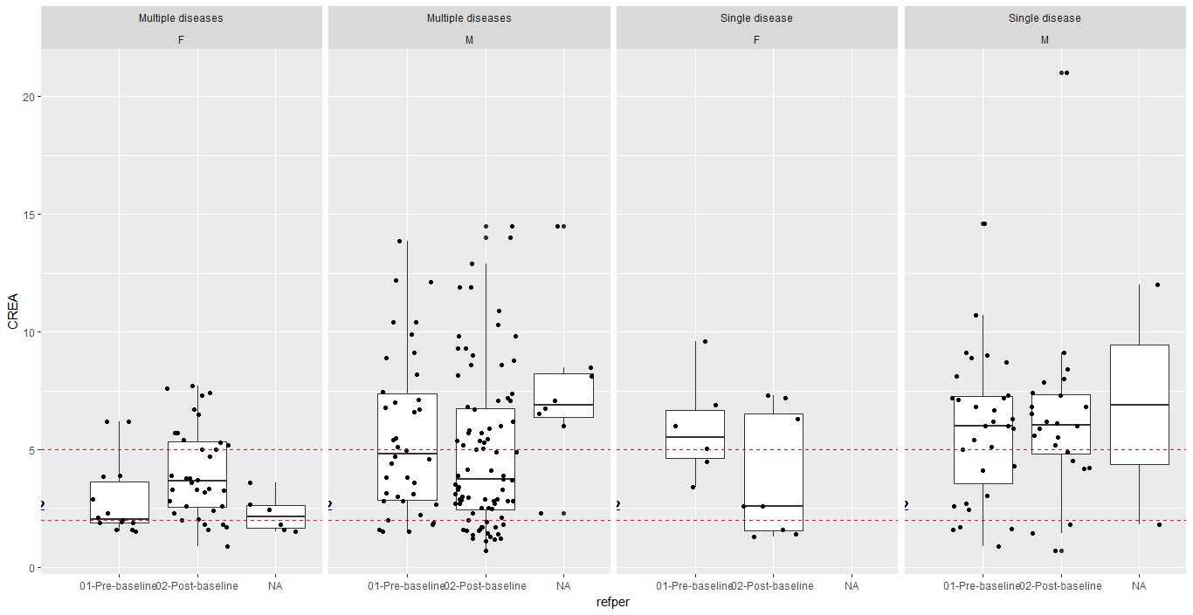

Analysis of lab parameter Potassium (mg/dL):

127 (40%) patients have reported creatinine value and summary statistics is as follows:

Unique patients | Mean | Median | SD | Min | Max
43 (13%) | 5.57 | 5.4 | 1.13 | 3.7 | 12.1

Analysis of lab parameter Hemoglobin (mg/dL):

127 (40%) patients have reported creatinine value and summary statistics is as follows:

Unique patients | Mean | Median | SD | Min | Max
76 (24%) | 9.73 | 9.8 | 2.07 | 4 | 14.5

- Is it a chronic disease or an acute disease, even if “chronic” is present in the name?
- Is it possible to cure it fully, or would it have frequent recurrence?
- What are the co-morbidities experienced, either along with disease or before as well as after?
- Is the disease experiences seasonal variations?
- What are the grades for CKD?
- Is it simple to diagnose CKD or is there a possibility of misdiagnosis?

Institutional Ethics Committee for Human Research
Application for Ethical Review of Research Protocol

To Date:

The Member Secretary
Institutional Ethics Committee
Institute of Tran-disciplinary Health Sciences and Technology
Bengaluru

Full name of Principal Investigator:
Designation:
Complete Postal Address:
Tel. No: Office and Fax. No.
E-mail:

Site of study:
Title of Project:
Sponsor Name and address:

Sl. No. | Name | Signature
Principal Investigator
Co-Investigator
Co-Investigator
Type of study: Local / National / International
Type of Trial: Multi center / Single center

Name & Signature of Principal Investigator Date:

{Application must be submitted along with the study protocol, consent form (English and local language), Approval letters (if any, other scientific committee or ethics committee) and other essential documents for the review}.
PROTOCOL COVER PAGE

PROTOCOL NAME
Use of Real World Evidence methods to drive clinical practice

PROTOCOL NUMBER: To be filled by IEC office (any amendments should bear the amendment number)

PROTOCOL VERSION & DATE:
V1.0 &21st Dec 2018

GENERAL INFORMATION

Name and address of the sponsor of the study
Dr. Girish Tillu
Dr. Ashwini Mathur
Vinay Mahajan

Name and address of the person authorized to sign the protocol and amendments

Name and address of study monitor

Name, title, address and telephone number(s) of the medical expert for the trial

Name and title of the investigator(s) and sub-investigators responsible for the trial with address and phone number(s)

Name and addresses of the clinical laboratories and/or other institutions involved in the trial
Not applicable

Table of Contents

List of Abbreviations

(e.g.)

CFR Code of Federal Regulations

ICH International Conference on Harmonisation

CRF Case Report Form

FDA Food and Drug Administration

GCP Good Clinical Practice

IRB Institutional Review Board

1 Background

Real world data is the data relating to patient health status and/or the delivery of health care routinely collected from a variety of sources.This data holds potential to allow us to better design and conduct clinical trials and studies in the health care setting to answer questions previously though infeasible. In addition, with the development of sophisticated, new analytical capabilities, we are better able to analyze these data and apply the results of our analyses to support standardized medical practice/methods, medical product development and approval.

Reported lack of efficacy of Ayurvedic treatments in clinical trials is often not due to inefficacy of the treatment itself, but arises from inadequacies of trial design and standardized/uniform administration practices.Ayurveda and other traditional medical systems often prescribe complex treatments consisting of a combination of drugs, diet, detoxification procedures, lifestyle changes, and yoga practices, customized to the needs of individual patients. To replicate these daily complexities into a clinical trial becomes a scientific and operational challenge; hence holistic treatment never gets tested. A lot of the clinical trials conducted and reported for ayurvedic treatments have come under criticism due to “reductionist” nature. Through our narrative review of 260+ clinical trials we have shown the quality of trials has been sub-optimal as well.

Efficacy of a drug or treatment method explains whether “it works”, effectiveness of a treatment explains whether “it works for population”. This is the fundamental gap between a clinical study designed and real world medical practice carried out on a day to day basis. Effectiveness of a drug could be defined as interactions between various components at play. These interactions could be defined in different contexts,
- Use of actual drug,
- Individual patient and disease characteristics and
- Healthcare system related characteristics.

The purpose of the effectiveness research is to assess these interactions. This covers the entire span of epidemiologic and public health research methods. Some of the following questions are answered through this investigation:
- Which interactions are universal,
- How do they distribute locally,
- What is magnitude of impact,
- What is the mechanism of action, etc?

Effectiveness of individual drug is of utmost importance as well as there is a need to understand comparative effectiveness when there is more than one treatment option available. Effectiveness of a drug could be under question due multiple reasons. Population using the drug may not be consistent with the population for which the drug was developed. Effectiveness could be affected by lack of adherence to the intended schedule of usage or intended practice. These situations could misrepresent the data and a perceived gap between efficacy and effectiveness could emerge. Methodological options for an integrated efficacy and effectiveness evidence generation plan should be explored.

Investigational Agent
The study is based on the already treated patients at IAIM hospital over the years. All the relevant prescribed treatments available in the database will be utilized for the analysis purpose.

Preclinical Data
The study will be carried out on the existing patient data.

Risk/Benefits
Benefits: the existing patient data will be used retrospectively. The planned study will provide the following insights:
- What kind of data has been collected so far for each patient visit?
- What part of data is related to the every day to day operations
- What part of the data is related to the patient background characteristics, disease conditions, prescribed medicines?
- What are the strengths of the collected data and what are the areas of improvement going forward.
- What kinds of diseases are getting treated more frequently?
- What kinds of treatments are prescribed for what kinds of diseases?
This analysis would add to the evidence base of ayurvedic treatment principles.

Risks: the existing database contains sensitive information related to individual patients. All the efforts will be made to protect sensitive information like
- Name of patient,
- Full address,
- Phone numbers,
- Socio economic status, etc.
This information will not be extracted from source data so that the patient cannot be traced back and contacted. The individual information cannot be used for any untoward purpose.

Dose Rationale
The existing prescribed medicines as well as procedure data will be used as is to understand the ayurvedic treatment principles.

Trial Conduct
Ayurvedic hospital in TDU is operational since year 2011 and perhaps hosts one of the largest electronic databases of Ayurvedic medical practice. The hospital database contains clinical data for more than 51000 patients since 2011 to October 2017. The Ayurvedic disease classification dictionary (ACD) is used to code the diseases [Dictionary developed at the University, and CDAC, Pune]. There are approximately 170,000 visits recorded, covering more than 900 unique diseases, more than 3000 medicinal procedures*, in-patient as well as out-patient visits.

The existing patient level data will be utilized. This data will be referred to as “Source data”. Source data will be accessed from the existing database. Source data reported from day 1 of hospital will used till the latest available date. Additional variables based on the source data will be created in datasets called as “analysis data”.

Population
Source data for patients having reported at least one disease in:
- Metabolic diseases area,
- Rheumatic and Musculoskeletal disease area, and
- Neuroscience area will be used.

Literature
Hospital database, Ayurvedic reference material, Statistical methodological reference material, R software reference material, Tableau software reference material, SQL software reference material, US FDA website, EMA website, References for Real World Evidence.

Trial Objectives
Real World Evidence methods, epidemiological research methods like quantitative, qualitative and mixed methods research would be employed to explore the available data. In qualitative health research observational methods provide direct access to what people do, as well as to what they say and think. These generate an emerging understanding about research questions with two main objectives:
- Preliminary analysis leads to the identification of issues where data need to be further enriched;
- It informs the sampling process, in the sense that researchers are aware of the point in the data collection in which no new categories/themes emerge – data saturation -, signaling that data collection is complete.

Studies of causation, prognosis, and clinical prediction will be carried out according to the quality of preceding evidence, using the optimal study design.

This proposed analysis, due to scale and size of the data, with no artificial limitations of inclusion and exclusion criteria should provide real world evidence view or the epidemiological view for the stated period (from the beginning of hospital in 2011 to October 2017). This will provide additional understanding about ayurvedic data that may be inaccessible using quantitative methods. Basic understanding of the demographic, background history, visit pattern, treatments prescribed at such a large scale should help in building empirical evidence.

Trial Design
The scientific integrity of the trial and the credibility of the data from the trial depend substantially on the trial design. A description of the trial design includes:

The database captures complete picture of patient experience in day to day clinical practice. It captures modern medical parameters obtained through various blood tests, scans, ECGs, etc. as well as it captures Ayurvedic parameters in carefully designed Case Report Forms. The source data is secured in a controlled environment with SQL database at the back end. This data is accessed using SQL queries and then using R programming language for necessary calculations. Summarization and tabulation are carried out using R libraries; visuals are built using tableau software for a very easy to use end user experience. The following steps were followed to convert an individual observation to a meaningful table or a visual (References in supplementary material, Fig 1, 2, 3, and 4). The source data is captured in multiple data tables or views, and these need to be combined or aggregated into meaningful data tables for further processing. To get to a consolidated Data version of 25 variables, 15 different data tables had to be processed.

R is a programming language and free software environment for statistical computing and graphics that is supported by the R Foundation for Statistical Computing. The R language is widely used among statisticians and data miners for developing statistical software and data analysis.

Tableau (French for 'little table' literally, also used to mean 'picture'; pl. tableauxor, rarely, tableaus) is a software providing visual query language interface to convert large amounts of data into beautiful interactive graphical displays.

All these softwares are freeware softwares or open source, hence there is no additional financial burden on researchers to procure the best in class analytical capabilities.

Fig 1:
Use R program to generate tabular or graphical analysis
Use R program to create analysis data tables
Use source tables from the SQLserver
Use SQL queries to combine necessary tables
Use Tableau to generate interactive visual analysis

- Login on the SQL server using the credentials
- Use the IAIM schema and access the following tables to generate base table with Demographics information, Patient Visit information and prescribed treatments
  - STATE_MASTER
  - COUNTRY_MASTER
  - CITY
  - STATE
  - PATIENT_DETAILS
  - PATIENT_REGISTRATION
  - MRD_DIAGNOSIS
  - PATIENT_PRESCRIPTION
  - PATIENT_MEDICINE_PRESCRIPTIONS
  - IP_PRESCRIPTION
  - SERVICES_PRESCRIBED
  - SERVICES
  - MEDICINE_SALES_VIEW
- There are many CRF pages built to collect relevant Ayurvedic data, measurement data, Hospital visit data, food / exercise advice, etc. This data is present in the following tables:
  - PATIENT_SECTION_DETAILS
  - PATIENT_SECTION_VALUES
  - SECTION_MASTER
  - SECTION_FIELD_OPTIONS
  - SECTION_FIELD_DESC
  - PATIENT_CONSULTATION_FIELD_VALUES
- The datasets created in steps 2 and 3 are further processed using R programming language and the analysis ready datasets are created

Fig 2: SQL code to extract data from the SQL database
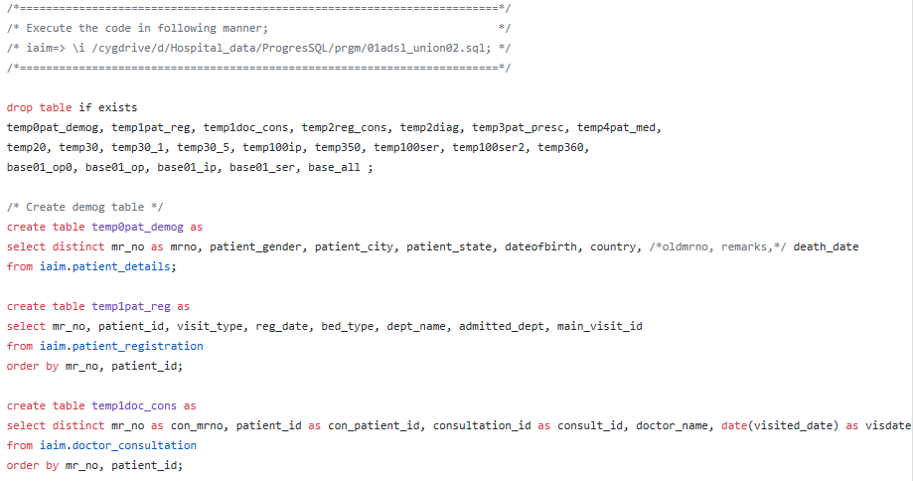
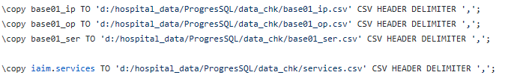

Fig 3: R code, use the input files created using SQL queries
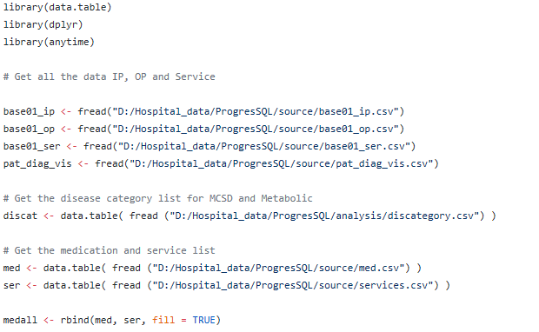
...
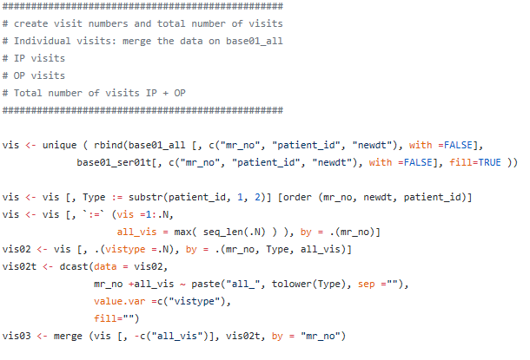

Fig 4: One of the datasets with key variables
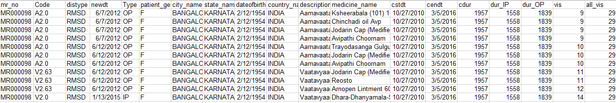

The snapshot shows following variables:
- patient ID,
- Disease code,
- Disease type,
- Date of visit,
- visit type (IP, OP),
- gender,
- city,
- state,
- date of birth,
- Country,
- Description of disease,
- Medicine name,
- Start date,
- End date,
- Total duration,
- In Patient duration,
- Outpatient duration,
- Visit number,
- Total number of visits, etc.

Primary Study Endpoints/Secondary Endpoints
Insert a specific statement of the primary endpoints and the secondary endpoints, if any to be measured during the trial.

Study Design/Type
Real World evidence approach employed to the existing data.

Randomization
Not applicable

Maintenance
Insert a description of the maintenance of the randomization codes and the procedure for breaking codes.

Trial Treatment
Insert a description of the trial treatment(s) and the dosage and dosage regimen of the investigational product(s). Also include a description of the dosage form, packaging, and labeling of the investigational product(s).

Duration
Insert the expected duration of subject participation and a description of the sequence and duration of all trial periods, including follow-up if any.

Discontinuation
Insert a description of the stopping rules or discontinuation criteria for individual subjects, parts of the trial, and entire trial.

Product Accountability
Insert accountability procedures for the investigational product(s), including the placebo(s) and comparator(s) if any.

Data Identification
Insert the identification of any data to be recorded directly on the CRFs (i.e. no prior written or electronic record of data), and to be considered to be source data.

Selection and Withdrawal of Subjects

Inclusion Criteria
Patients having the following diseases reported at least once in the hospital database

Metabolic diseases list
M10.0 | Medoroga | Metabolic
M10.1 | Medoroga - Sthula medho roga | Metabolic
M10.2 | Medoroga - Sukshma medho roga | Metabolic
M2.0 | Madhumeha | Metabolic
P5.0 | Prameha | Metabolic
P5.1 | Prameha - Krusha | Metabolic
P5.2 | Prameha - Pidaka | Metabolic
P5.3 | Prameha - Sthula | Metabolic
P5.4 | Prameha - Upadrava | Metabolic

Rheumatic and Musculoskeletal diseases list:
A2.0 | Aamavaata | RMSD
A2.1 | Aamavaata - Kaphaja | RMSD
A2.2 | Aamavaata - Pittaja | RMSD
A2.3 | Aamavaata - Vaataja | RMSD
A3.0 | Abhighataja Shoola | RMSD
S10.0 | Stambha | RMSD
S10.1 | Stambha - Baahu Stambha | RMSD
S10.10 | Stambha - Prishtha Stambha | RMSD
S10.12 | Stambha - Sandhi Stambha | RMSD
S10.13 | Stambha - Siraa Stambha | RMSD
S10.14 | Stambha - Uru Stambha | RMSD
S10.4 | Stambha - Greevaa Stambha | RMSD
S10.5 | Stambha - Hanu Stambha | RMSD
S10.6 | Stambha - Hridaya Stambha | RMSD
S13.0 | Sthaanabhedena Graha | RMSD
S13.1 | Sthaanabhedena Graha - Anga Graha | RMSD
S13.11 | Sthaanabhedena Graha - Katee Graha | RMSD
S13.13 | Sthaanabhedena Graha - Manyaa Graha | RMSD
S13.14 | Sthaanabhedena Graha - Marma Graha | RMSD
S13.17 | Sthaanabhedena Graha - Paada Graha | RMSD
S13.18 | Sthaanabhedena Graha - Paarshva Graha | RMSD
S13.19 | Sthaanabhedena Graha - Prishtha Graha | RMSD
S13.20 | Sthaanabhedena Graha - Shiro Graha | RMSD
S13.22 | Sthaanabhedena Graha - Uro Graha | RMSD
S13.23 | Sthaanabhedena Graha - Vaak Graha | RMSD
S13.3 | Sthaanabhedena Graha - Gala Graha | RMSD
S13.5 | Sthaanabhedena Graha - Hanu Graha | RMSD
S13.6 | Sthaanabhedena Graha - Hrid Graha | RMSD
S13.7 | Sthaanabhedena Graha - Jaanugraha | RMSD
S13.8 | Sthaanabhedena Graha - Janghaa Graha | RMSD
S14.0 | Sthaanabhedena Shoola | RMSD
S14.11 | Sthaanabhedena Shoola - Guda Shoola | RMSD
S14.13 | Sthaanabhedena Shoola - Gulpha Shoola | RMSD
S14.14 | Sthaanabhedena Shoola - Hanu Shoola | RMSD
S14.15 | Sthaanabhedena Shoola - Hasta Shoola | RMSD
S14.16 | Sthaanabhedena Shoola - Hrid Shoola | RMSD
S14.17 | Sthaanabhedena Shoola - Jaanu Shoola | RMSD
S14.18 | Sthaanabhedena Shoola - Janghaa Shoola | RMSD
S14.19 | Sthaanabhedena Shoola - Kantha Shoola | RMSD
S14.21 | Sthaanabhedena Shoola - Katee Shoola | RMSD
S14.23 | Sthaanabhedena Shoola - Kukshi Shoola | RMSD
S14.24 | Sthaanabhedena Shoola - Manyaa Shoola | RMSD
S14.3 | Sthaanabhedena Shoola - Amsa Shoola | RMSD
S14.4 | Sthaanabhedena Shoola - Anga Shoola | RMSD
S14.5 | Sthaanabhedena Shoola - Anguli Shoola | RMSD
S14.6 | Sthaanabhedena Shoola - Asthi Shoola | RMSD
S14.7 | Sthaanabhedena Shoola - Baahu Shoola | RMSD
S15.28 | Sthaanabhedena Shoola - Nakha Shoola | RMSD
S15.31 | Sthaanabhedena Shoola - Paada Shoola | RMSD
S15.32 | Sthaanabhedena Shoola - Paarshni Shoola | RMSD
S15.34 | Sthaanabhedena Shoola - Parva Shoola | RMSD
S15.36 | Sthaanabhedena Shoola - Prishtha Shoola | RMSD
S15.41 | Sthaanabhedena Shoola - Sakthi Shoola | RMSD
S15.42 | Sthaanabhedena Shoola - Sandhi Shoola | RMSD
S15.43 | Sthaanabhedena Shoola - Skandha Shoola | RMSD
S15.44 | Sthaanabhedena Shoola - Snaayu Shoola | RMSD
S15.45 | Sthaanabhedena Shoola - Sphik Shoola | RMSD
S15.46 | Sthaanabhedena Shoola - Stanaanta Shoola | RMSD
S15.47 | Sthaanabhedena Shoola - Trika Shoola | RMSD
S15.48 | Sthaanabhedena Shoola - Urah Shoola | RMSD
S1A.0 | Shoola | RMSD
V1.0 | Vaatarakta | RMSD
V1.1 | Vaatarakta - Dvandvaja | RMSD
V1.2 | Vaatarakta - Gambheera | RMSD
V1.3 | Vaatarakta - Kapha Vaataja | RMSD
V1.4 | Vaatarakta - Kaphaadhika Vaatarakta | RMSD
V1.5 | Vaatarakta - Pittaadhika Vaatarakta | RMSD
V1.7 | Vaatarakta - Uttaana | RMSD
V1.8 | Vaatarakta - Vaata Kaphaja | RMSD
V1.9 | Vaatarakta - Vaataadhika Vaatarakta | RMSD
V2.0 | Vaatavyaadhi | RMSD
V2.12 | Vaatavyaadhi - Stabdhagaatra | RMSD
V2.16 | Vaatavyaadhi - Baahugata Vaata | RMSD
V2.23 | Vaatavyaadhi - Gridhrasee | RMSD
V2.30 | Vaatavyaadhi - Jaanugata Vaata | RMSD
V2.31 | Vaatavyaadhi - Janghaagata Vaata | RMSD
V2.36 | Vaatavyaadhi - Kateegata Vaata | RMSD
V2.42 | Vaatavyaadhi - Maamsagata Vaata | RMSD
V2.43 | Vaatavyaadhi - Maamsamedogata Vaata | RMSD
V2.44 | Vaatavyaadhi - Majjaagata Vaata | RMSD
V2.45 | Vaatavyaadhi - Majjaasthigata Vaata | RMSD
V2.46 | Vaatavyaadhi - Manyaagata Vaata | RMSD
V2.47 | Vaatavyaadhi - Manyaastambha | RMSD
V2.48 | Vaatavyaadhi - Medogata Vaata | RMSD
V2.61 | Vaatavyaadhi - Prishthagata Vaata | RMSD
V2.63 | Vaatavyaadhi - Sandhigata Vaata | RMSD
V2.64 | Vaatavyaadhi - Sarvaangagata Vaata | RMSD
V2.65 | Vaatavyaadhi - Shaakhaagata Vaata | RMSD
V2.68 | Vaatavyaadhi - Siraagata Vaata | RMSD
V2.69 | Vaatavyaadhi - Siraagraha | RMSD
V2.70 | Vaatavyaadhi - Snaayugata Vaata | RMSD
V2.72 | Vaatavyaadhi - Trikgata Vaata | RMSD
V2.73 | Vaatavyaadhi - Tvaggata Vaata | RMSD
V2.74 | Vaatavyaadhi - Urugata Vaata | RMSD
V2.75 | Vaatavyaadhi - Vaatakantaka | RMSD
V2.77 | Vaatavyaadhi - Vishvaachee | RMSD
V2.9 | Vaatavyaadhi - Asthigata Vaata | RMSD

Neuroscience diseases list:
NEURO
NEURO
NEURO

Exclusion Criteria
Patients who do not have any of the above reported diseases in the hospital database.

Subject Withdrawal
Insert subject withdrawal criteria (i.e. terminating investigational product treatment/trial treatment) and procedures specifying:
- When and how to withdraw subjects from the trial/investigational product treatment.
- The type and timing of the data to be collected for withdrawal of subjects.
- Whether and how subjects are to be replaced.
- The follow-up for subjects withdrawn from investigational treatment/trial treatment.

Treatment of Subjects
Insert how the treatment(s) is(are) to be administered, including the name(s) of all the product(s), the dose(s), the dosing schedule(s), the route/mode(s) of administration, and the treatment period(s), including follow-up period(s) for subjects for each investigational product treatment/trial treatment group/arm of the trial.

Medication
Insert medication(s)/treatment(s) permitted (including rescue medication) and not permitted before and/or during the trial.

Monitoring for subject compliance
Insert the procedures for monitoring subject compliance

Assessment of Efficacy

Efficacy Parameters
Insert the specifications of the efficacy parameters.

Method and Timing
Insert methods and timing for assessing, recording and analyzing efficacy parameters.

Assessment of Safety

Safety Parameters
Insertspecifications for safety parameters.

Method and Timing
Insert the methods and timing for assessing, recording and analyzing safety parameters.

Adverse Event Reporting
Insert a statement about compliance with the local IRB requirements and the requirements of other regulatory authorities that may apply (most commonly the Food and Drug Administration).

Procedures for eliciting reports of and for recording and reporting adverse event and intercurrent illnessesshould be described in this section.

Definitions
See http://www.research.umn.edu/irb/ae/ prior to completing this section. Insert definitions for how you will apply the terms “unanticipated”, “serious”, and “related” to problems that arise during the study.
See definitions for adverse events and serious adverse events under the Code of Federal Regulations at: http://www.ahc.umn.edu/research/indide/definitions/home.html.

Adverse Event Follow-up
Insert the type and duration of the follow-up of subjects after adverse events.

Statistical Plan

Statistical Methods
Insert a description of the statistical methods to be employed including timing of any planned interim analysis(ses).

Subject Population(s) for Analysis
Insert the number of subjects planned to be enrolled. In multi-center trials, the number of enrolled subjects projected for each trial site should be specified. Provide a reason for choice of sample size, including reflection on (or calculations of) the power of the trial and clinical justification. Also include, here, how you will select the group of subjects for analysis (e.g., all randomized subjects, all dosed subjects, all eligible subjects, and only evaluable subjects).

Significance
Insert the level of significance to be used.

Termination Criteria
Insert the criteria for the termination of the trial.

Accountability Procedure
Insert the procedure for accounting for missing, unused and spurious data.

Deviation Reporting
Insert the procedures for reporting any deviation(s) from the original statistical plan. Any deviation(s) from the original statistical plan should be described and justified in the protocoland/or in the final report.

Direct Access to Source Data/Documentation
It should be specified in the protocol or other written agreement the investigator(s)/institution(s) will permit trial-related monitoring, audits,
IRB/IEC(s) review and regulatory inspection(s) by providing direct access
to source data/documentation.

Quality Control and Quality Assurance
Insert how you will ensure that this study is conducted – and that data are generated, documented (recorded), and reported - in compliance with this protocol, with GCP, and any other applicable regulatory requirements.

Ethical Considerations
Describe the ethical considerations relating to this study. The following language is an example:

This study will be conducted according to US and international standards of Good Clinical Practice (FDA regulations 21 CFR 312 for IND studies and FDA guidance E6) for all studies. Applicable government regulations and University of Minnesota research policies and procedures will also be followed.

This protocol and any amendments will be submitted to the University of Minnesota Institutional Review Board (IRB) for formal approval to conduct the study. The decision of the IRB concerning the conduct of the study will be made in writing to the investigator.

All subjects for this study will be provided a consent form describing this study and providing sufficient information for subjects to make an informed decision about their participation in this study. This consent form will be submitted with the protocol for review and approval by the IRB. The formal consent of a subject, using the IRB-approved consent form, will be obtained before that subject is submitted to any study procedure. This consent form must be signed by the subject or legally acceptable surrogate, and the investigator-designated research professional obtaining the consent.

Data Handling and Record Keeping
Insert a description of who, what, where and why

Finance and Insurance
Insert financing and insurance statements if not addressed in a separate agreement. Who will be responsible for paying for research related costs? Who will be responsible for paying for injuries in case of accident?

Publication Plan
Where ownership of the data is not in question – this section may be omitted. Otherwise, insert a publication policy, if not addressed in a separate agreement (most commonly a contract).

Supplements
Insert any other documentation for the trial.

Following documents must be submitted:
1. Application form (scanned copy/original can be submitted while applying for review; original must be submitted to receive approval letter)
2. Study protocol
3. Data collection tools
4. Consent form (English and local language)
5. CV of investigators
6. Any other relevant documents

